

A202 - STIA1123 PROGRAMMING 2 (GROUP C).

GROUP 1

PROJECT

EDUCATION BUSINESS

LECTURE NAME : PROF. MADYA DR. AZMAN BIN YASIN.

GROUP MEMBERS :

|  |  |  |
| --- | --- | --- |
| **NO** | **NAME** | **MATRIC NUMBER** |
| 1. | NUR QISTINA LIYANA BINTI ZULKERNAINI | 276995 |
| 2. | NOR AIN LIDYIA NATASHA BINTI FAUZI | 269423 |
| 3. | MUHAMMAD VICKY ROMADHAN | 268802 |

# TABLE OF CONTENTS

|  |  |  |
| --- | --- | --- |
| **NO** | **TITLE** | **PAGE** |
|  | MAIN PAGE | 1 |
|  | TABLE OF CONTENTS | 2 |
| 1.0 | COMPANY BACKGROUND | 3-4 |
| 2.0 | UML DIAGRAM    2.1 Education Business  2.2 E-Book Writing  2.3 Education Camps Day  2.4 Software Training | 5-7 |
| 3.0 | PROGRAM DESCRIPTION  3.1 Education Business  3.2 E-Book Writing  3.3 Education Camps Day  3.4 Software Training | 8  8 -20  20 - 47  48 - 74 |

1. **COMPANY BACKGROUND:**

Business education is a type of education that focuses on the skills and procedures of the business world. This subject of study can be found at all levels of education, including secondary and higher education institutions. Business education has numerous forms, the majority of which take place in a school classroom. Internships are another option for obtaining this type of knowledge. As the business industry as a whole comprises many diverse areas, a business education contains many different components. The curriculum and popularity of a business education vary widely around the world. Career development is frequently a part of a business education. Lastly, there are three small business education in our project which are E-book writing, education day camps and Software Training.

The first company name listed in the business education is **E-Book Writing**. The location of our company at Tg.Balai Karimun, RiauIsland Indonesia. Our e-mail is [CSWriting@gmail.co.id](mailto:CSWriting@gmail.co.id). If user have question can contact +6282288173253. In addition, the purpose of this company is to provide services or help people make e-books correctly and creatively with the guidance of a professional teachers we had. We guarantee who has registered, after learning they will create e-books perfectly. Finally, our company will provide a good E-book writing for you all to learn it.

For business education afterwards is **education day camps**. The name of the company is 7DS Company Sdn Bhd. Founded by Lidyia Fauzi. 7DS Company Sdn Bhd was established in Bandar Johor, Johor Bahru which in No. 32 Bangunan Wangsa, Johor Bahru on 09 January 2019. Our contact number is 03-77356970 and email is 7DS1234@gmail.com. Typically, these day camps run a day in length with sessions available in multiple time zones. As all know, The next generation will be in charge of continuing technical breakthroughs in a world dominated by them and a civilization that is becoming increasingly reliant on them. People that are interested in coding today are laying the groundwork for a successful profession later on. 7DS Company Sdn Bhd provide education for better coding for people who has interests on that while also providing them with an enjoyable and memorable day camps education. 7DS Company Sdn Bhd has lay out perfect 3 subject such as Introduction To Programming, Object Oriented Programming and the last is Graphical User Interface. In nutshell, 7DS Company Sdn Bhd always provide a good education day camps for people who wants to learn.

The last company name listed in the education business is **Software Training** by giving the name as Intelleq QS. The location of my company is in the urban area, namely G-85, 1-85, 2, 85, Jalan Prima SG 3, Prima Seri Gombak, 68100 Batu Caves, Selangor and email is IntellectQS@gmail.com. Customer can also contact us using by this number 783478249. Beside that, the purpose of the intelleq QS company established is to provide them with training and encouragement in software training to gain broad and advanced knowledge to students and unemployed who register at my company and guarantee jobs to those who register. In addition, intelleq QS company has an estimated 100 employees ready to serve in intelleq QS company. We have offered three software training courses to students and unemployed, namely JAVA, PYTHON, and C++. Finally, our clients are mainly made up of students and unemployed to get jobs in company software training.

1. **UML DIAGRAM:**

**2.1 Education Business**

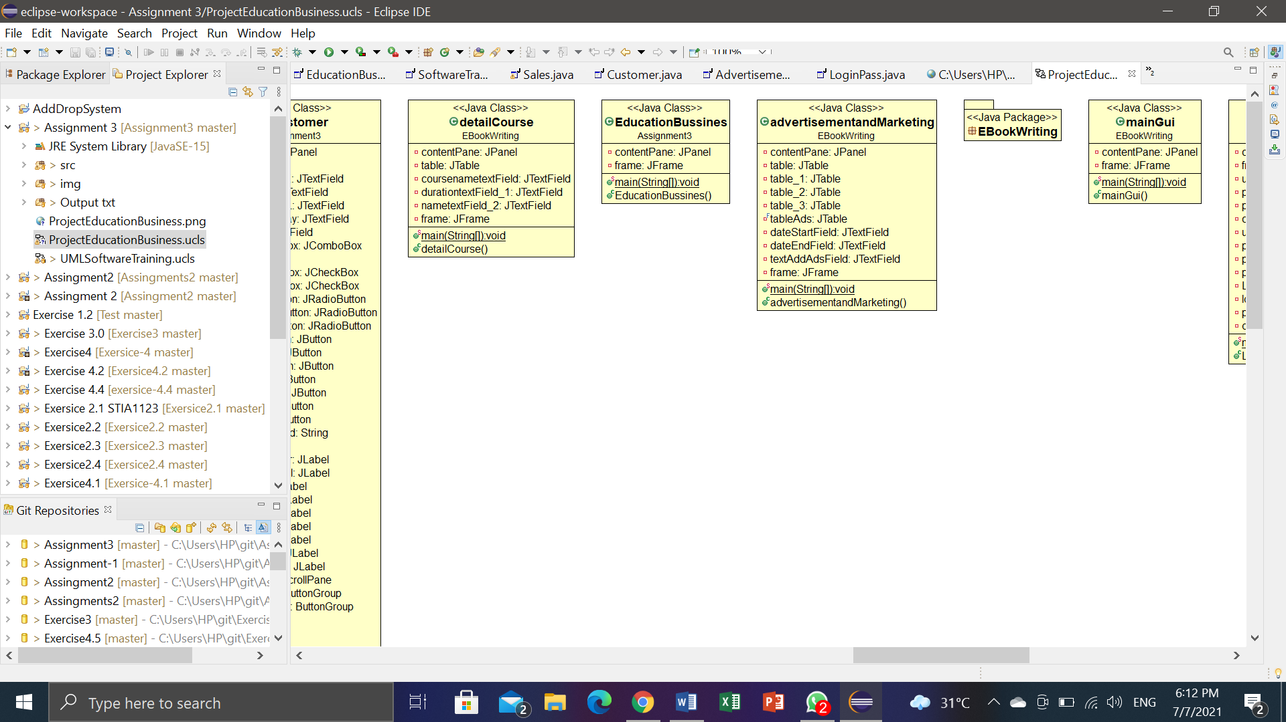

**2.2 E-Book writing**

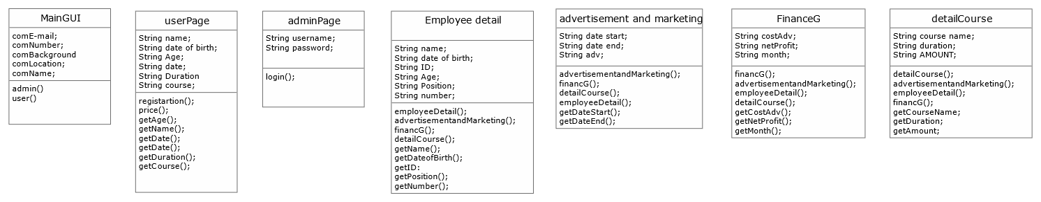

**2.3 Education camps day**

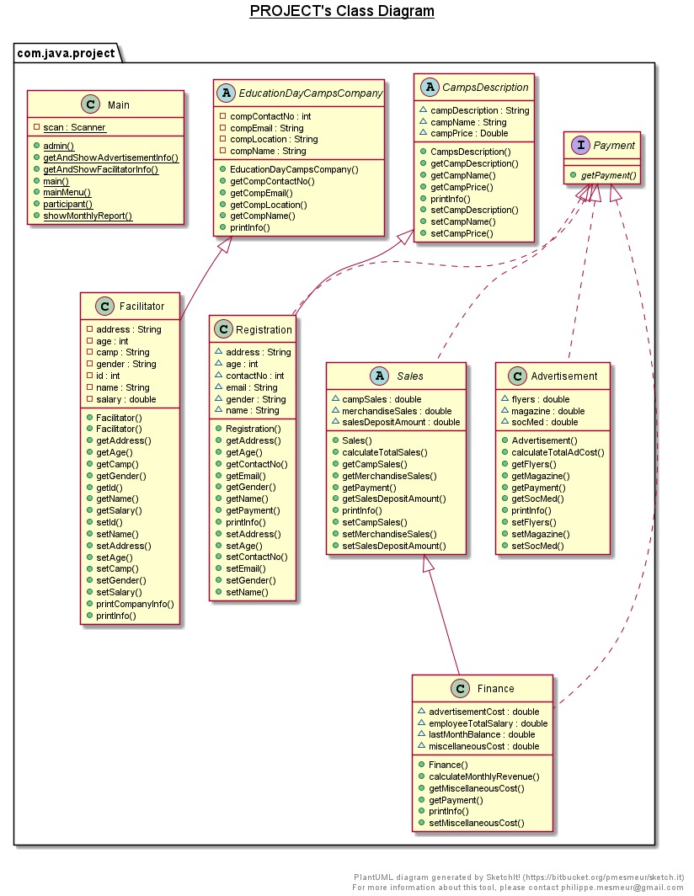

**2.4 Software training**

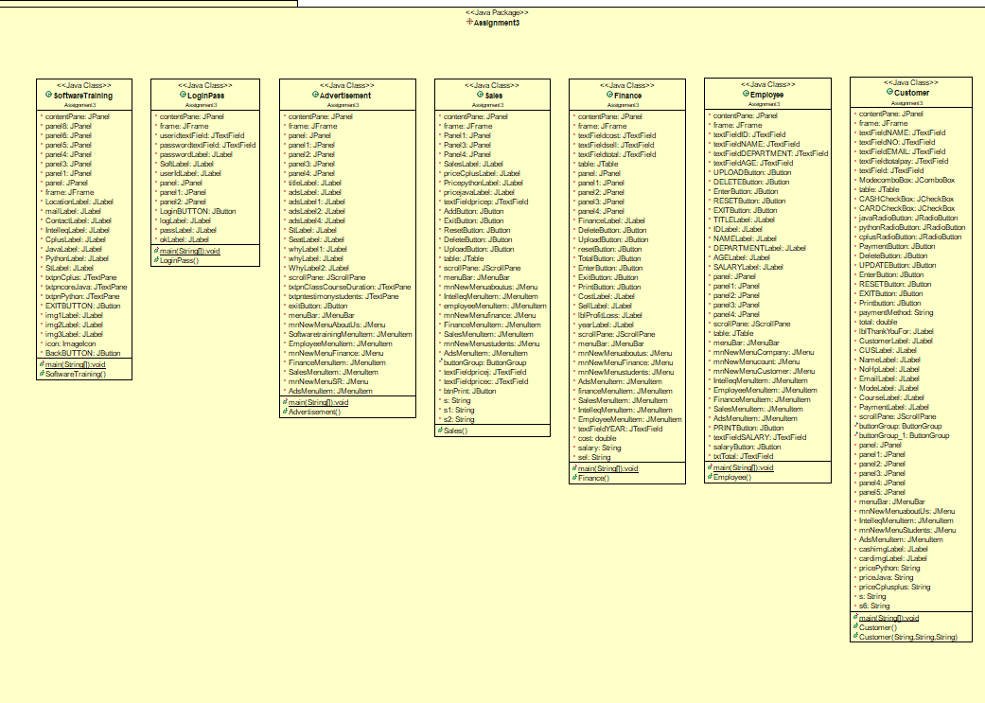

1. **PROGRAM DESCRIPTION:**
   1. EDUCATION BUSINESS –

- This is the main page for our project group, education business. There are three buttons that can click to enter the page which are button E- Book writing, Education camps day, and software training.

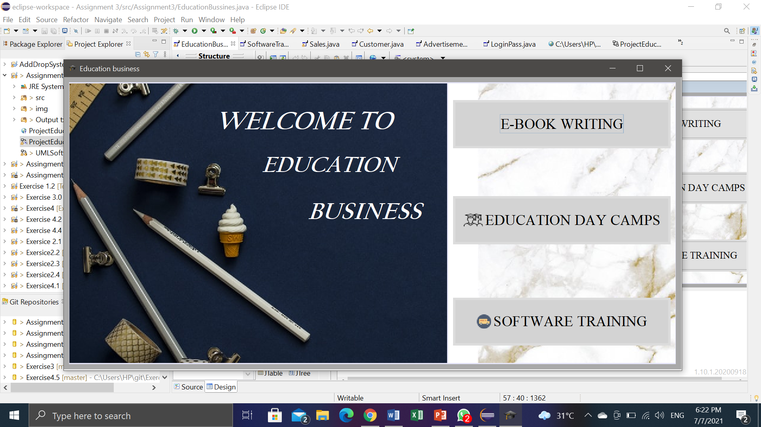

3.2 E-BOOK WRITING –

**COMPANY BACKGROUND**

* This is background of company at Main GUI. To access this background, users have to click button “About Us” and “Contact” at main Page.

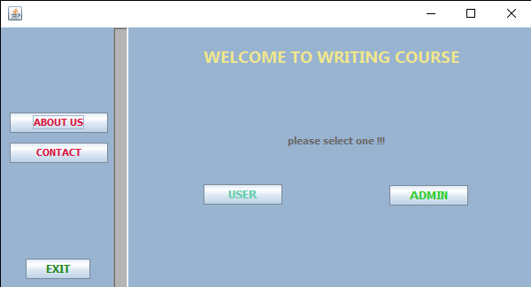

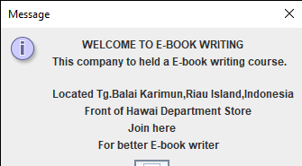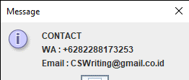

**ADMIN-BUTTON LOGIN**

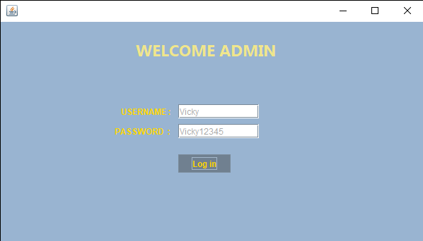

- if correct will pop up message show “login successfully”

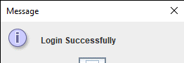

**EMPLOYEE DETAIL**

-Enter name, date birth, ID, age, position, number of row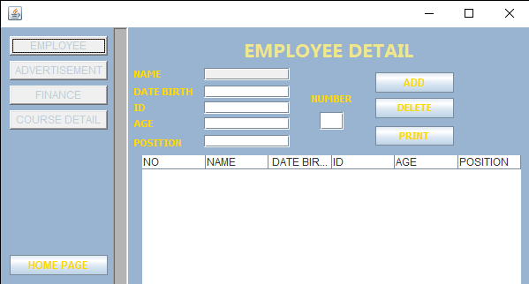

- add

Click button “ADD” for adding data to table.

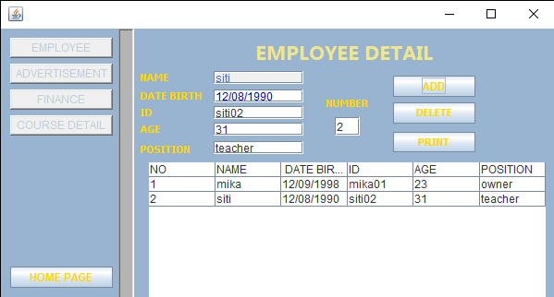

* delete

click row and click button delete

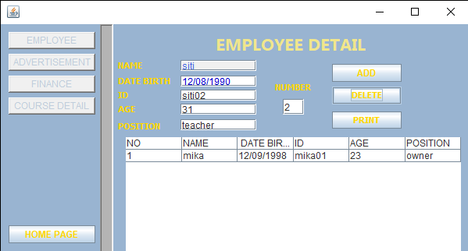

- Print

Click button “Print” for print data.

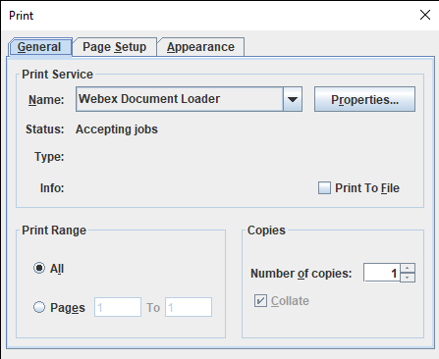

**ADVERTISEMENT**

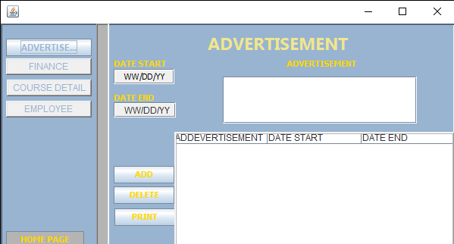

- add

Click button “ ADD “ for add data to table.

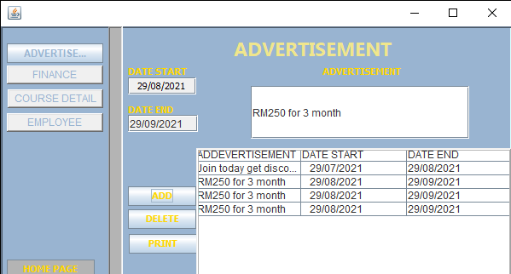

- delete

Click row than delete.

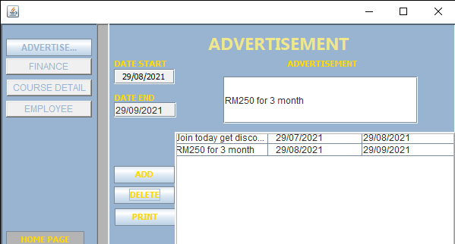

- Print

Click button “ Print” for print data.

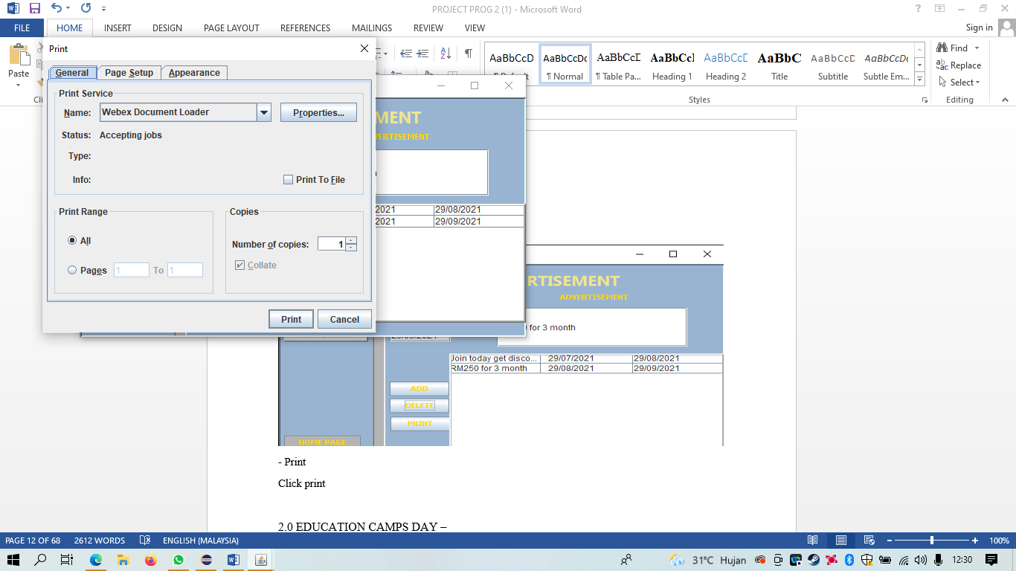

**FINANCE**

Add cost advertisement, Net profit, Month, than click add

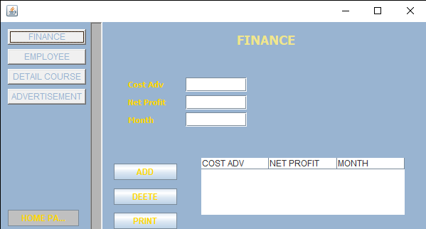

* - add
* click button “ ADD “ to add data.

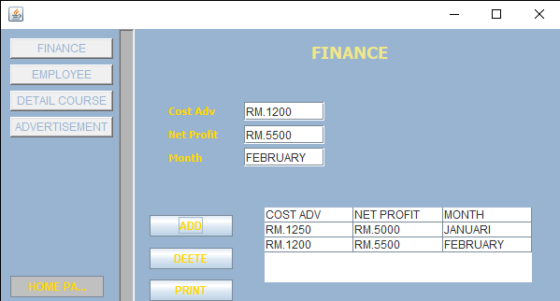

- delete

Click row , than delete

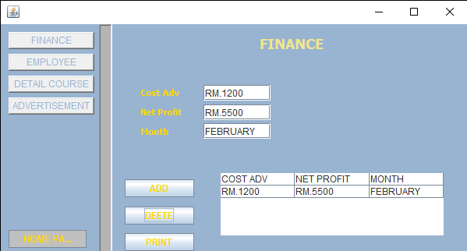

- Print

Click button “print” for print.

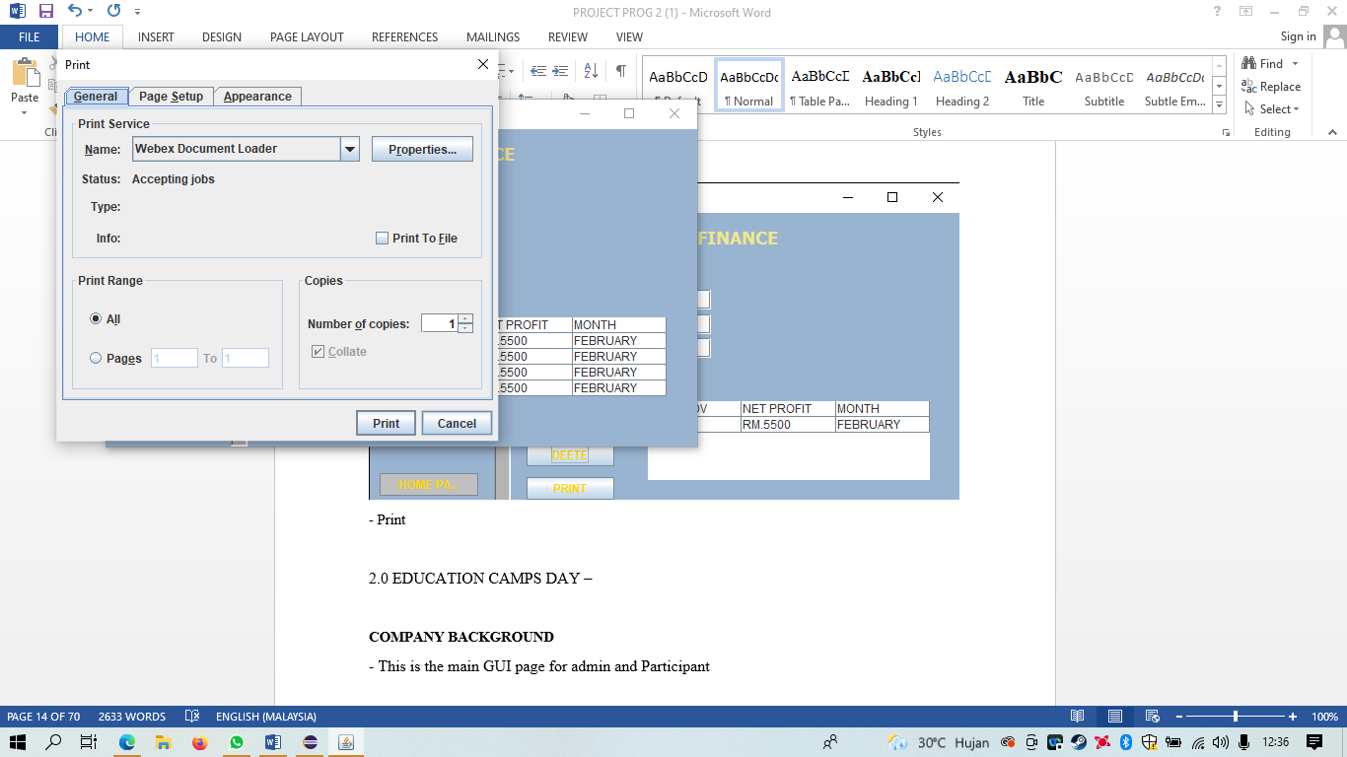

**COURSE DETAIL**

Add course name, Duration, Amount than click button “ ADD” to add data

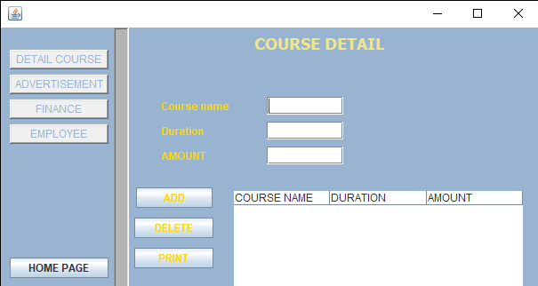

- add

Click button “ ADD “ for add data to table

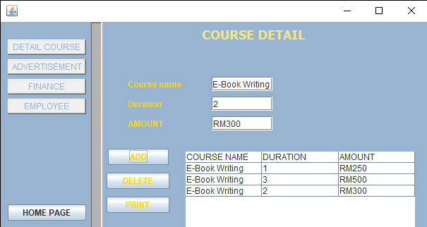

-delete

Select row , and click button “Delete” for delete row

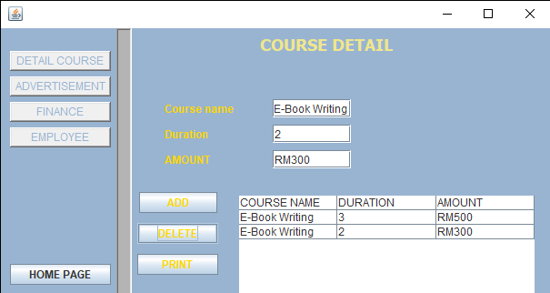

-print

Click button “ Print “ to print data.

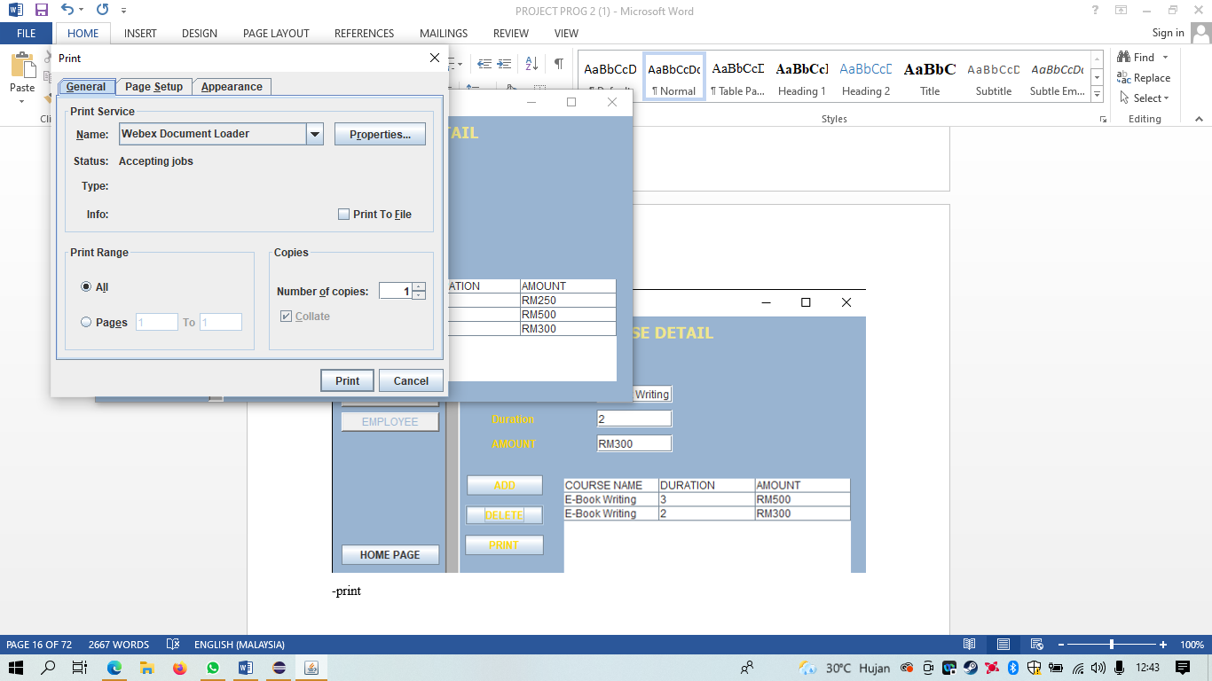

**BUTTON HOME PAGE**

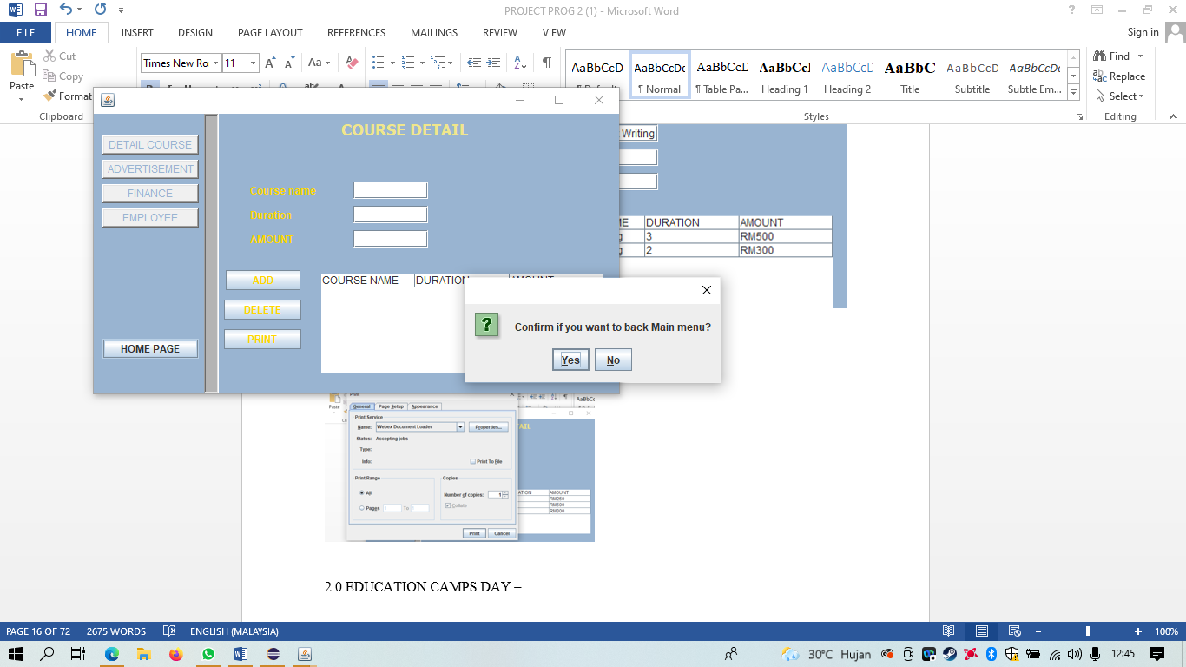

if user click button “ Home Page” pop up message will show “Confirm if you want to back main menu?” click “yes” for back main menu, click “No” to stay at page.



“yes” for back main menu.

**BUTTON EXIT**

Click button “EXIT” you will closed from this system or application.

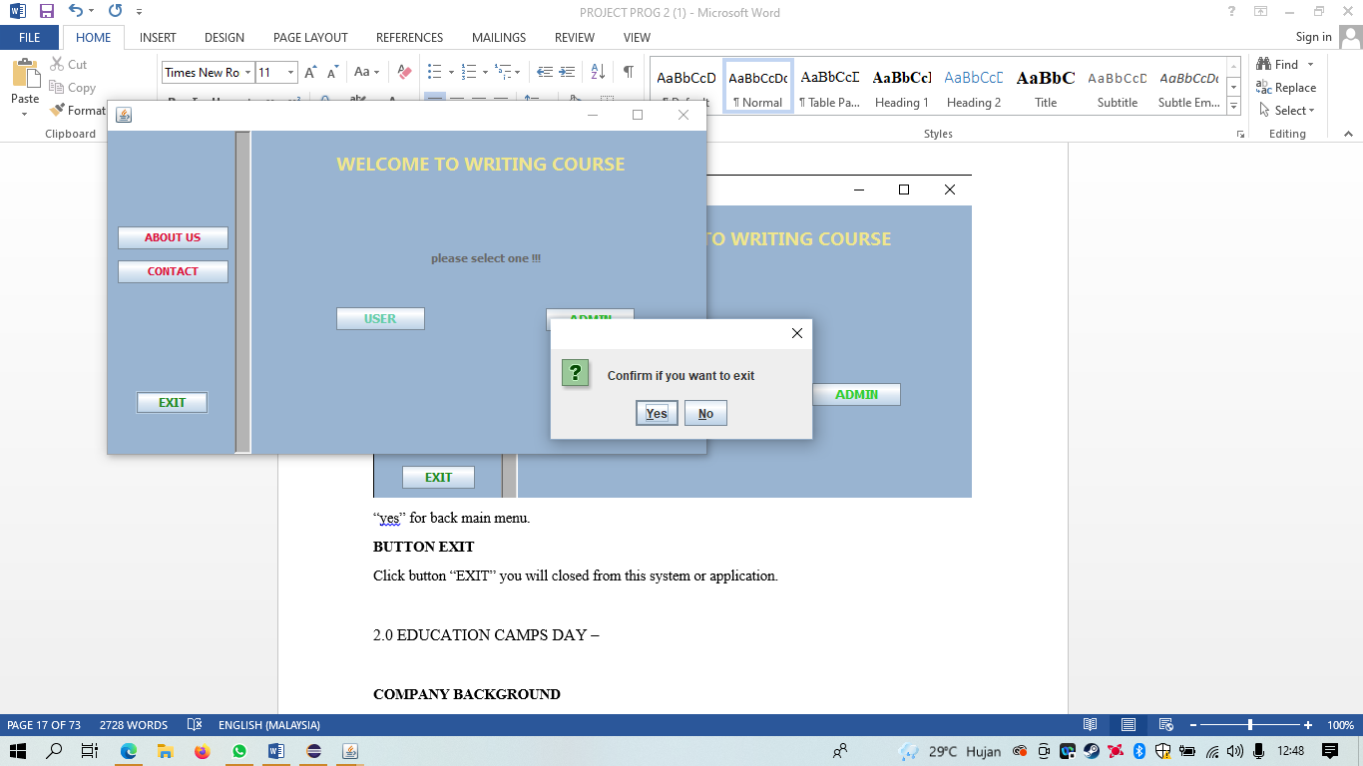

Pop up message will show “confirm if you want to exit?” click “yes” for exit, “no” for stay.

**BUTTON IN USER PAGE**

* ADD

Add Name, Date of Birth, Age, Date today, Duration, Course, Month. Than click “ADD” for add dta.

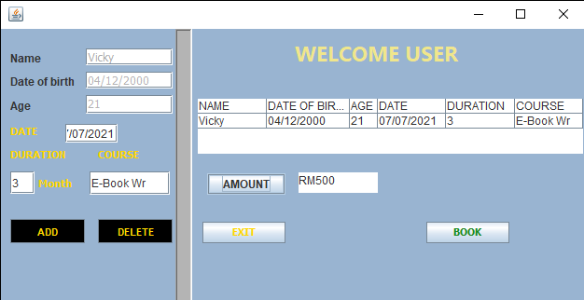

- DELETE

Select row, than click Delete

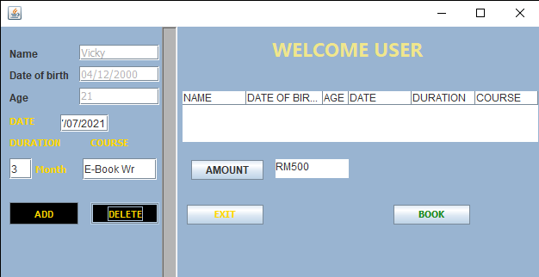

-BOOK

Click button “BOOK” for booking course and print data

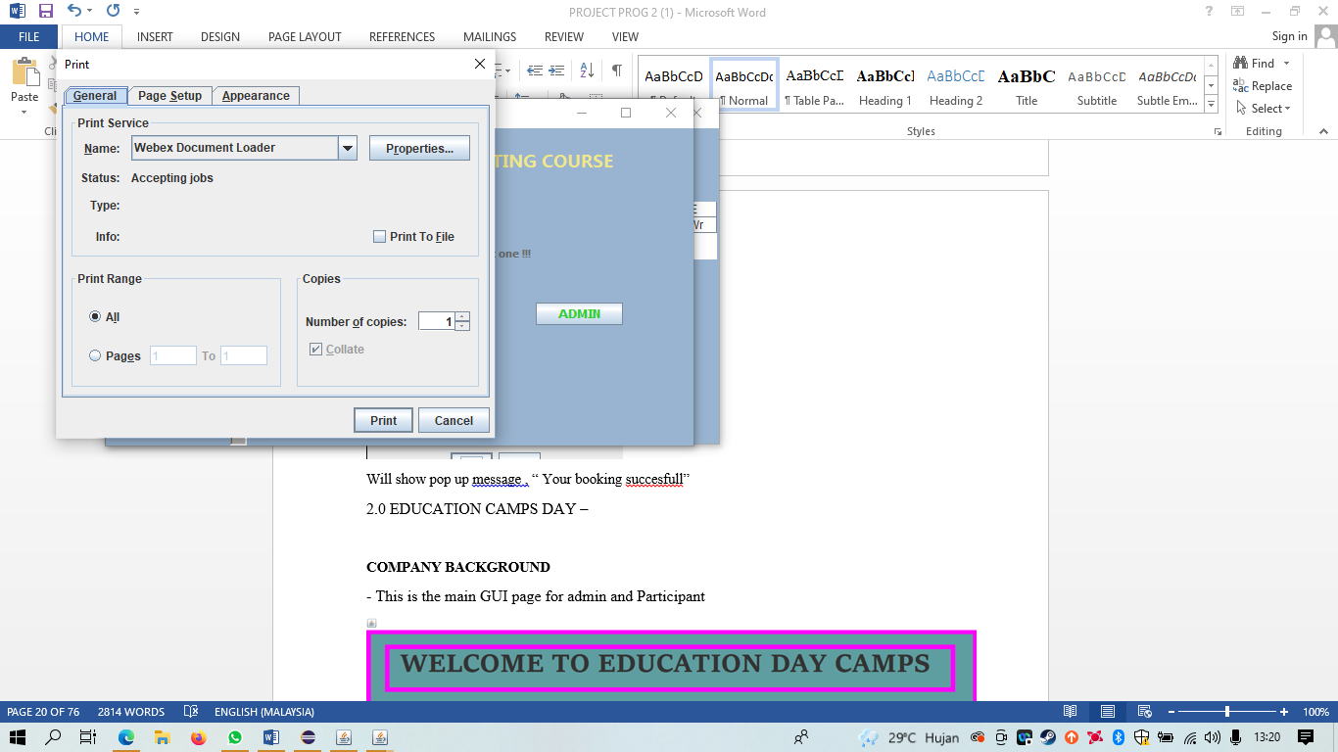

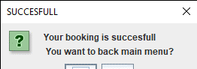

Will show pop up message , “ Your booking succesfull”

3.3 EDUCATION CAMPS DAY –

**COMPANY BACKGROUND**

- This is the main GUI page for admin and Participant

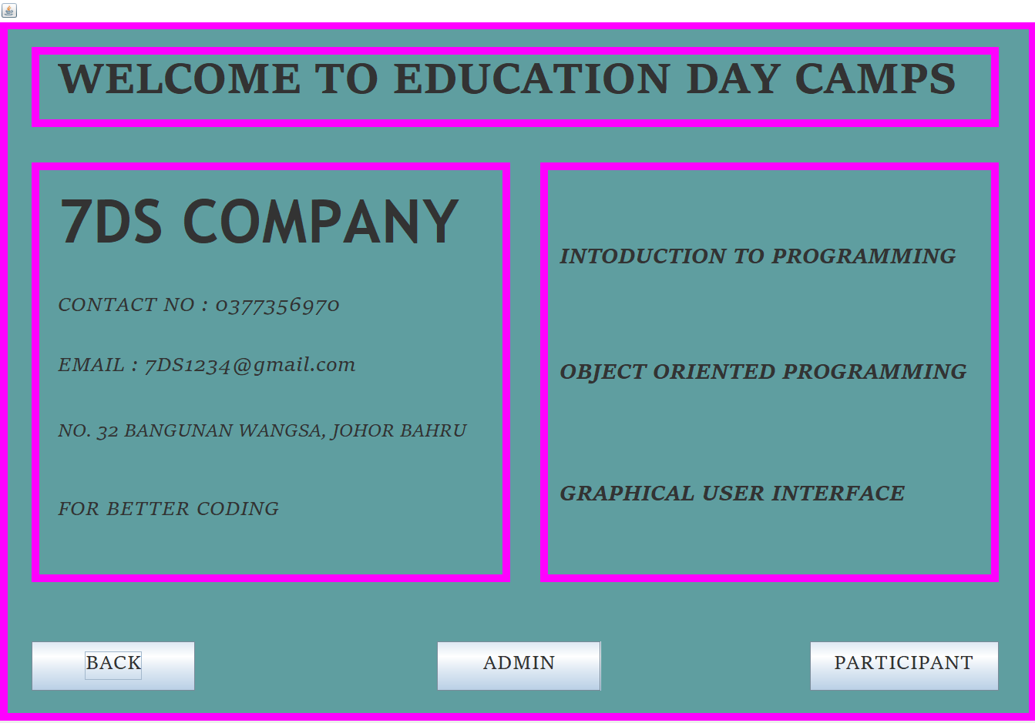

**ADMIN BUTTON-LOGIN**

* First Enter the User ID in Text field and Enter Password. Then click button LOGIN.

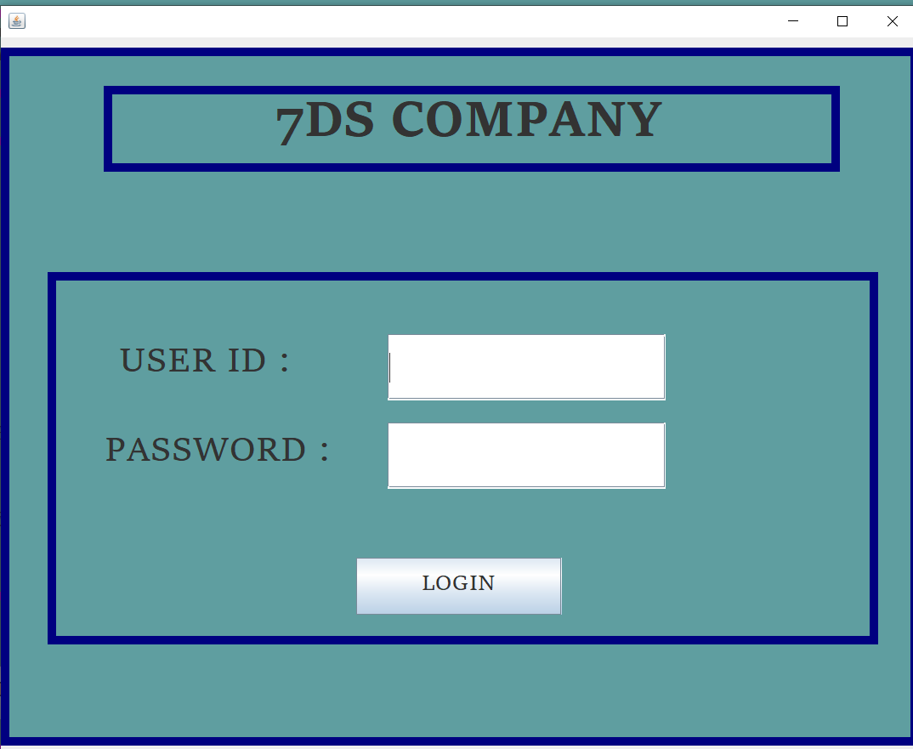

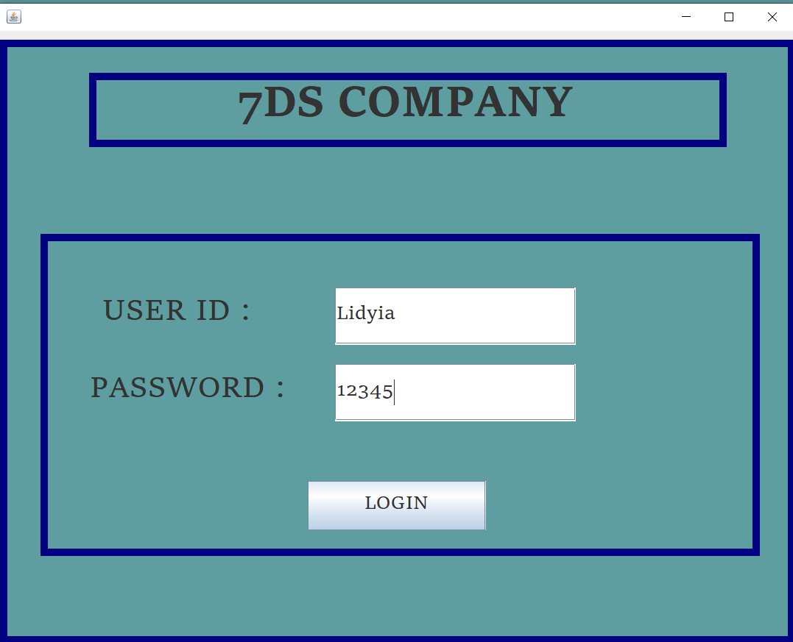

Then, will pop-up “Login Successful”. But, if you enter the wrong User Id and password. Then it will pop-up “invalid username / Password Combo”.

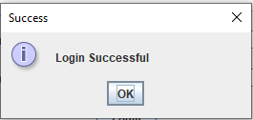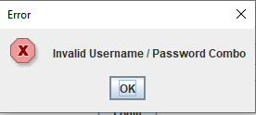

**FACILITATOR REGISTRATION**

First enter the Facilitator name, surname, address, ID No, Camps instruction, Salary and Gender in the Text field. Then click the **Add Record** button. Then, the information will appear in the table.

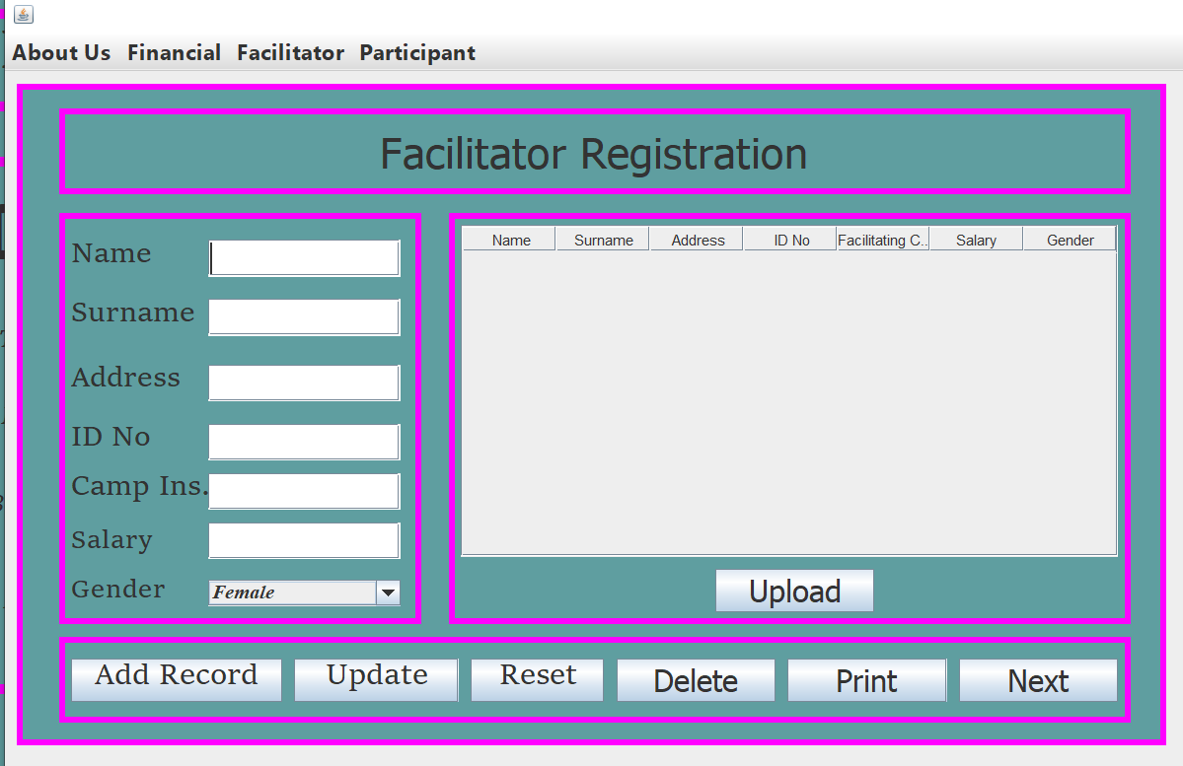

* **ADD RECORD**

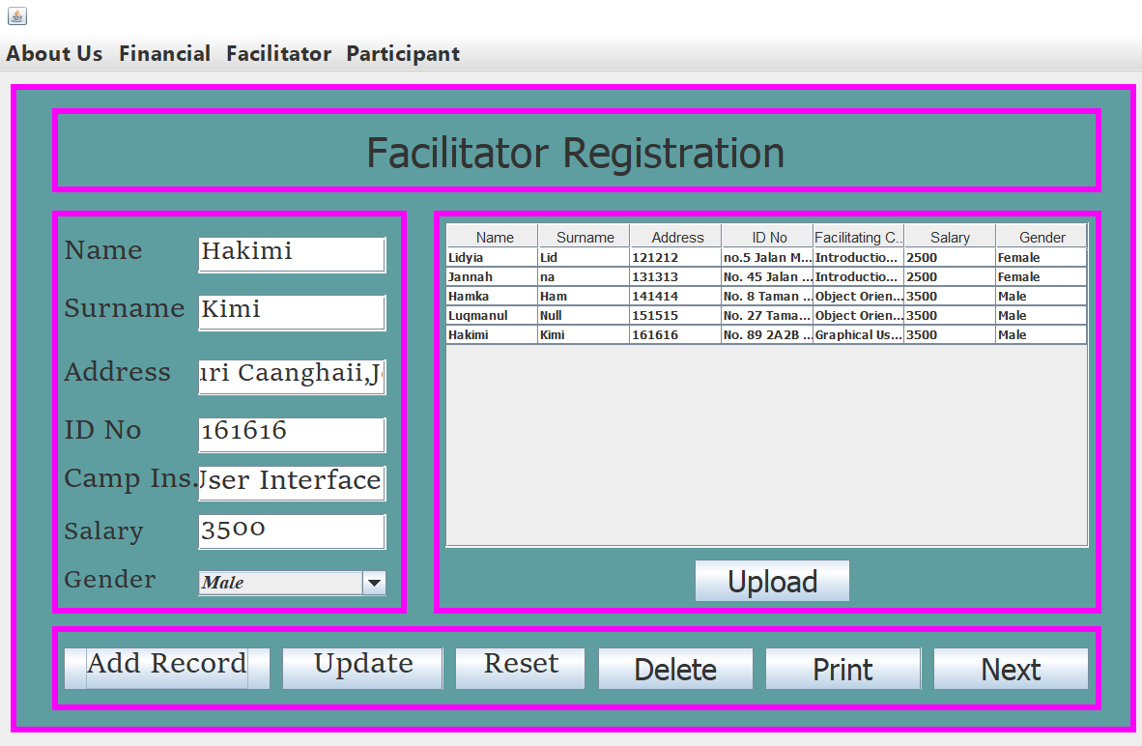

* **UPDATE**

**-** Please select the row that you want to update. If you not select the row you want to update the massage will pop-up “Please Select a Row First!” . Once already select the row just simplify update the data and the message will pop up “Update Successfully”.

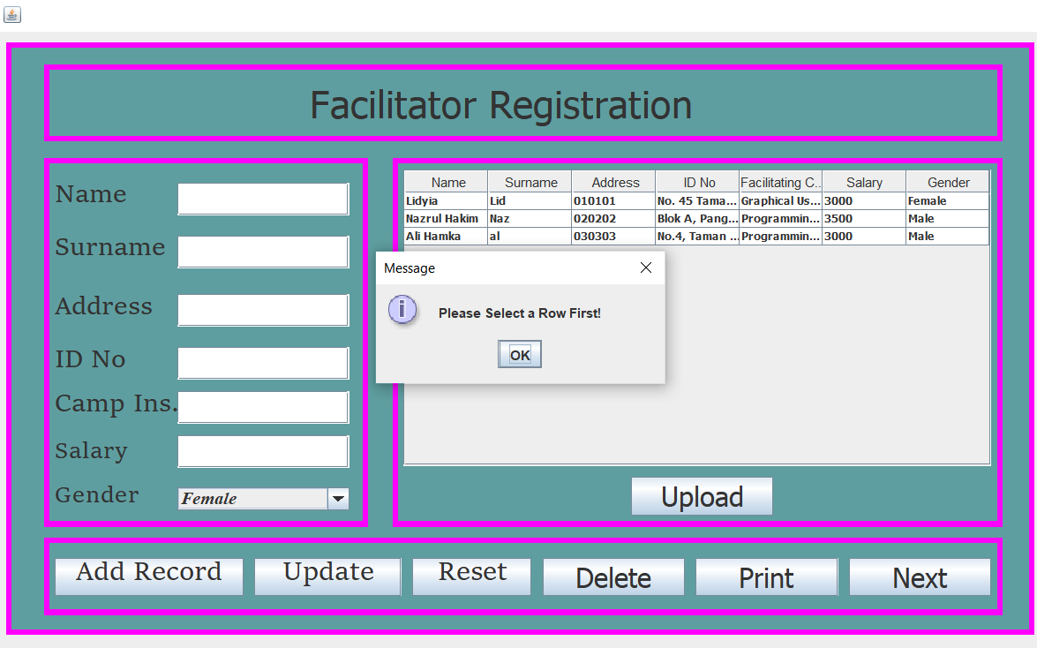

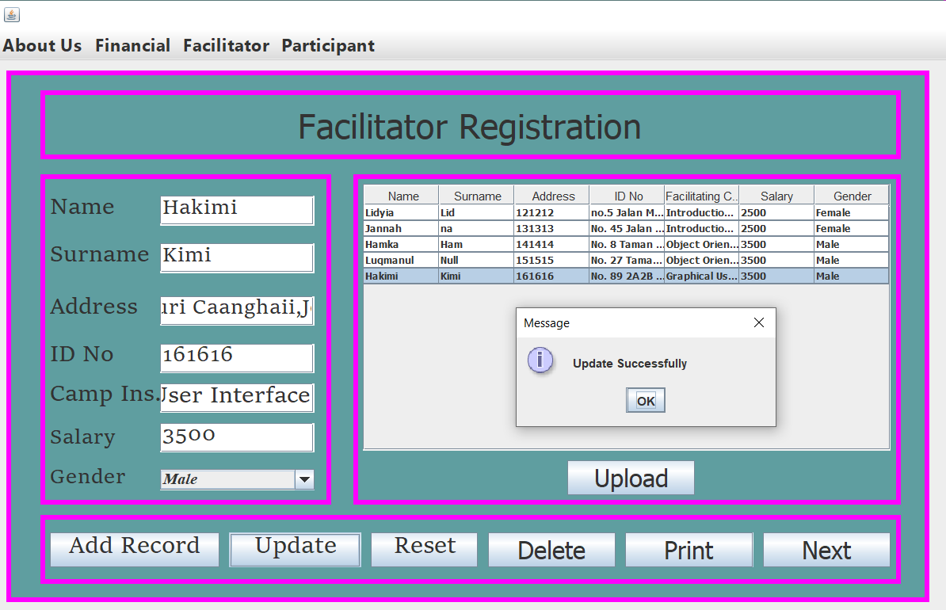

* **RESET**

- Simplify click button RESET when don’t write data or key in data. So, you don’t have to clean one by one.

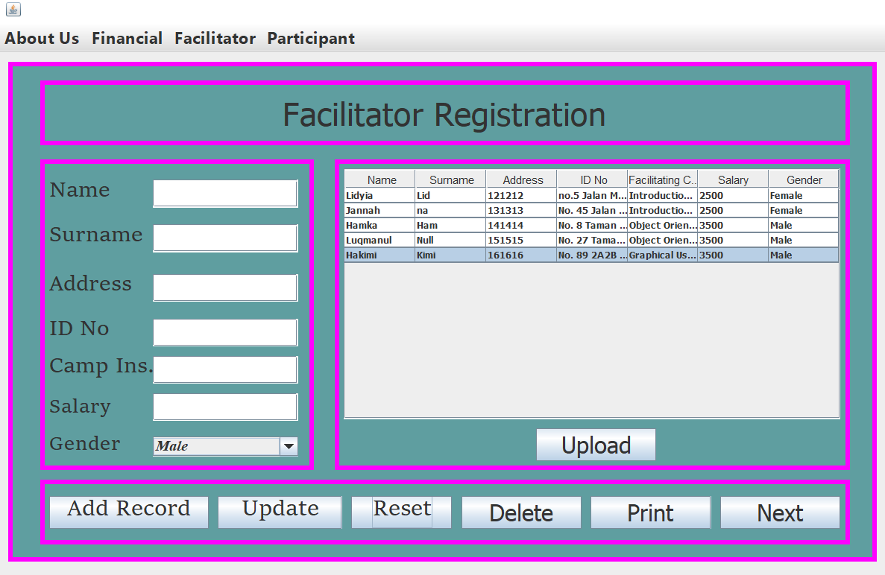

* **DELETE**

First you have to select row at table which one want to delete then click button DELETE, if you don’t click row to delete it will pop-up “Select a row to delete” then click OK



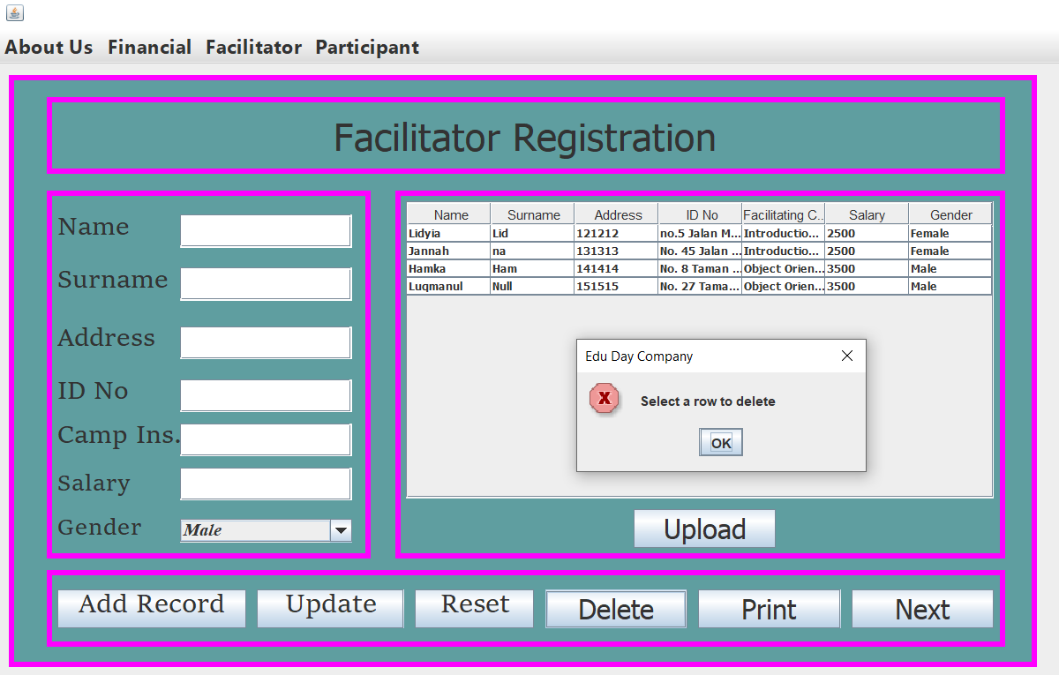

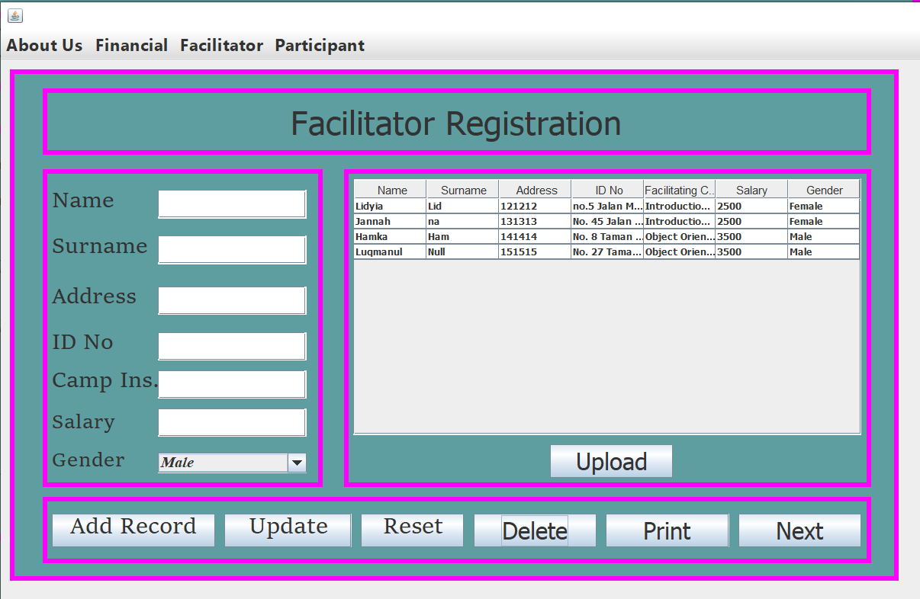

* **UPLOAD**

Click button UPLOAD. Then message will pop up “Uploaded”

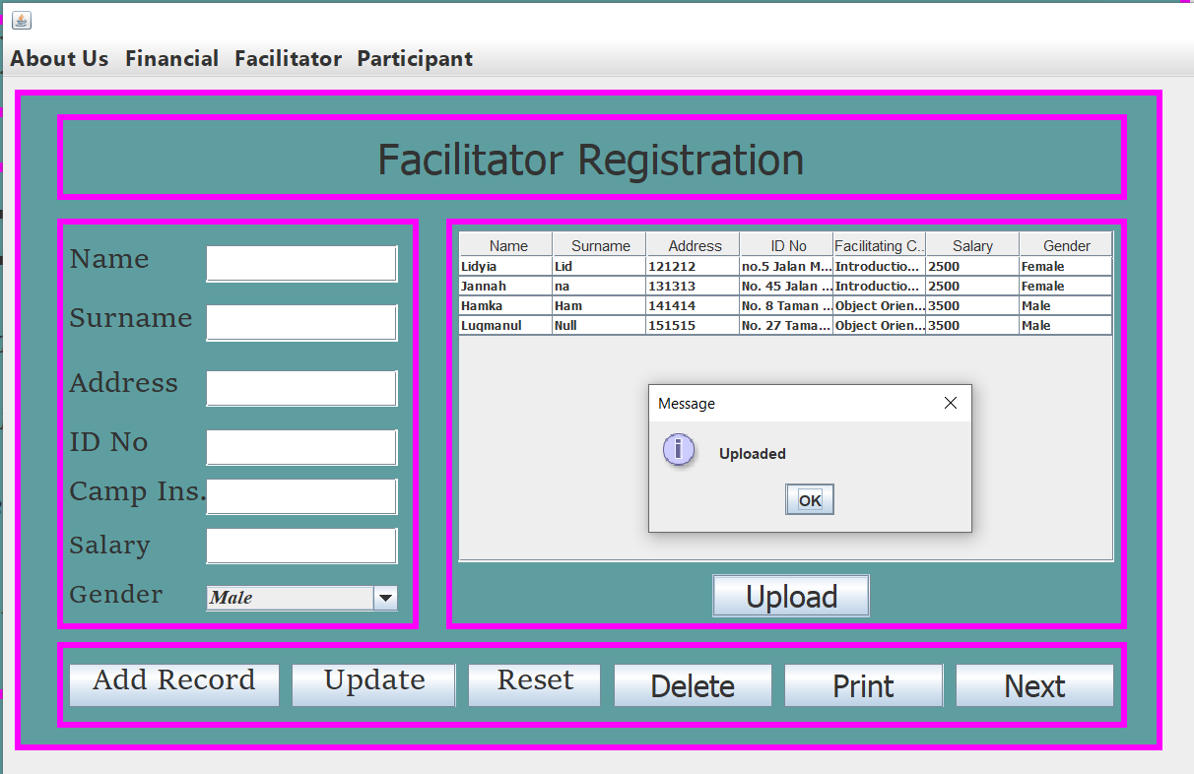

* **PRINT**

- Click Button Print then it will pop up the print information.

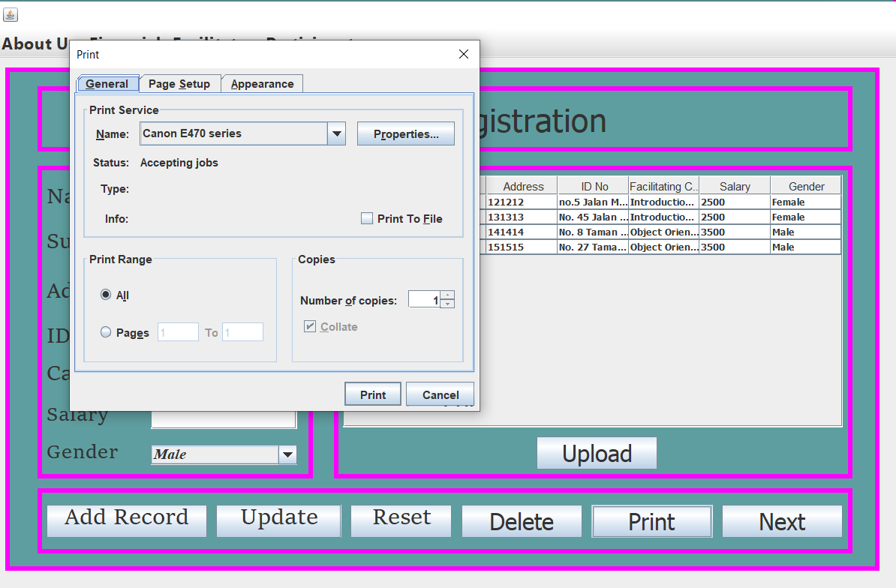

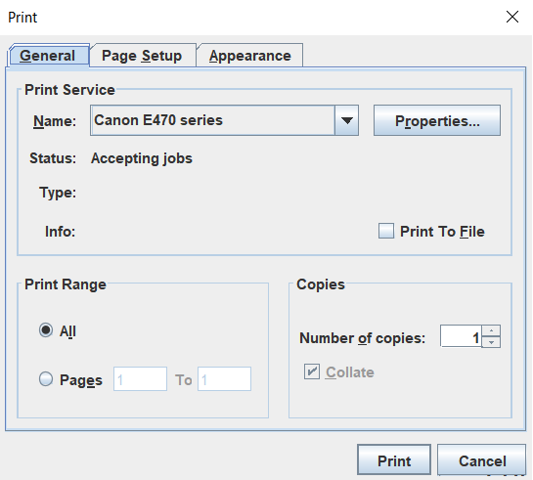

**FINANCE**

* **TOTAL Button**

**-** First select the month, enter the Merchandise Sales, enter Camp Sales and then click button TOTAL to get the total of the data entered.

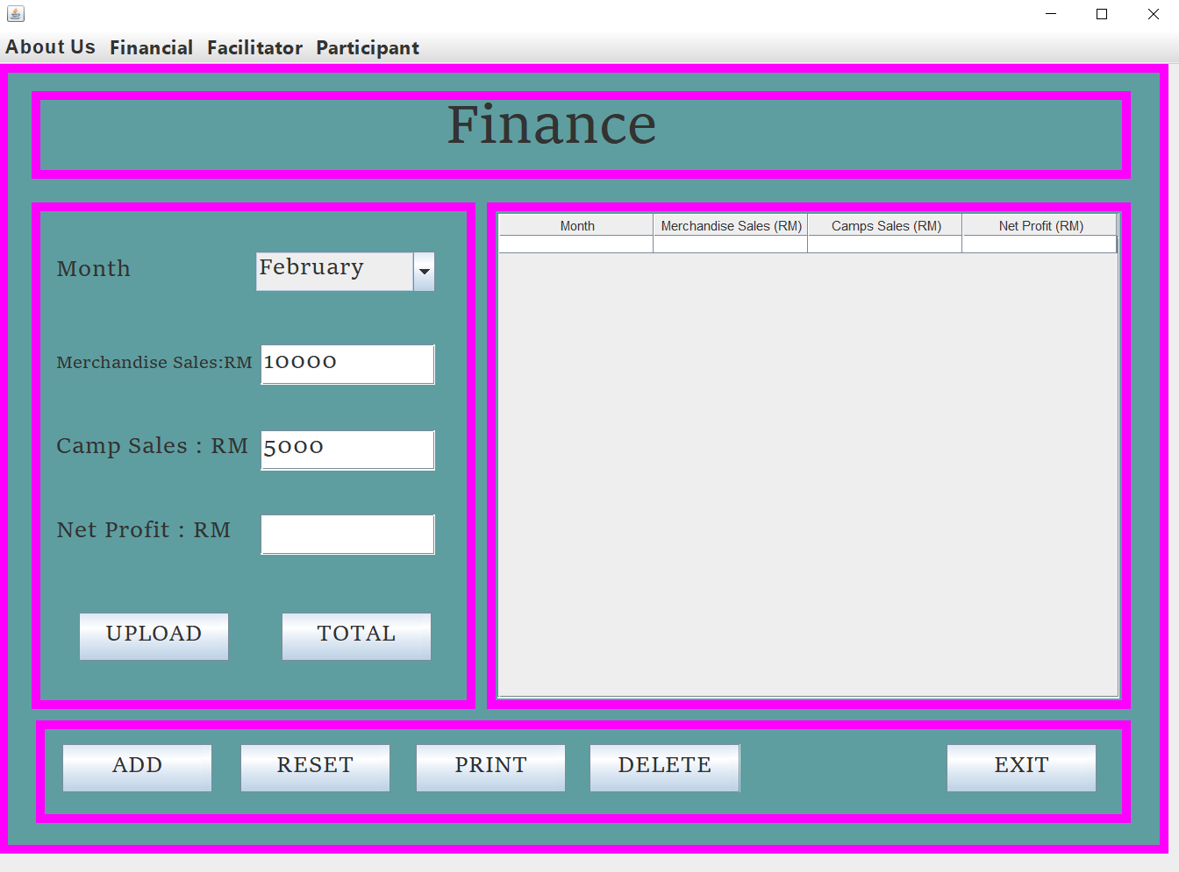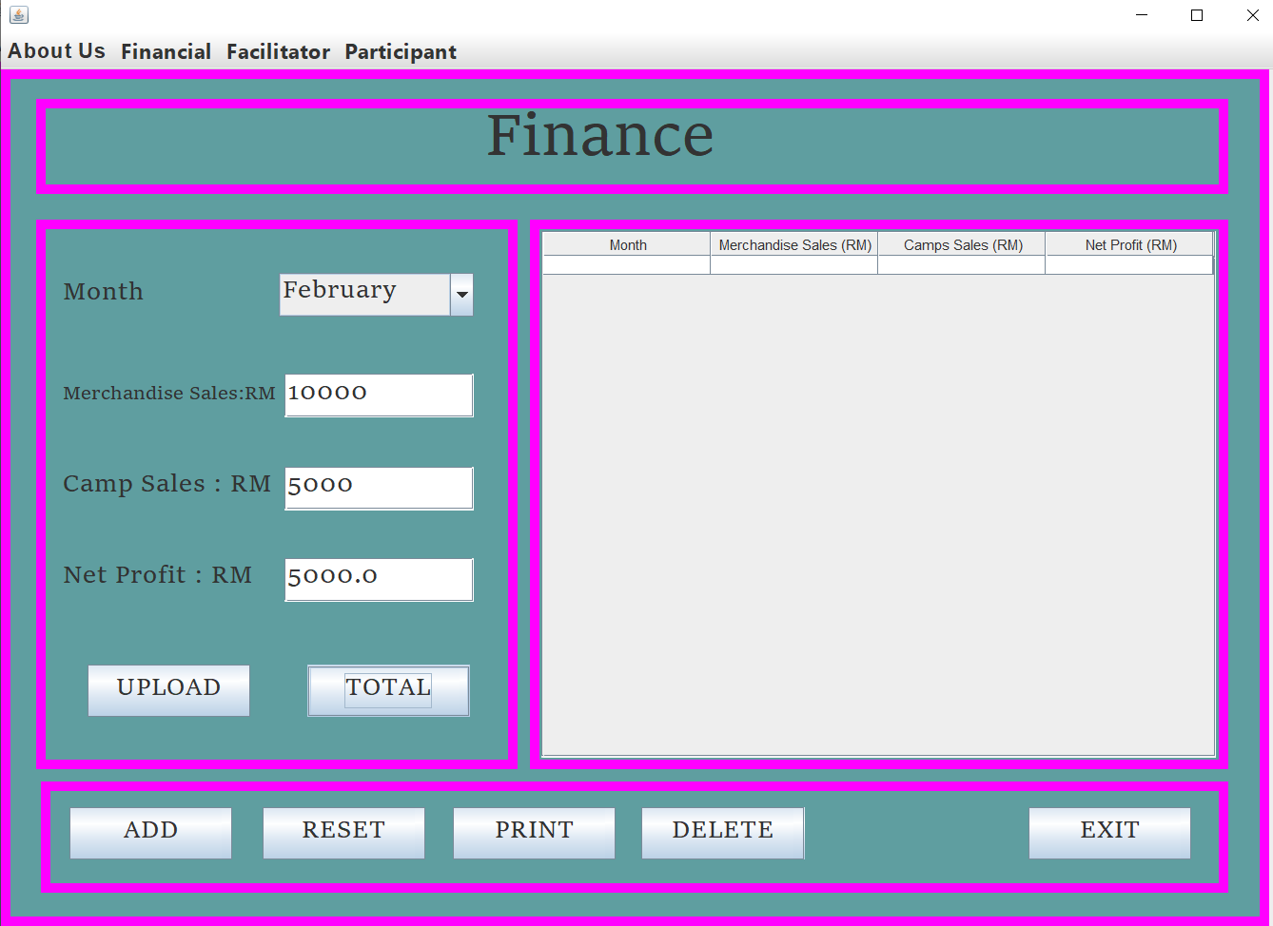

* **ADD RECORD**

- Click button ADD to display data that entered into the table.

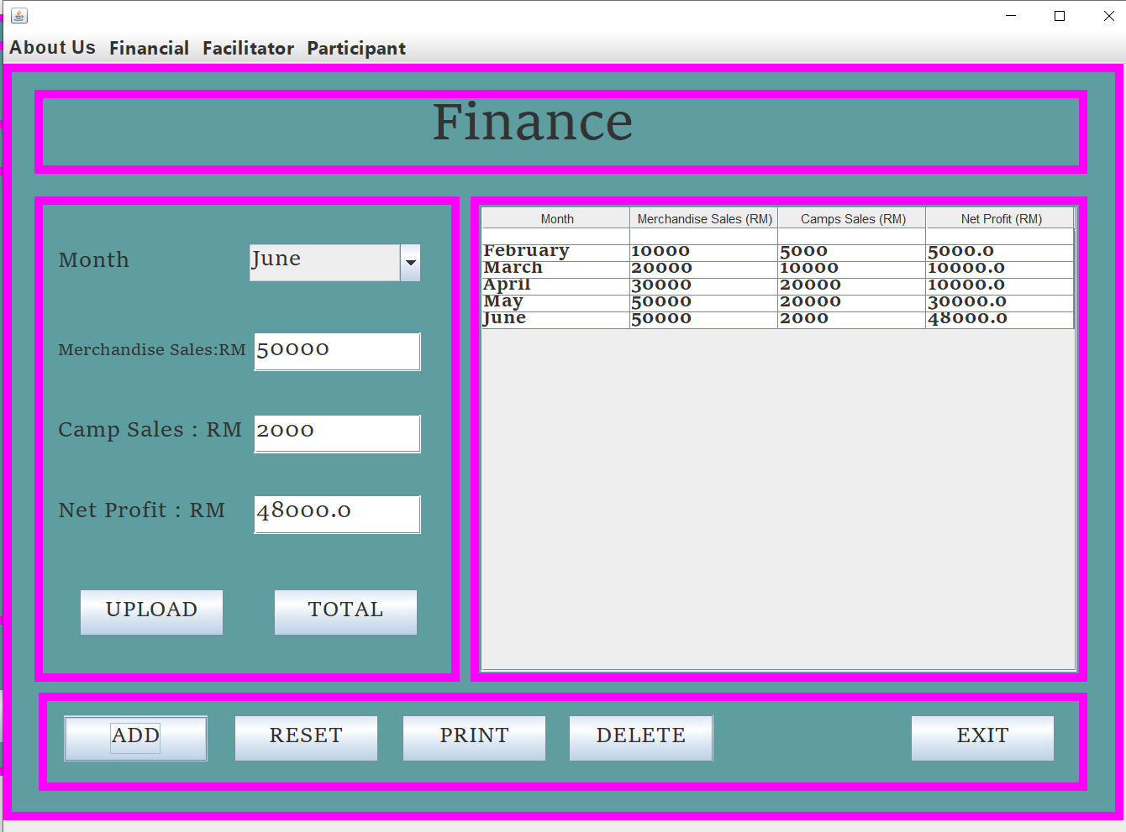

* **UPLOAD**

- Click the button UPLOAD. Then will pop-up “DATA EXPORTED”

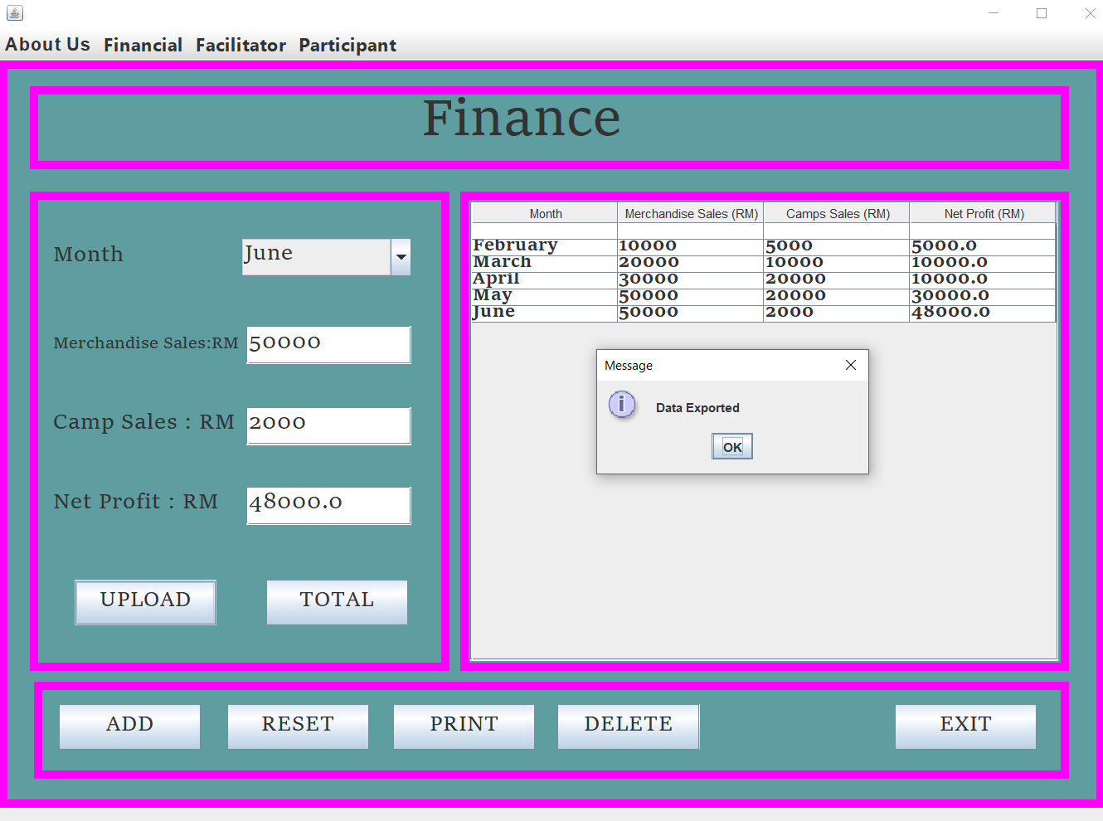

* **RESET**

- Simplify click button RESET when don’t write data or key in data. So, you don’t have to clean one by one.

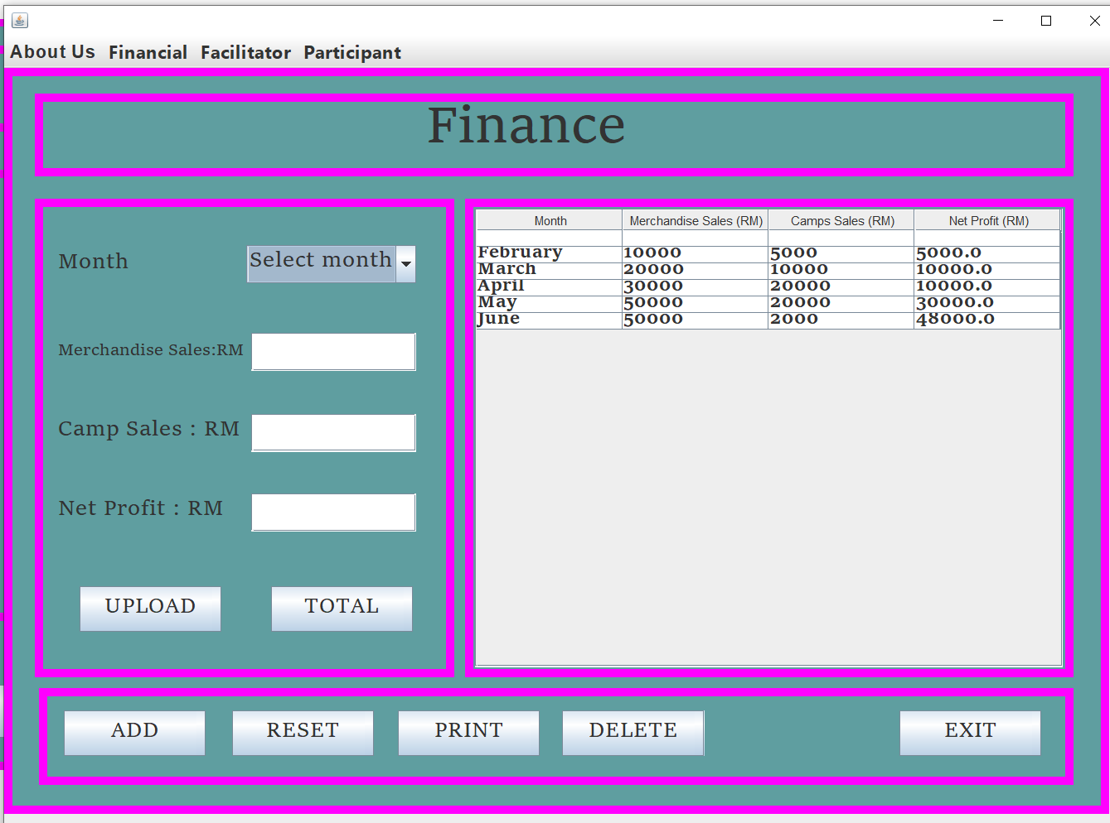

* **DELETE**

First you have to select row at table which one want to delete then click button DELETE, if you don’t click row to delete it will pop-up “Select a row to delete” then click OK

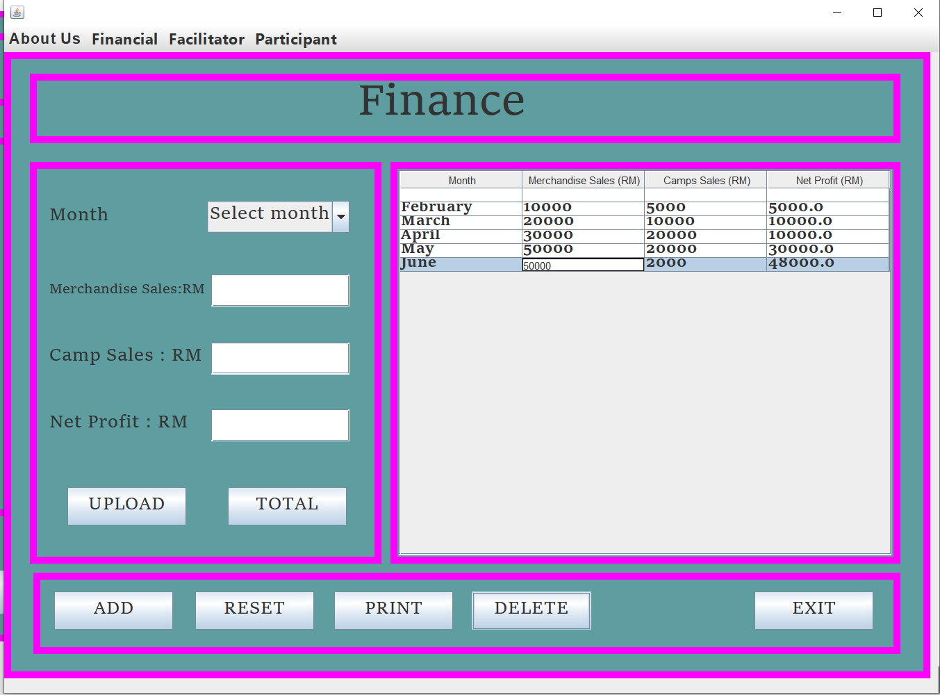

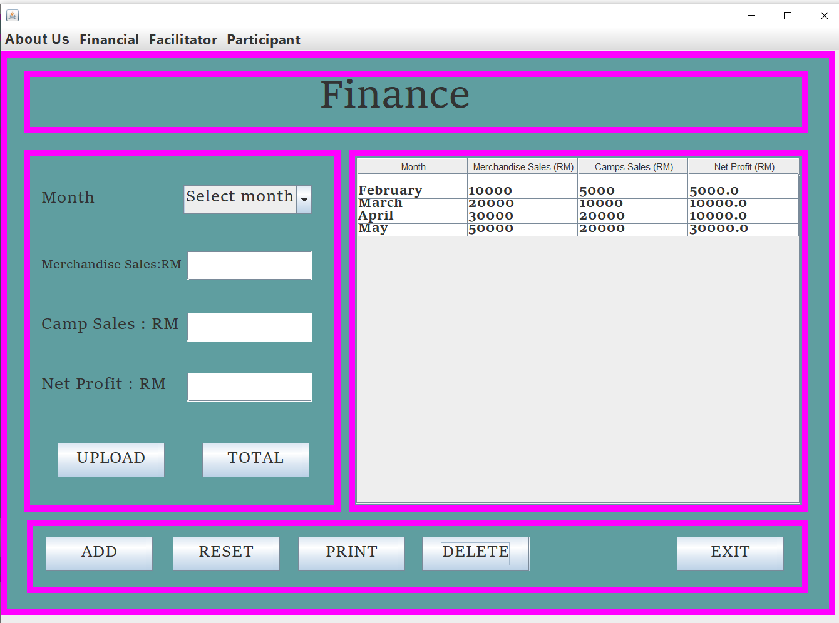

* **EXIT**

- If you are click exit button, it will pop-up” Confirm if you want to exit”. Then just click Yes or No.

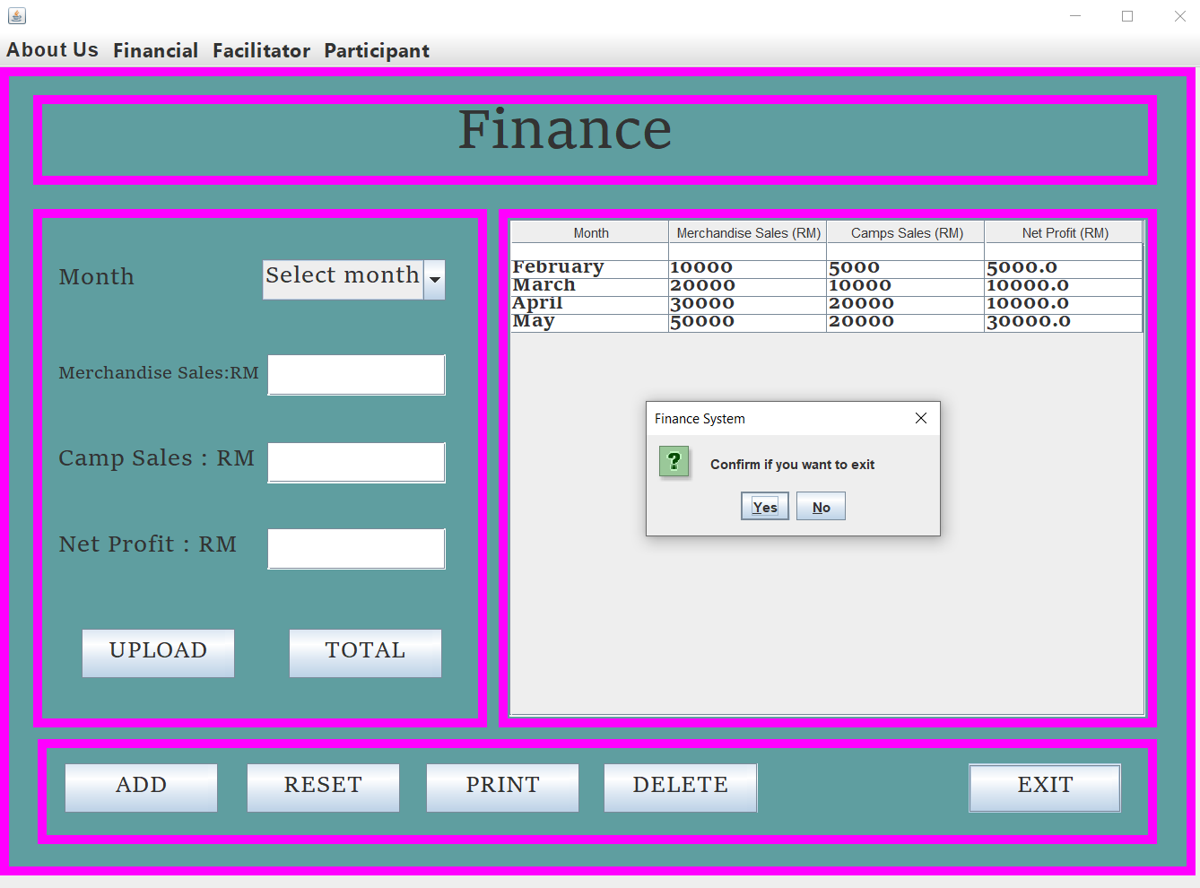

**ADVERTISEMENT**

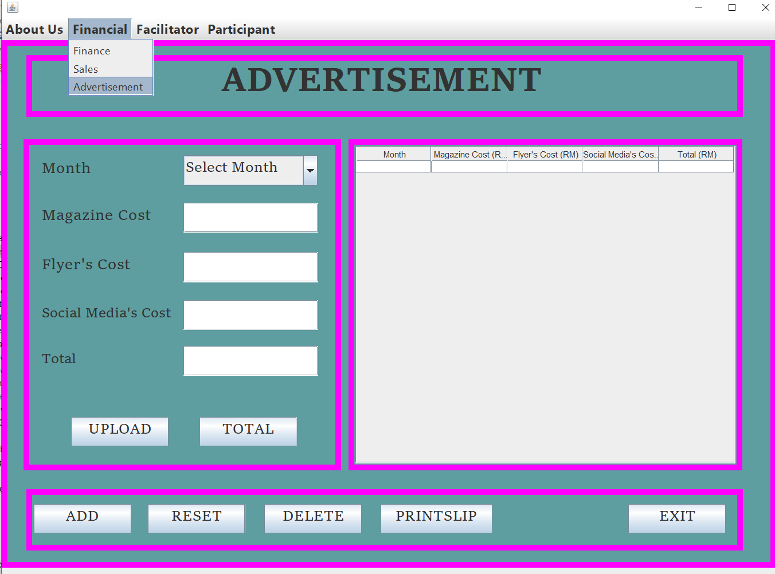

* **TOTAL**

First enter the Month, enter the Magazine Cost, enter the Flyer’s Cost, and Social Media’s Cost then click button TOTAL to get the total.

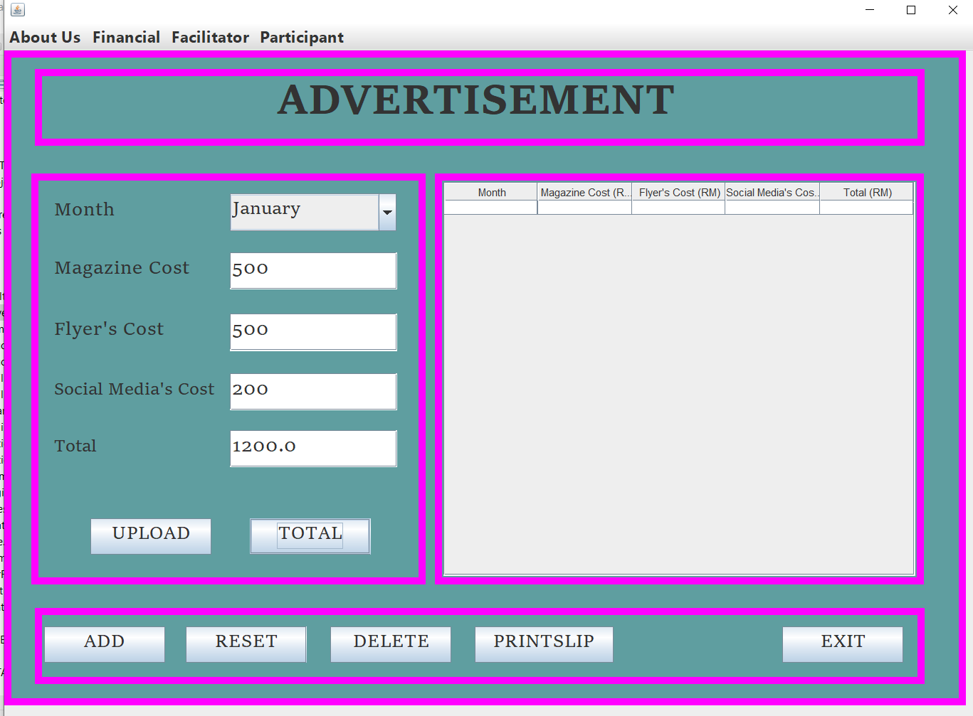

* **ADD RECORD**

First Enter Month, Enter Magazine, Flyer’s Cost, Sosial Media’s Cost and Total. Then click button ADD.

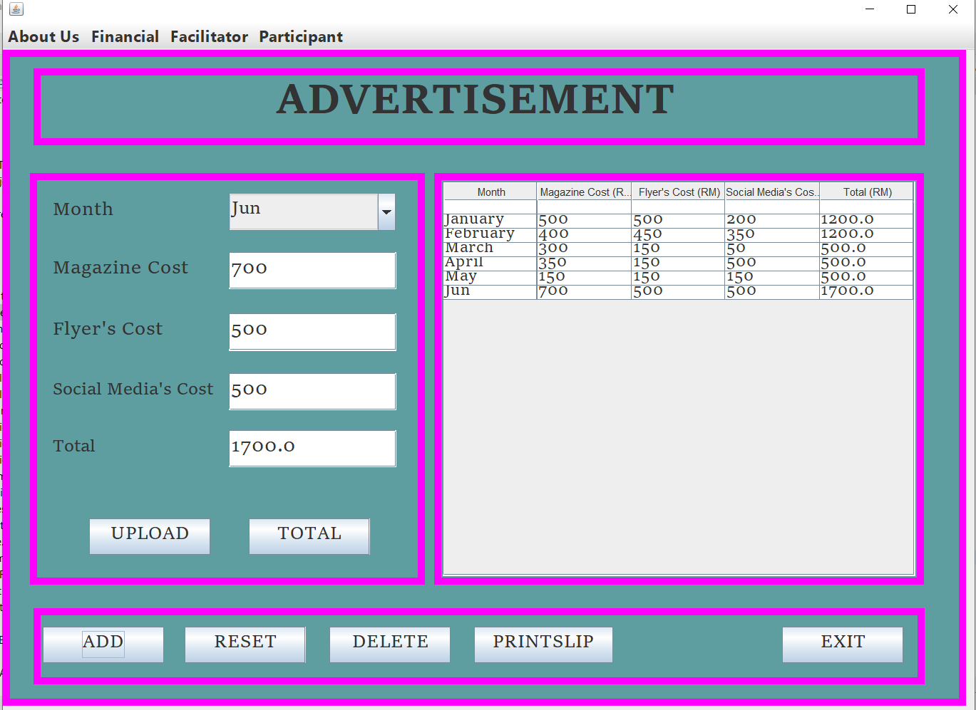

* **UPLOAD**

- Click the button UPLOAD. Then will pop-up “DATA EXPORTED”

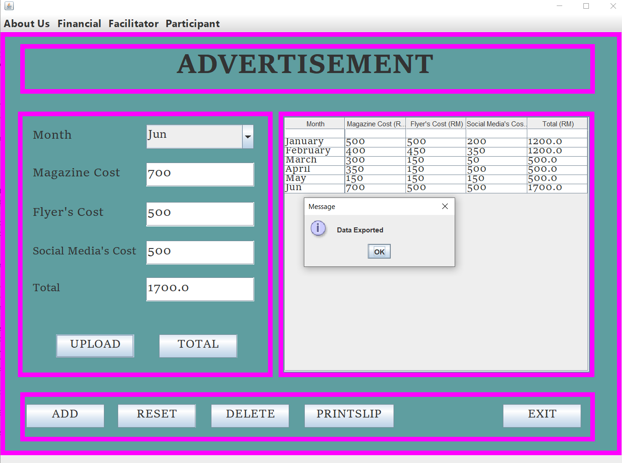

* **RESET**

Click button RESET when don write data or key in data. So you don’t have to clean

one by one.

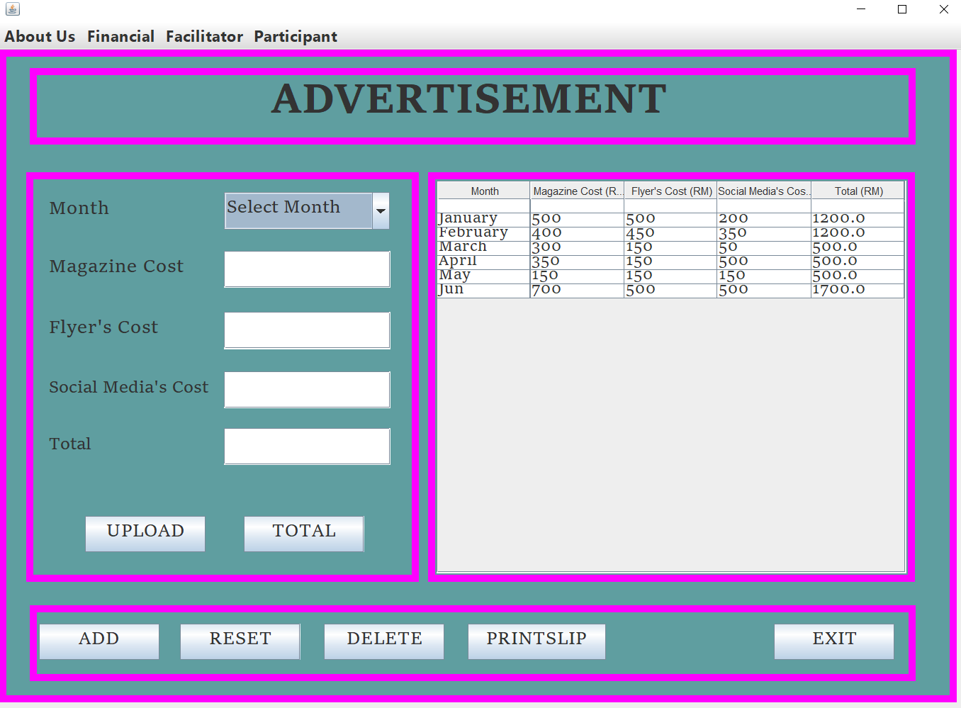

* **DELETE**

First you have to select row at table which one want to delete then click button DELETE, if you don’t click row to delete it will pop-up “Select a row to delete” then click OK.

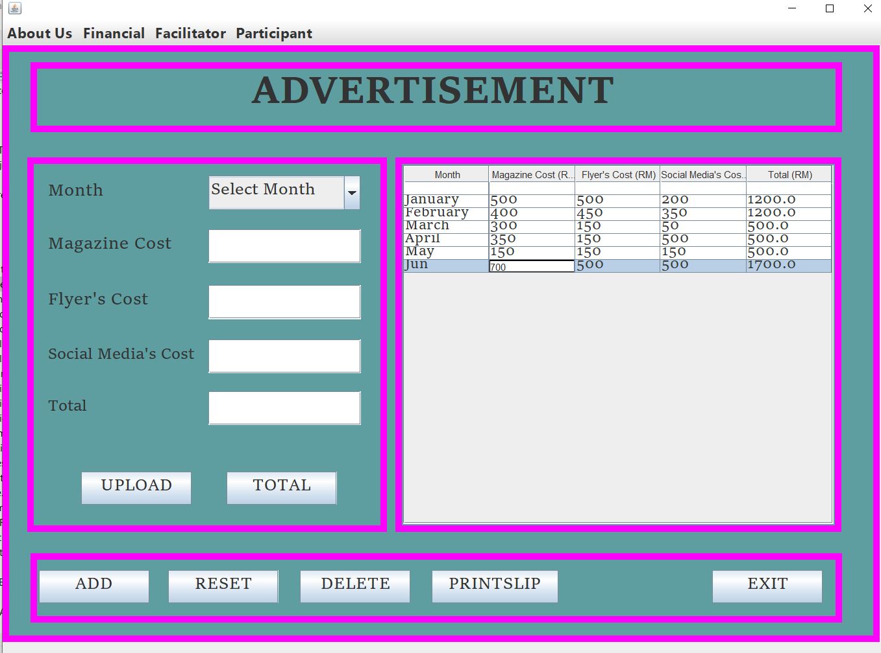

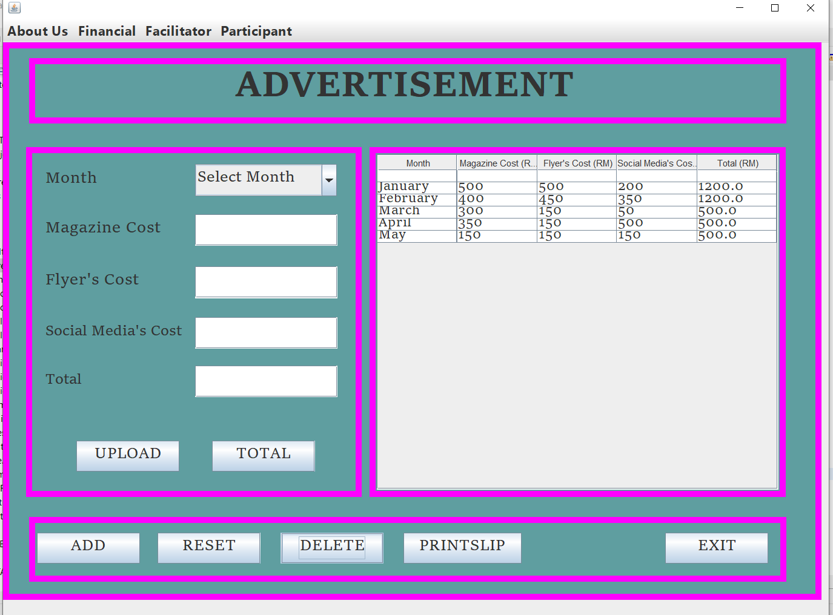

* **EXIT**

- If you are click exit button, it will pop-up” Confirm if you want to exit”. Then just click Yes or No.

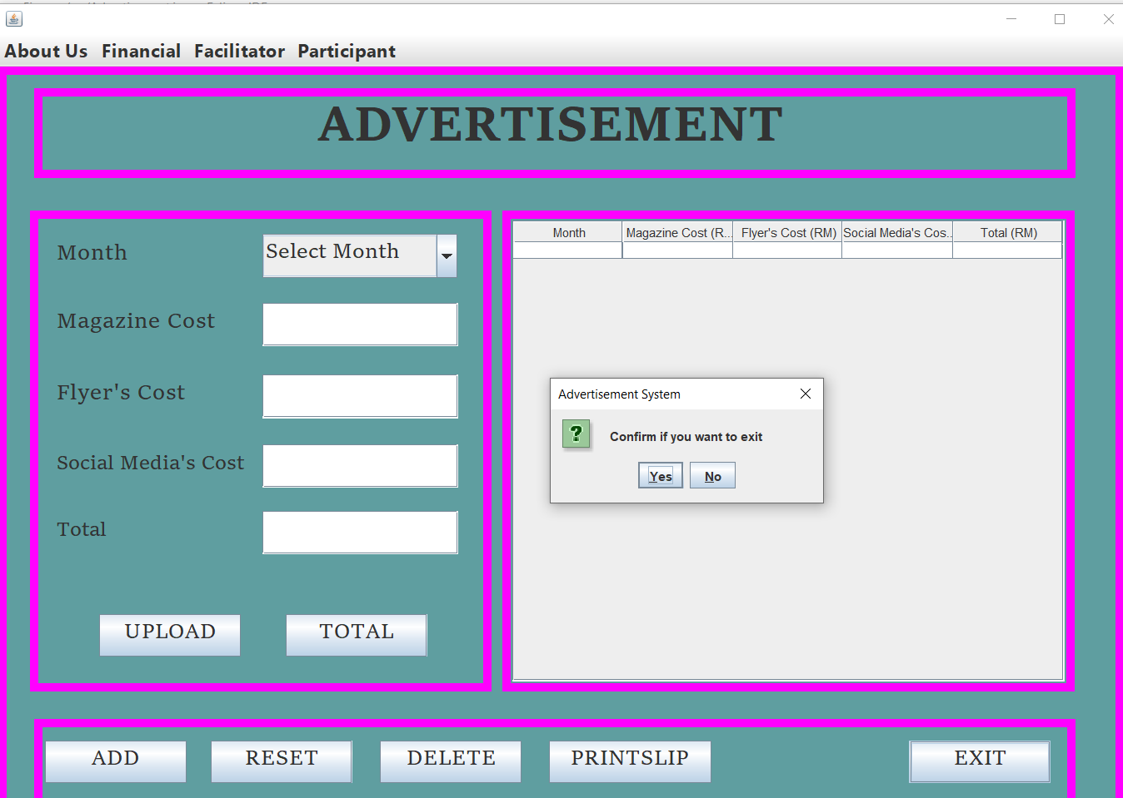

**SALES**

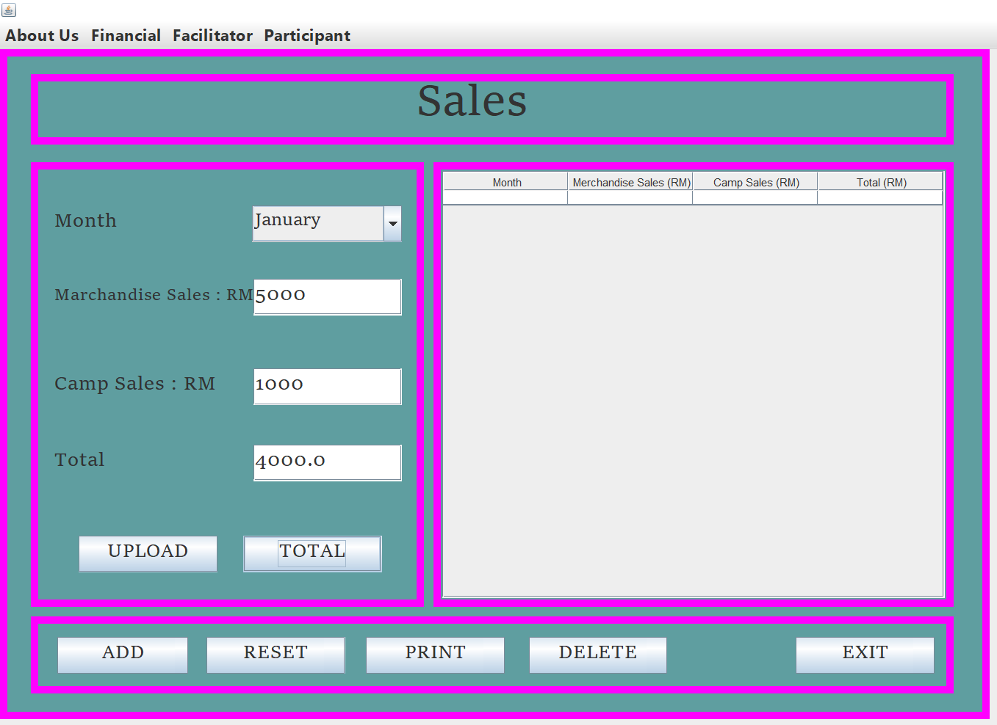

* **TOTAL**

First enter the Month, enter the Magazine Sales, enter the Flyer’s Sales, and then click button TOTAL to get the total.

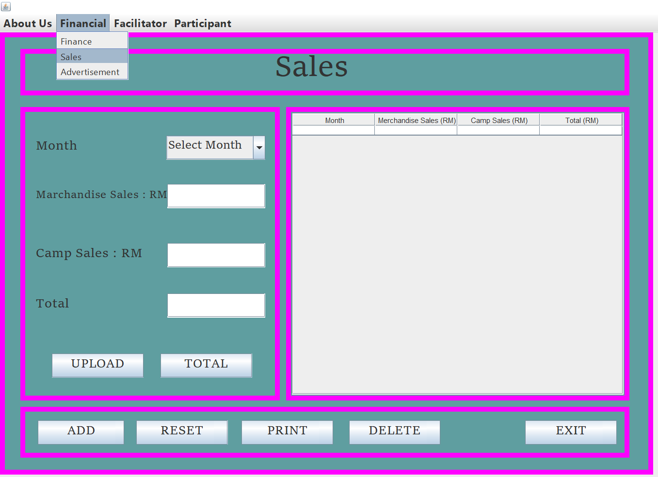

* **ADD RECORD**

- First Enter Month, Enter Magazine Sales, Flyer’s Sales, Sosial and Total. Then click button ADD to add data into the table.

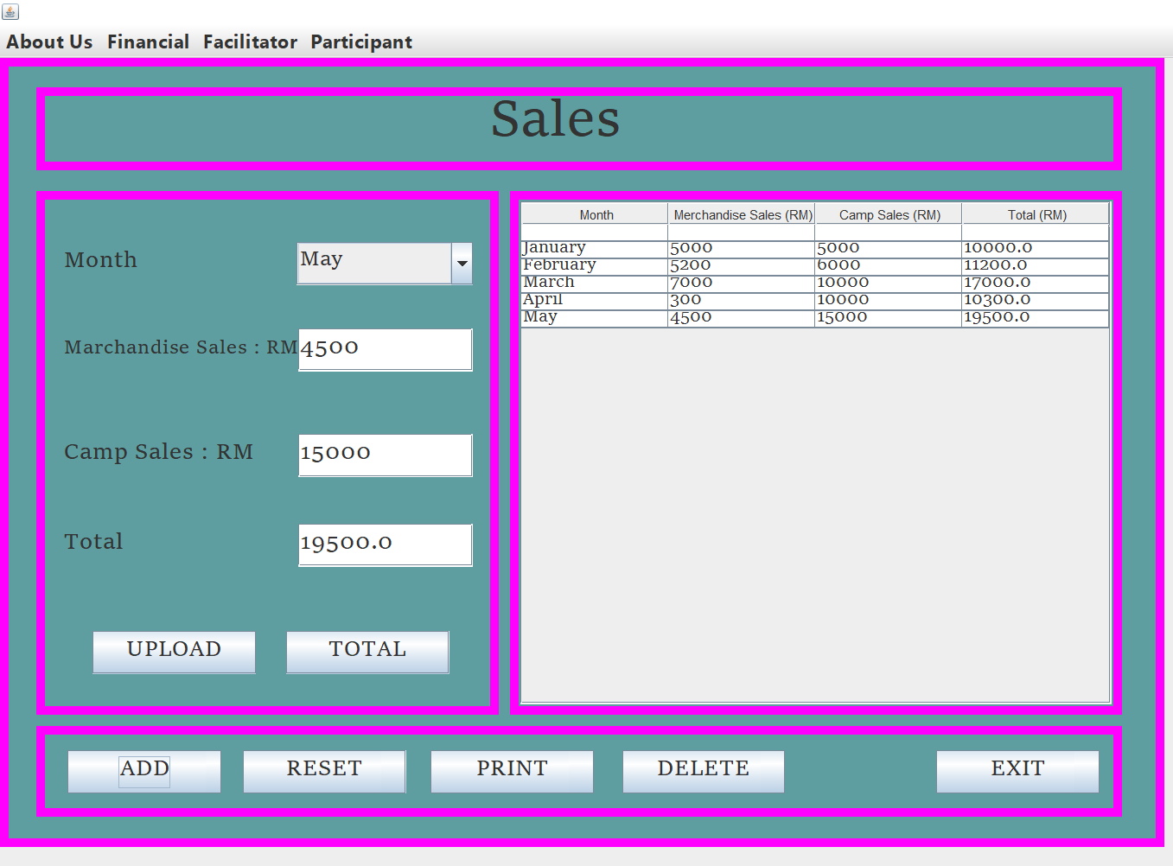

* **UPLOAD**

- Click the button UPLOAD. Then will pop-up “DATA EXPORTED”

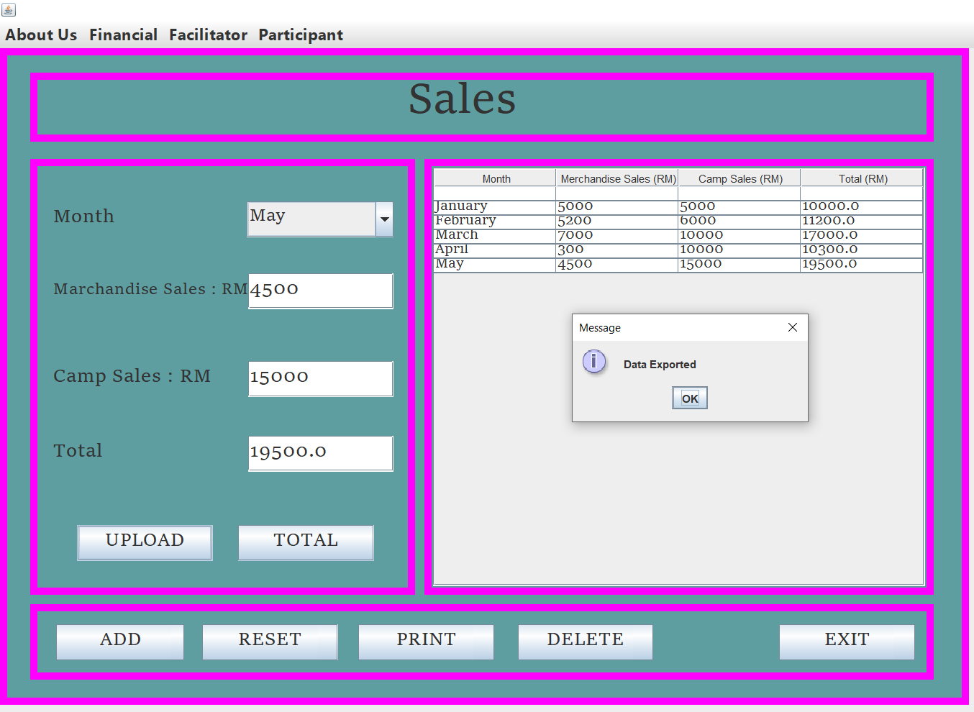

* **RESET**

- Simplify click button RESET when don’t write data or key in data. So, you don’t have to clean one by one.

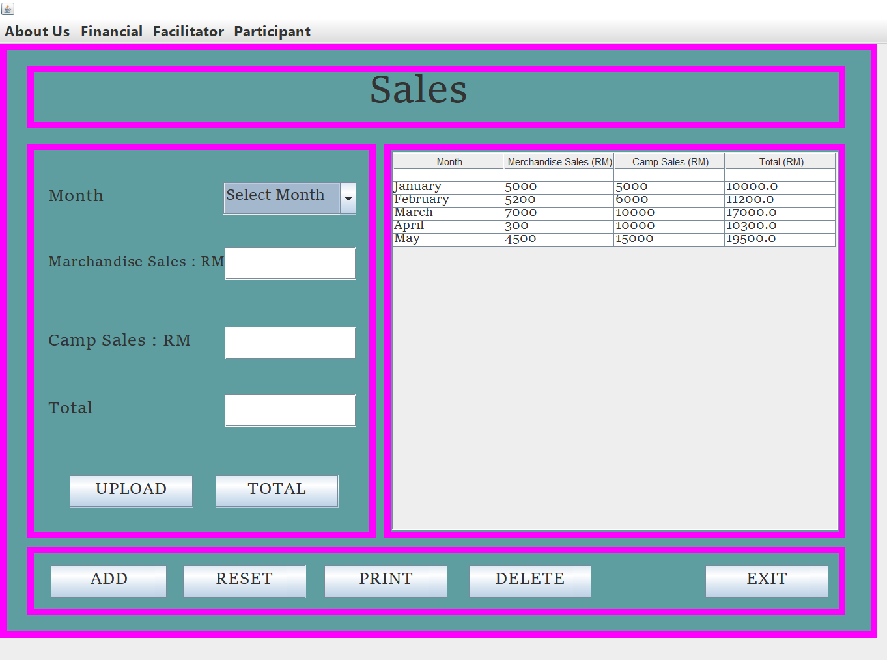

* **PRINT**

- Click Button Print then it will pop up the print information.

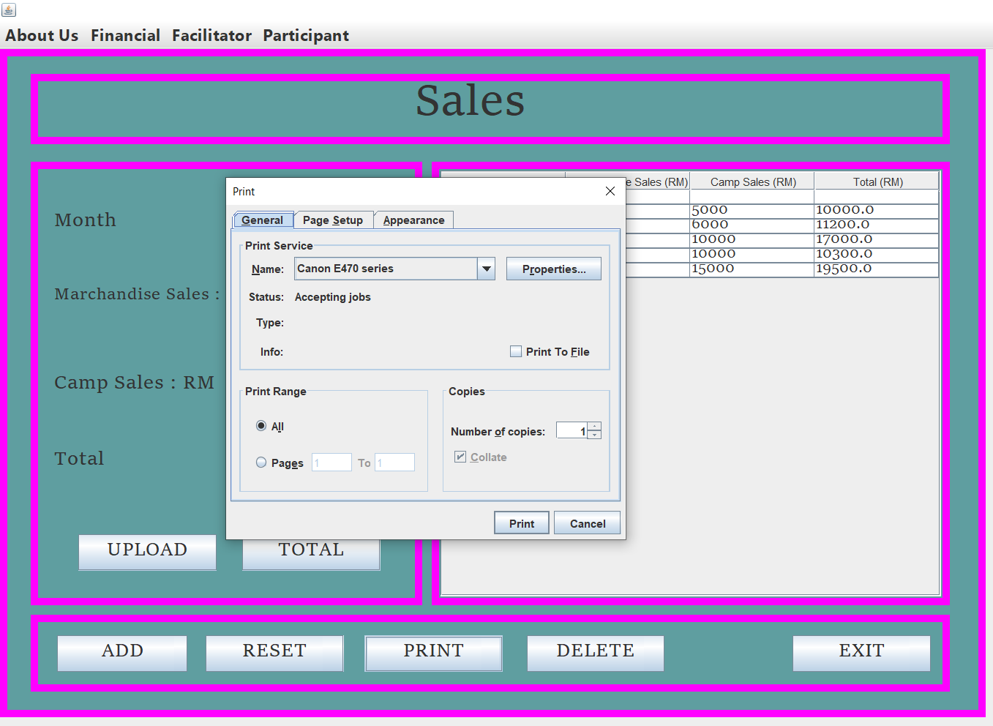

* **DELETE**

-First you have to select row at table which one want to delete then click button DELETE, if you don’t click row to delete it will pop-up “Select a row to delete” then click OK.

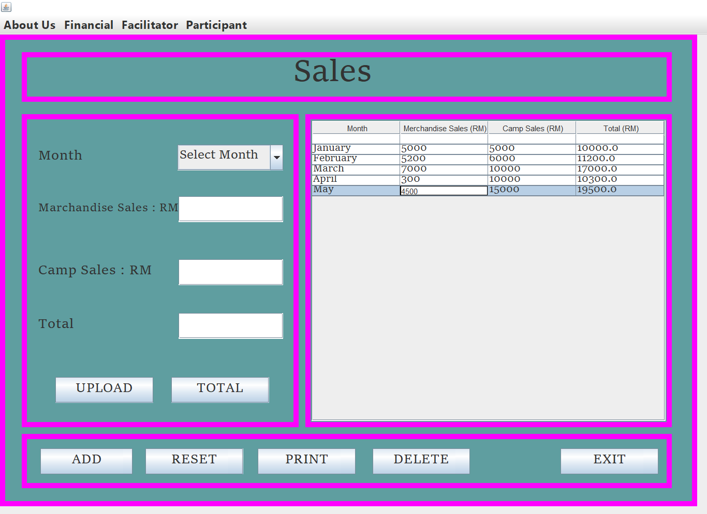

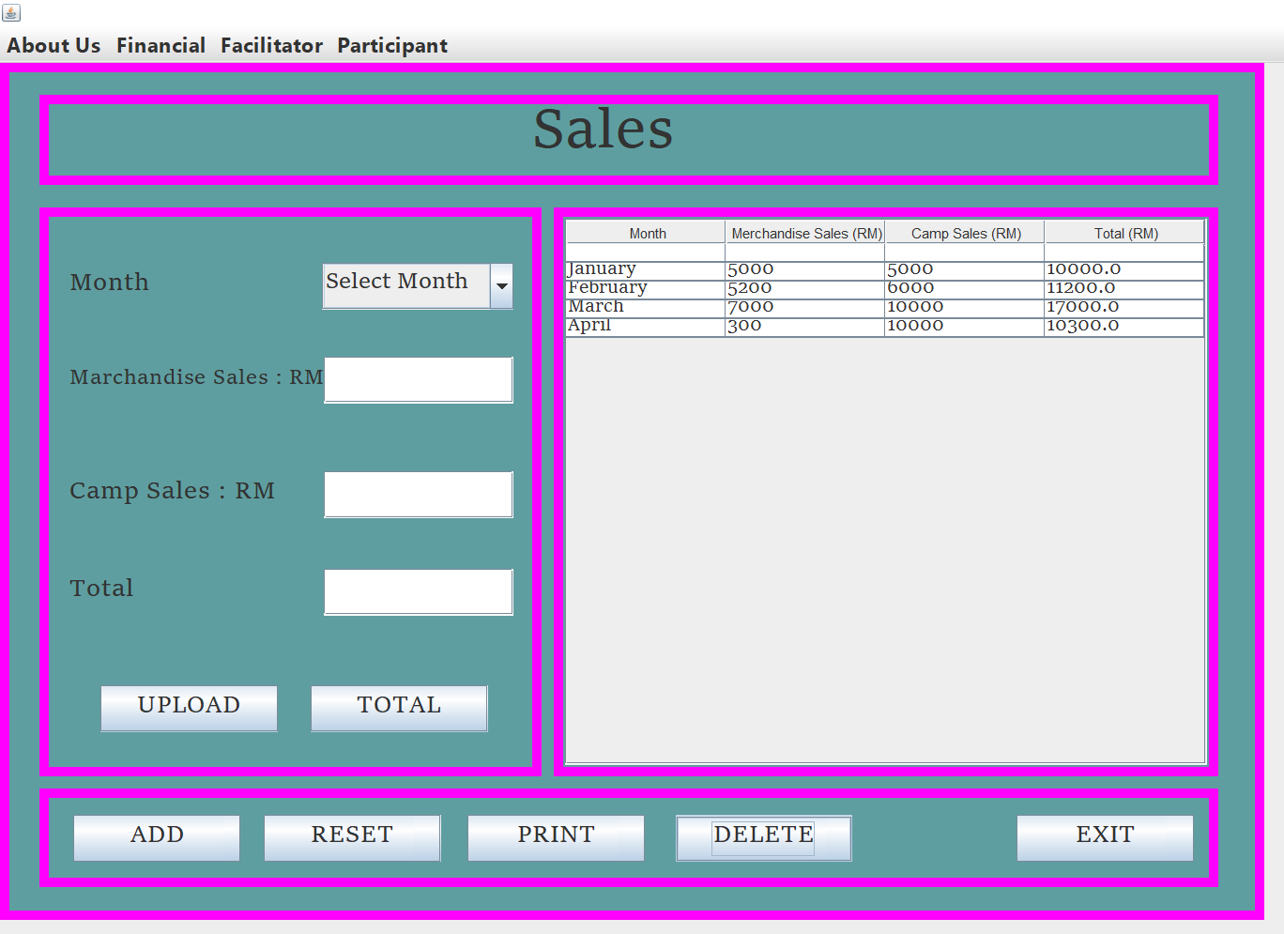

* **EXIT**

- If you are click exit button, it will pop-up” Confirm if you want to exit”. Then just click Yes or No

**PARTICIPANT REGISTRATION**

* **REGISTERS**

- First enter the Participant’s Name, Age, Contact Number, Email in text field, select the option of gender and select camps subject in combo Box. Then click the REGISTER button. Entered information will appear in the table. Once done, The message will pop up “Registered”.

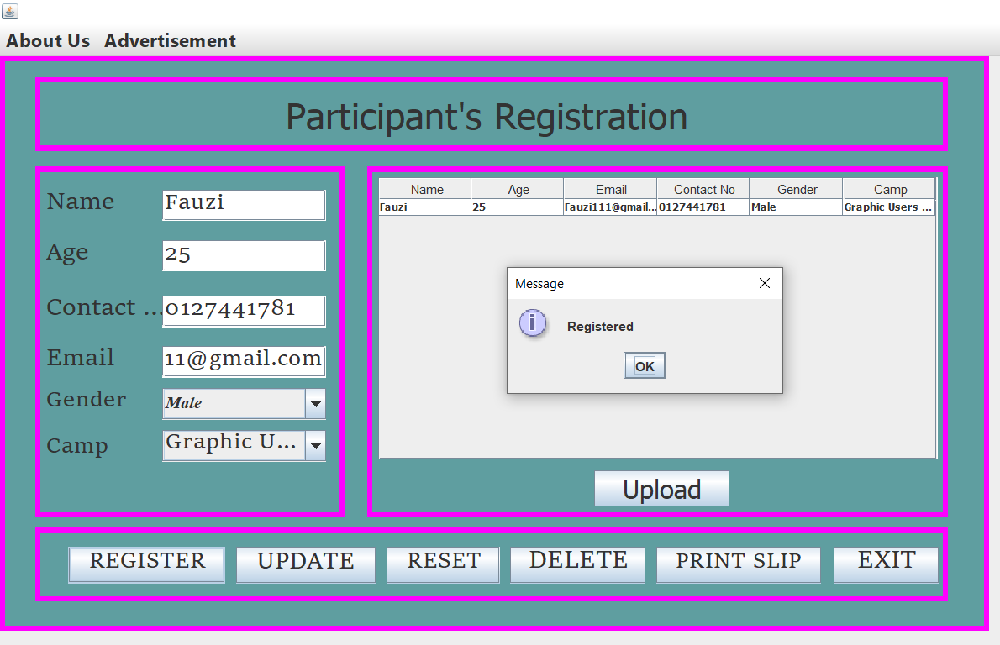

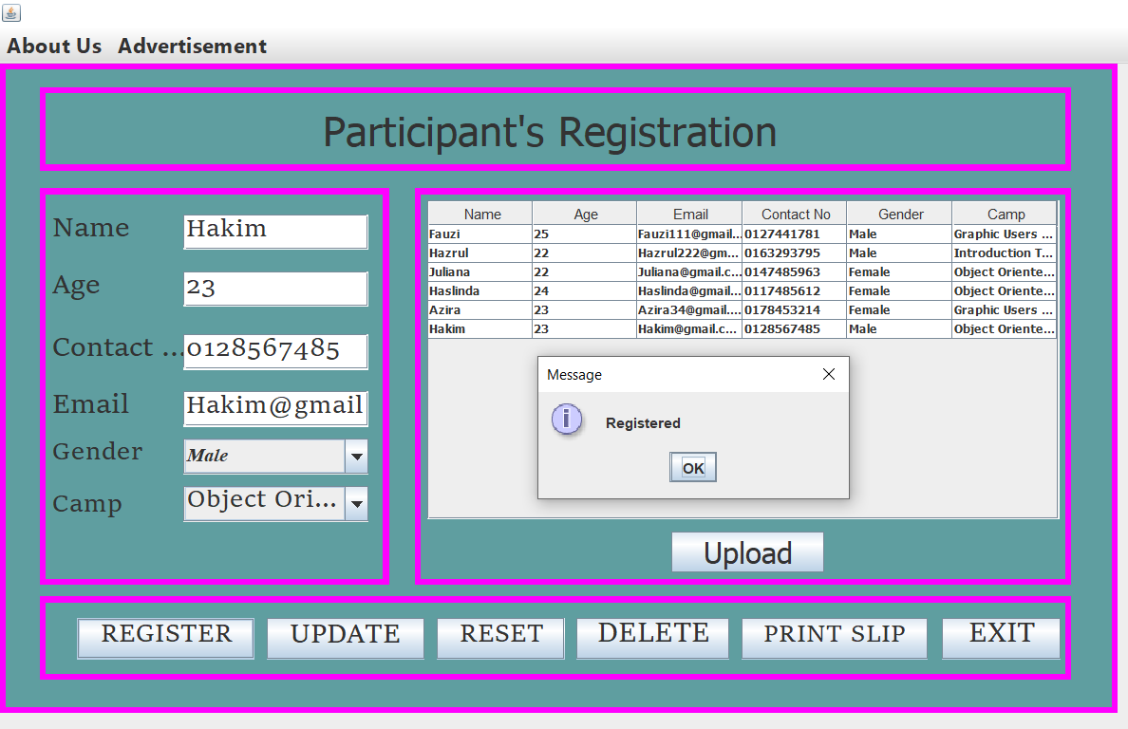

* **UPLOAD**

- Click the button UPLOAD. Then will pop-up “DATA EXPORTED”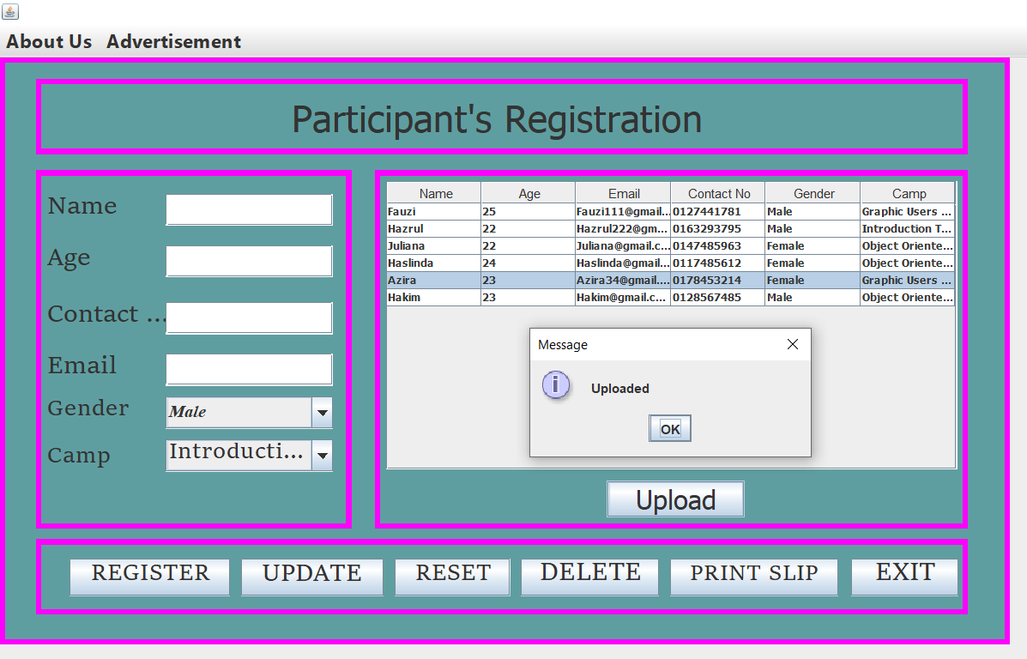

* **UPDATE**

**-** Please select the row that you want to update. If you not select the row you want to update the massage will pop-up “Please Select a Row First!” . Once already select the row just simplify update the data and the message will pop up “Update Successfully”.

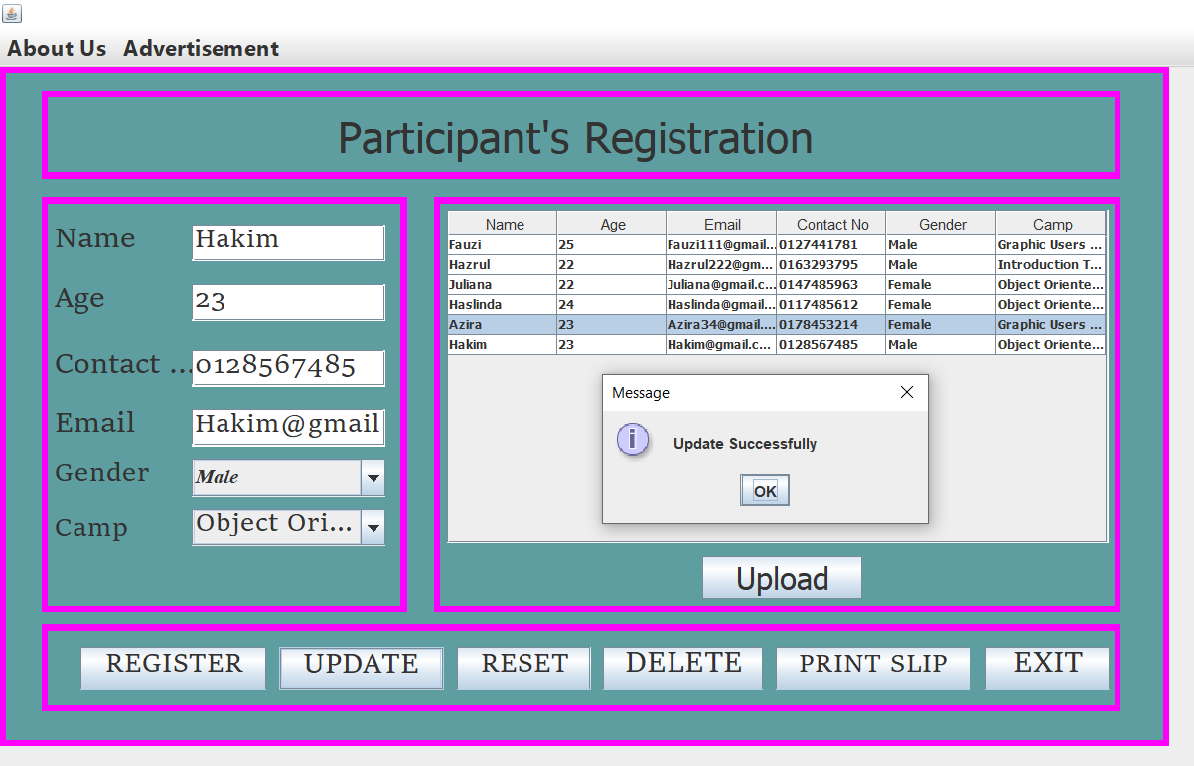

* **RESET**

- Simplify click button RESET when don’t write data or key in data. So, you don’t have to clean one by one.

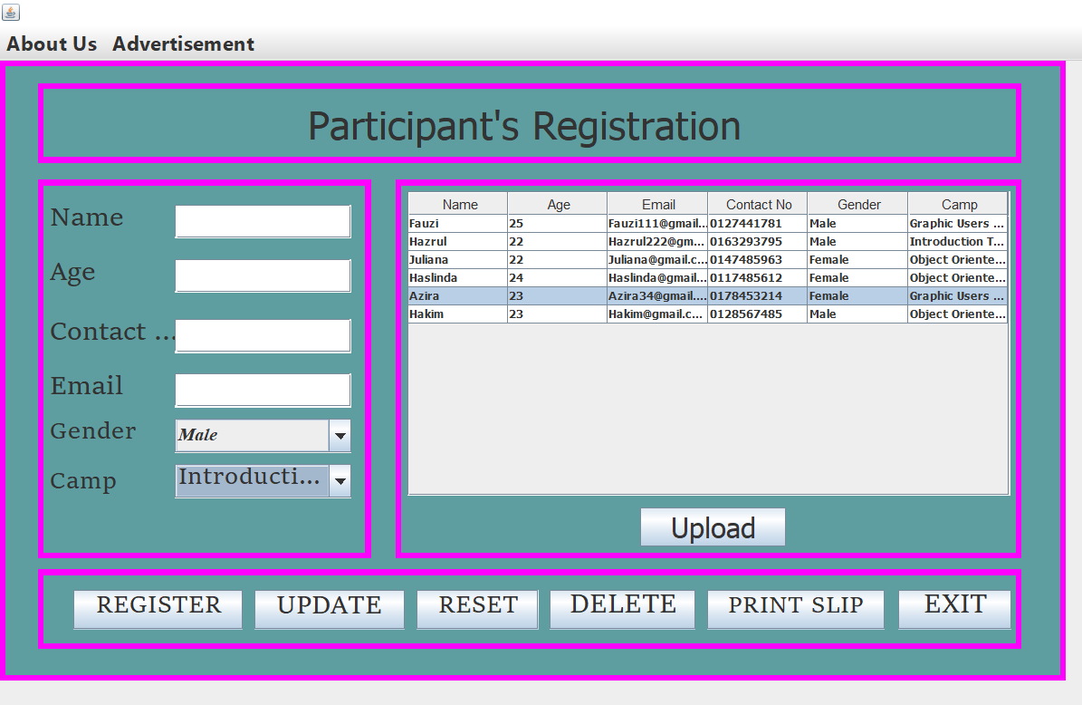

* **DELETE**

-First you have to select row at table which one want to delete then click button DELETE, if you don’t click row to delete it will pop-up “Select a row to delete” then click OK.

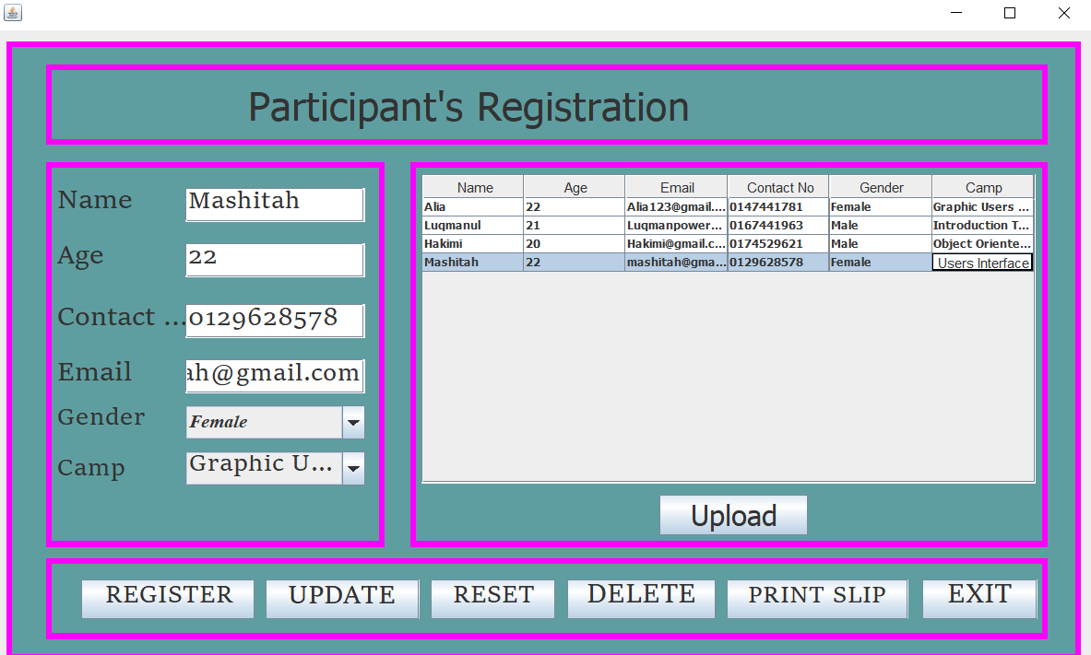

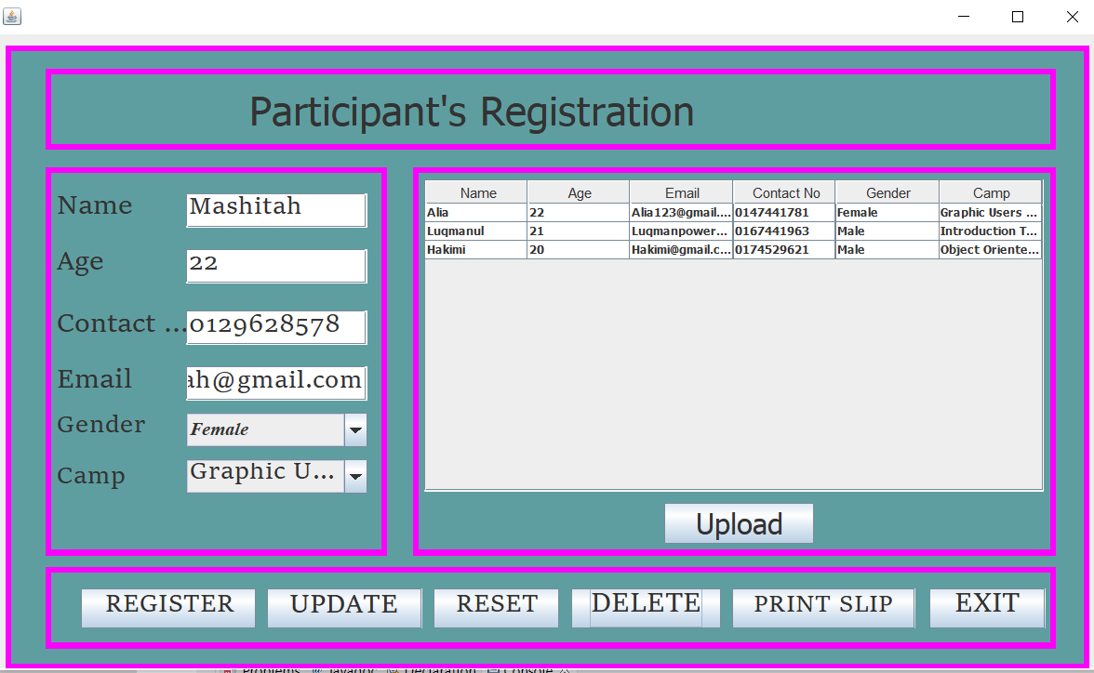

* **PRINT SLIP**

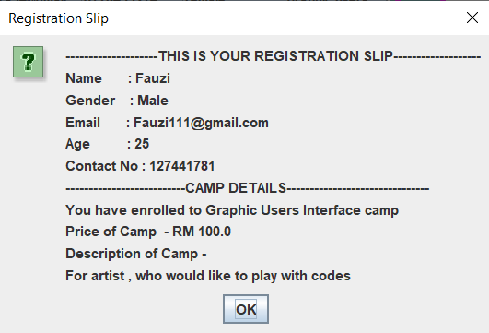

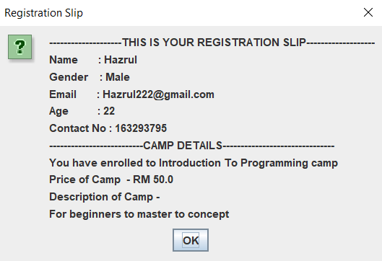

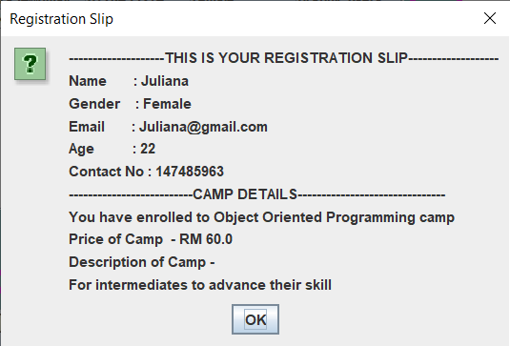

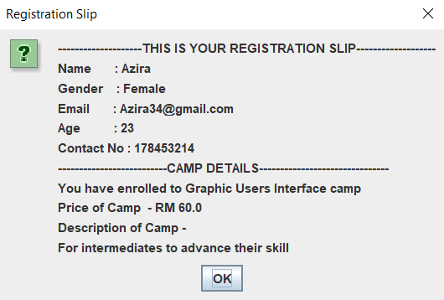

* **EXIT**

- If you are click exit button, it will pop-up” Confirm if you want to exit”. Then just click Yes or No.

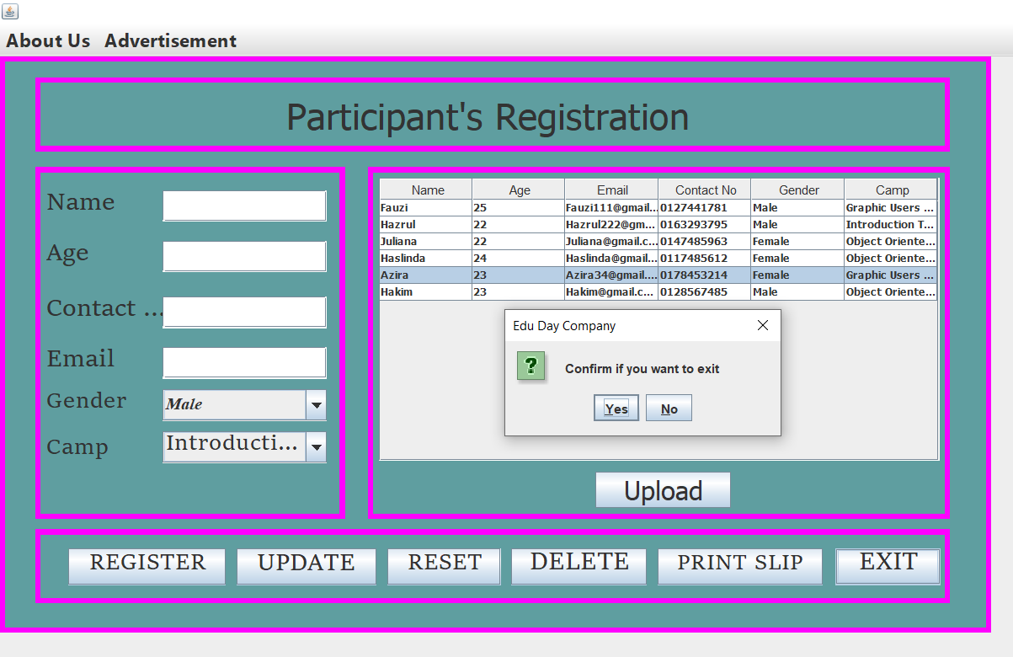

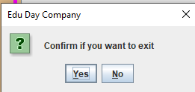

**Menu bar.**

- For the menu bars, you can click

1. About Us, it’s contains Education Day Camps which is the company information.
2. Financial, contains Finance, Sales and Advertisement.
3. Facilitator.
4. Participant it’s contains Participant Registration.

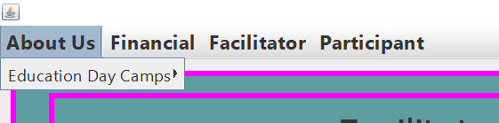

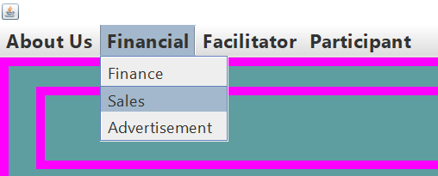

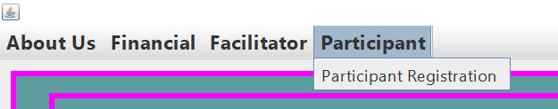

3.4 SOFTWARE TRAINING –

1. **Software Training (Intelleq QS).**

* This is the main GUI page for admin and user.

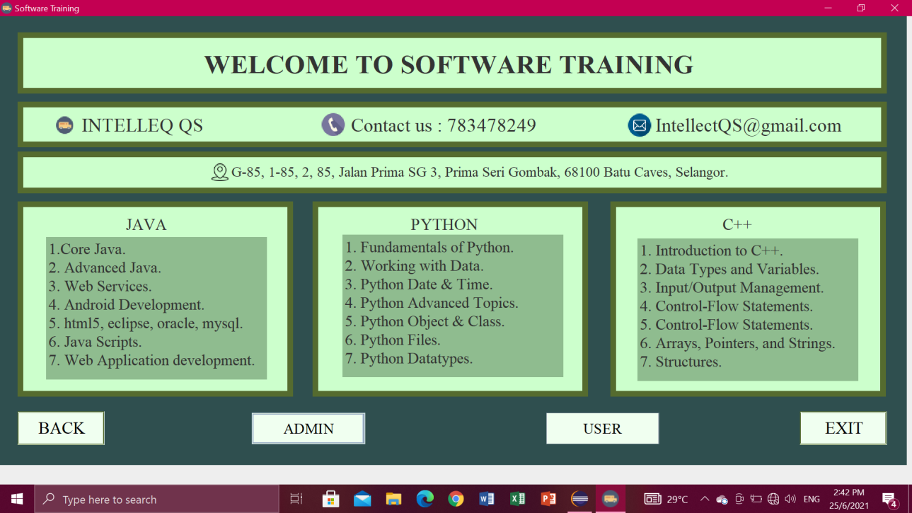

**Exit button**

* If you are click exit button, it will pop-up” Confirm if you want to exit”. Then just click Yes or No.

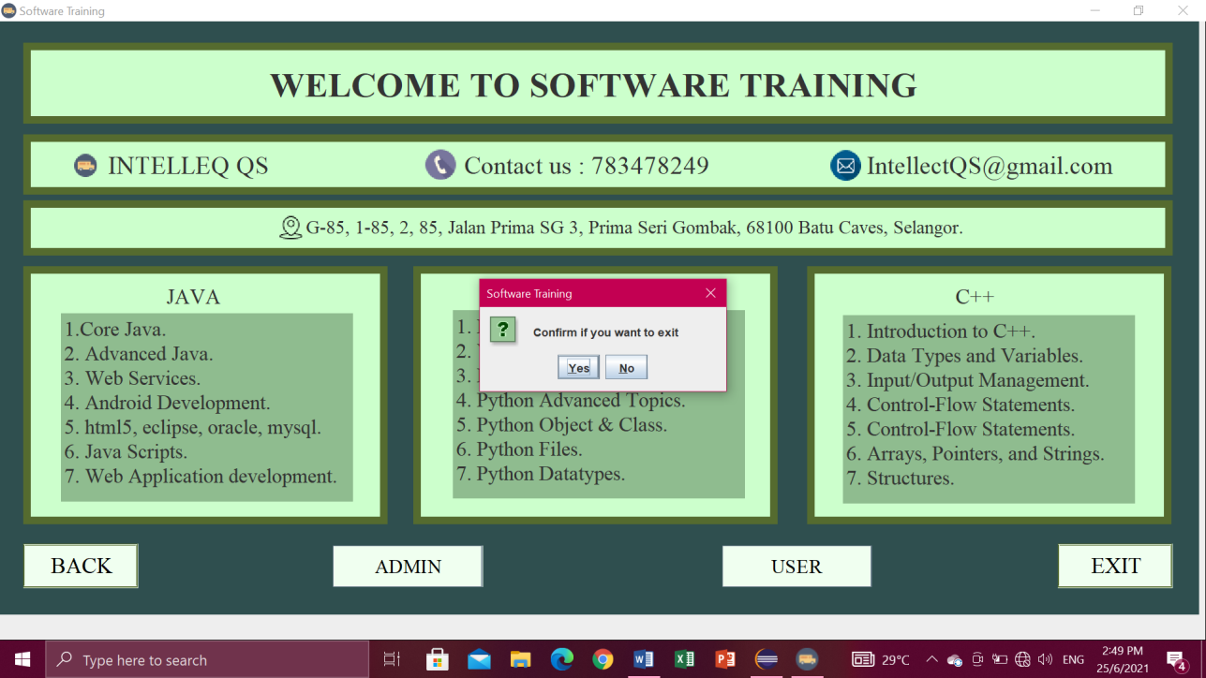

**Admin or Users button**

- Click Admin or user button, if you click the admin button will go to the login, employee, finance, sales and ads pages.

- If you click the user it will go to the customer page and ads.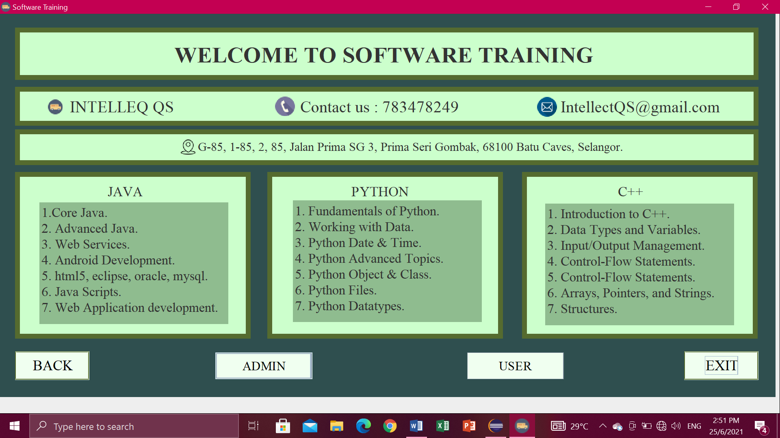

1. **(ADMIN BUTTON) – LOGIN**

* First enter the User ID in Text field and enter Password. Then click button LOGIN.

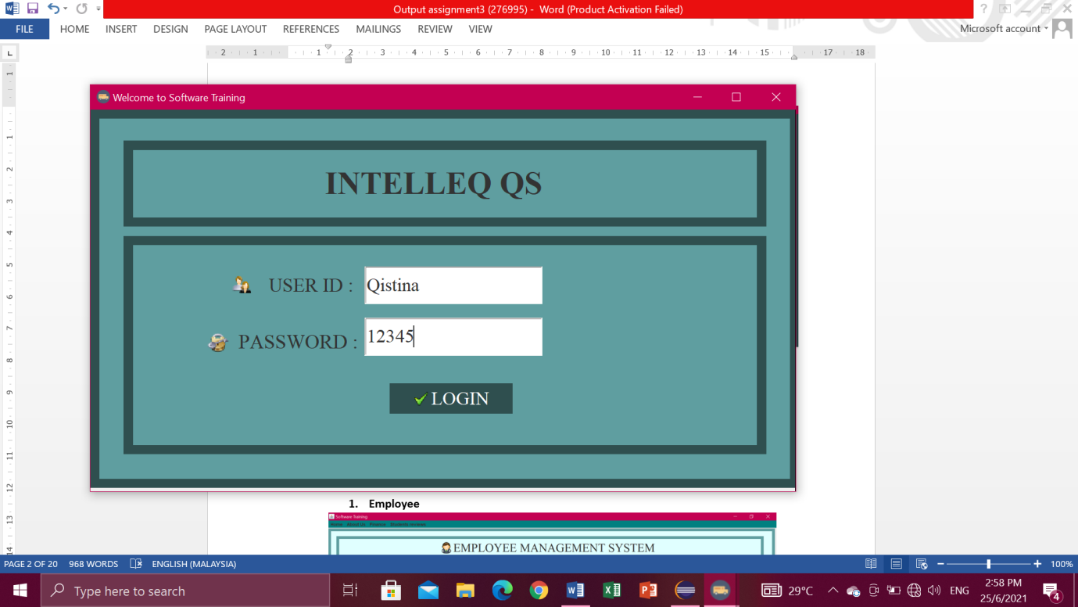

* Then, will pop-up “Login Successful”.

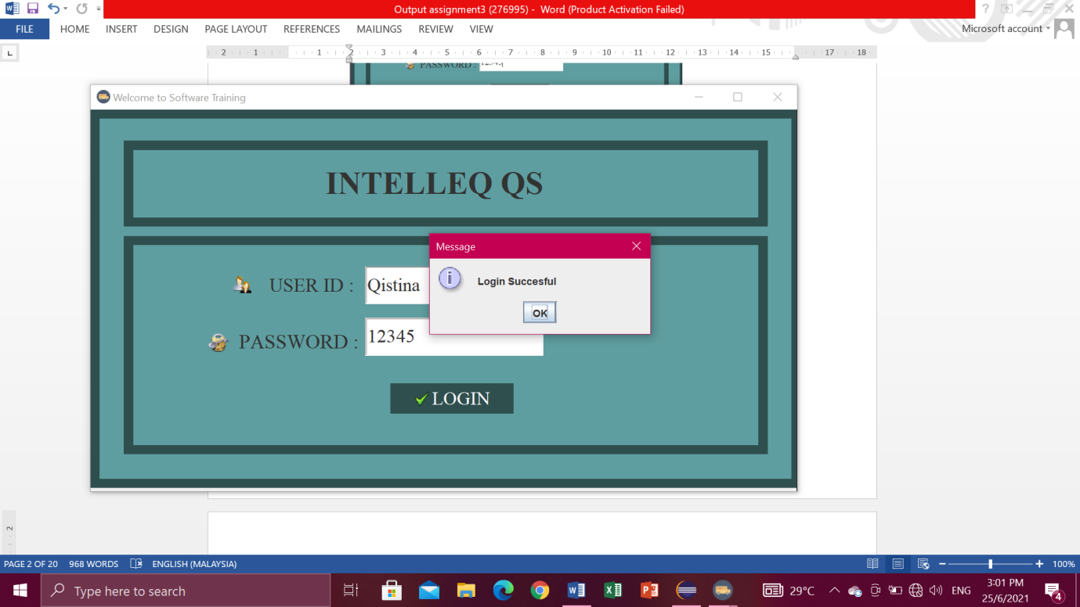

* If you enter the wrong User ID and password. Then it will pop-up "Please enter the right user id and password". 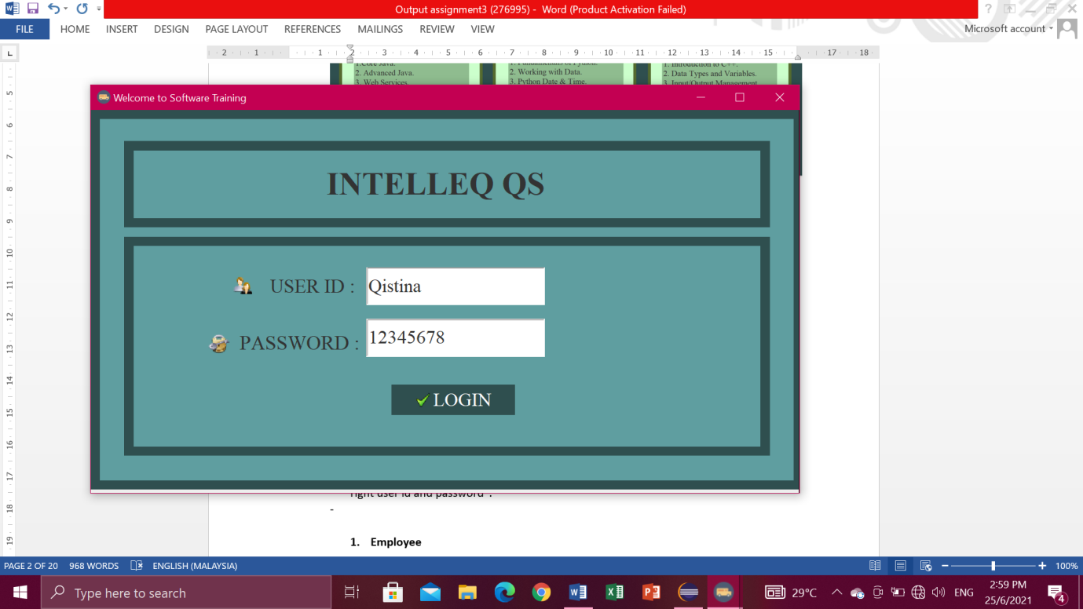

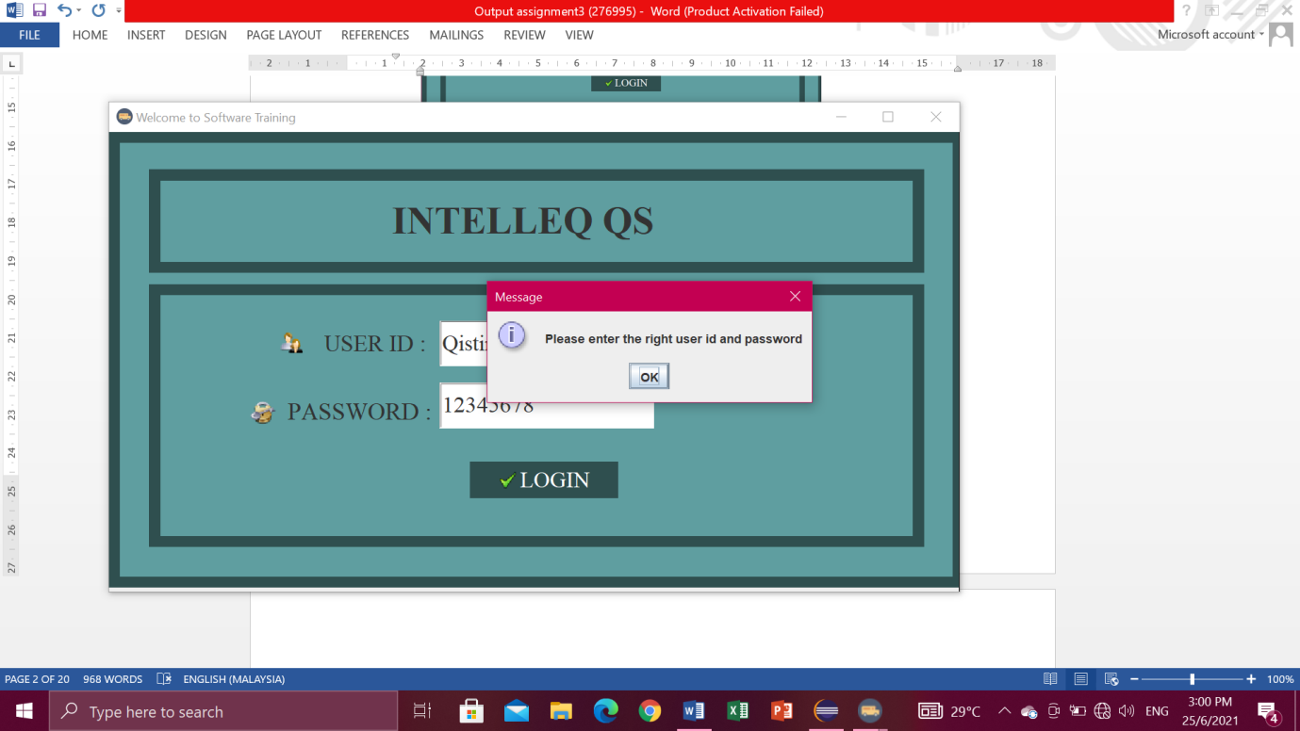

**EMPLOYEE**

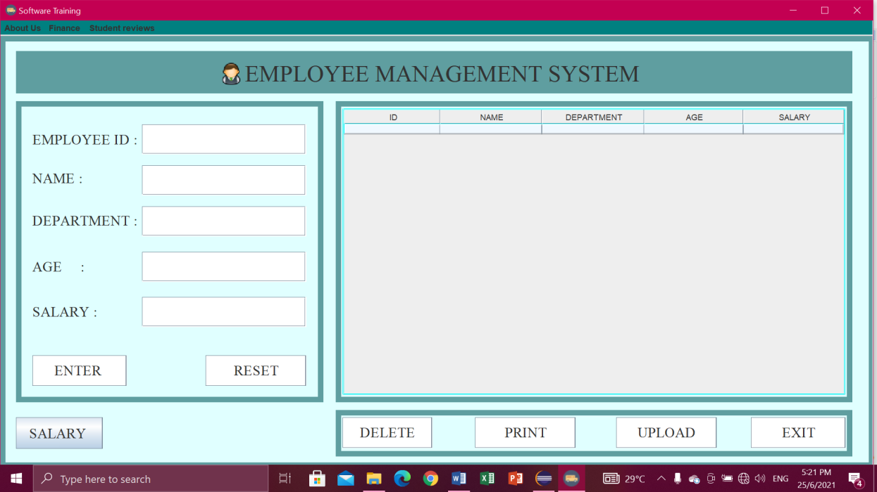

**Enter button**

* First enter the employee id, name, department, age, and salary in the Text field. Then click the ENTER button. Entered information will appear in the table.

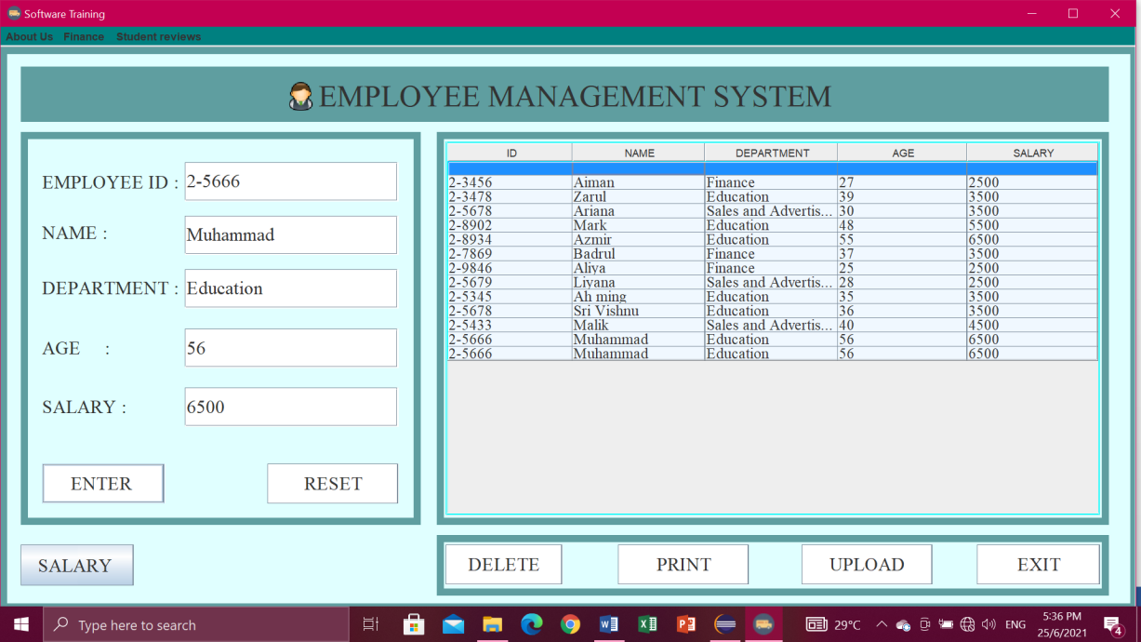

**Reset button**

* Click button RESET when don’t write data or key in data. So you don’t have to clean one by one.

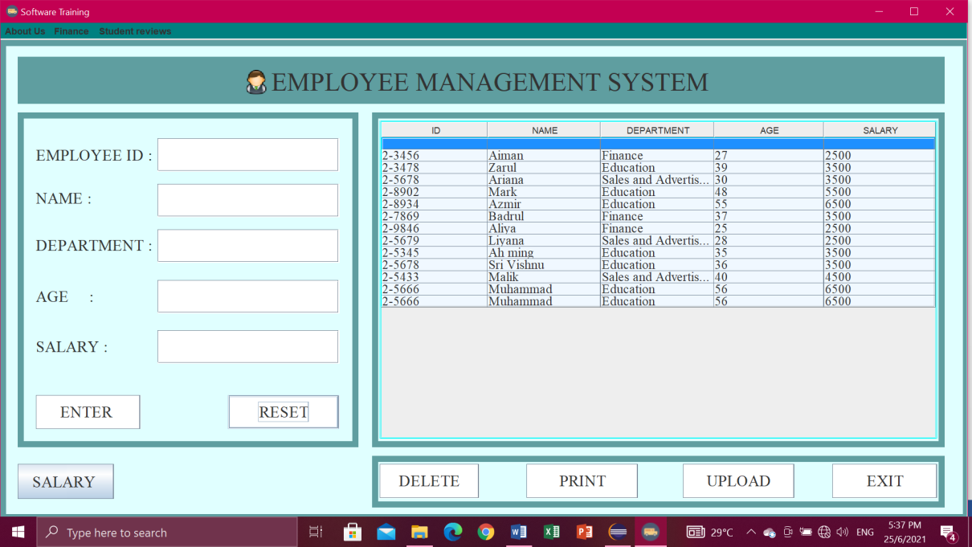

**Delete Button**

* First you have to select row at table which one want to delete then click button DELETE, if you don’t click row to delete it will pop-up “Select a row to delete” then click OK.

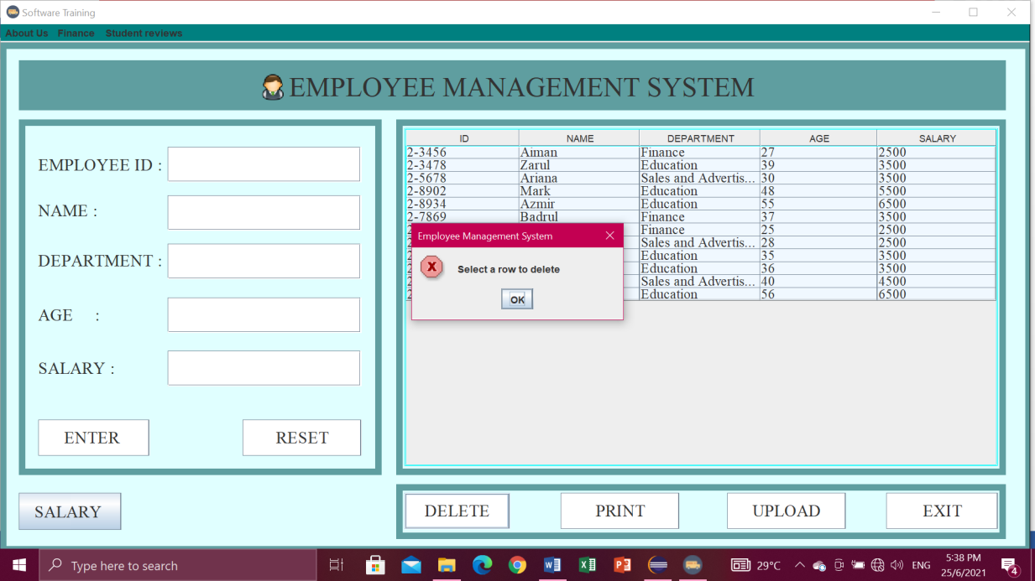

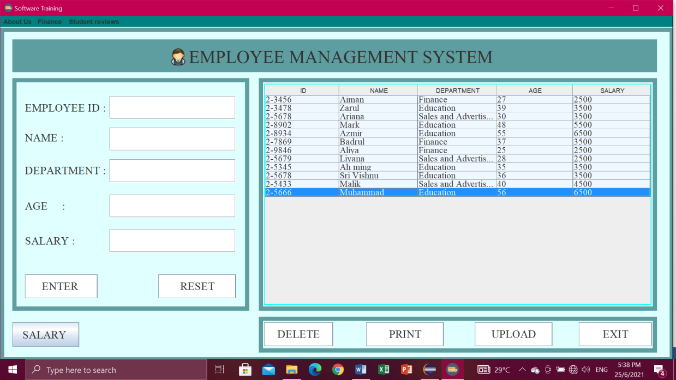

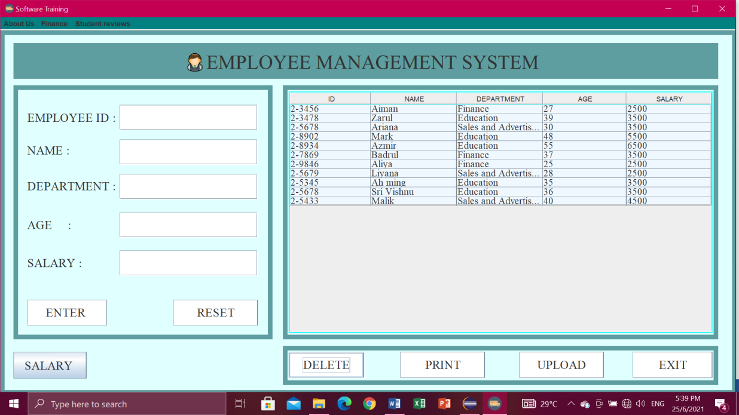

**Upload button**

* Click button UPLOAD. Then will pop-up “Data Exported”.

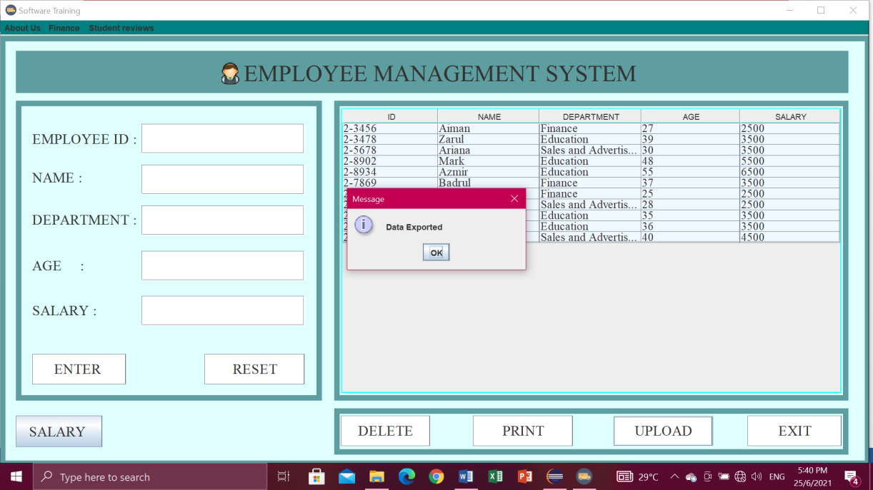

* Data exported into the file io.

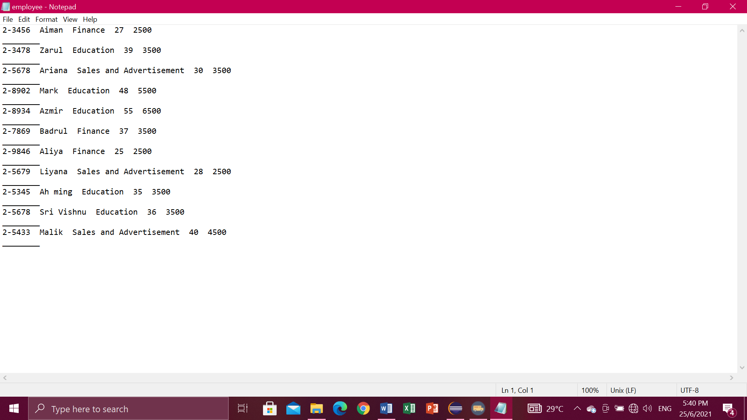

**Print button**

* Need to "Please select a row first!”. Then click OK.

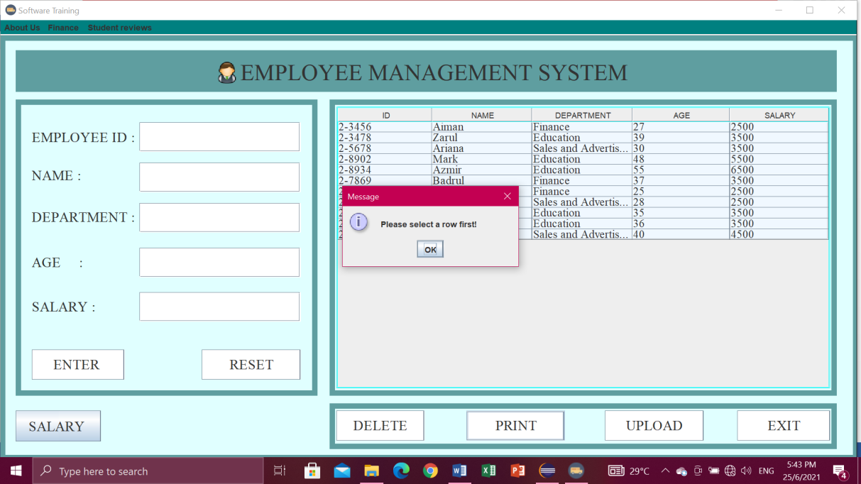

* Select a row first to print.

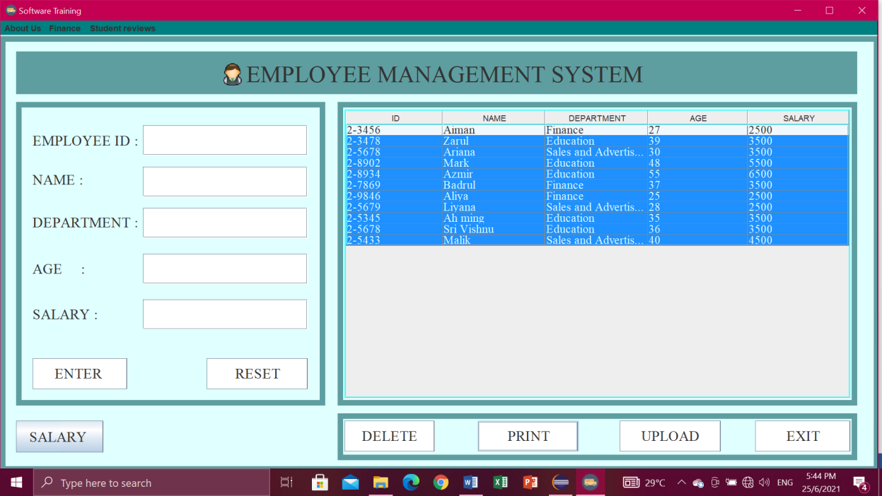

* Then it will pop-up “Print Successfully” and click OK.

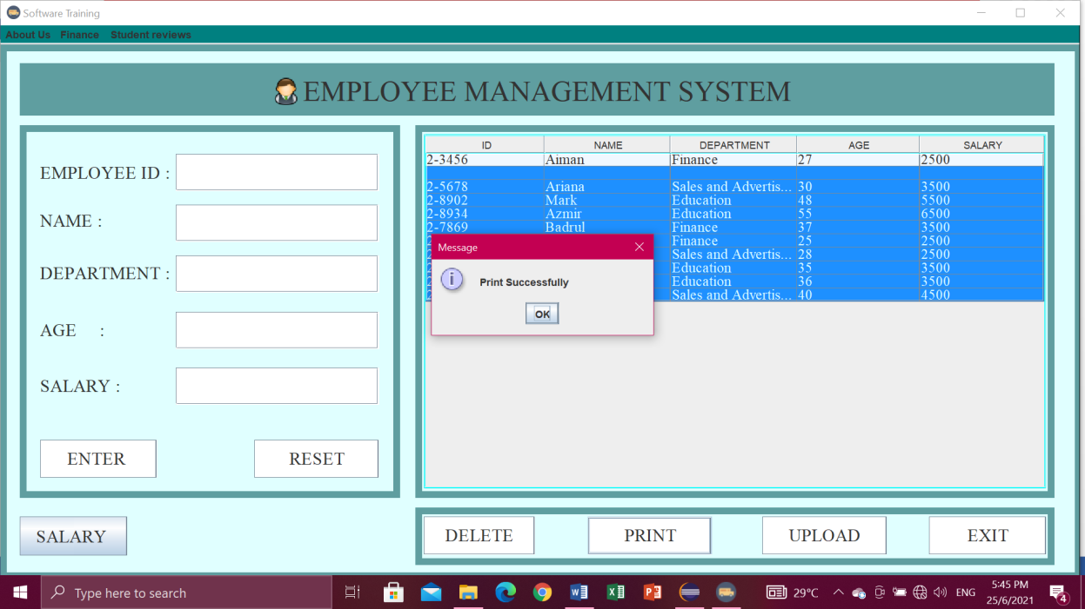

**Salary button**

* Display the Total Amount of Salary and appear "Total Salary". Then click OK or Cancel.

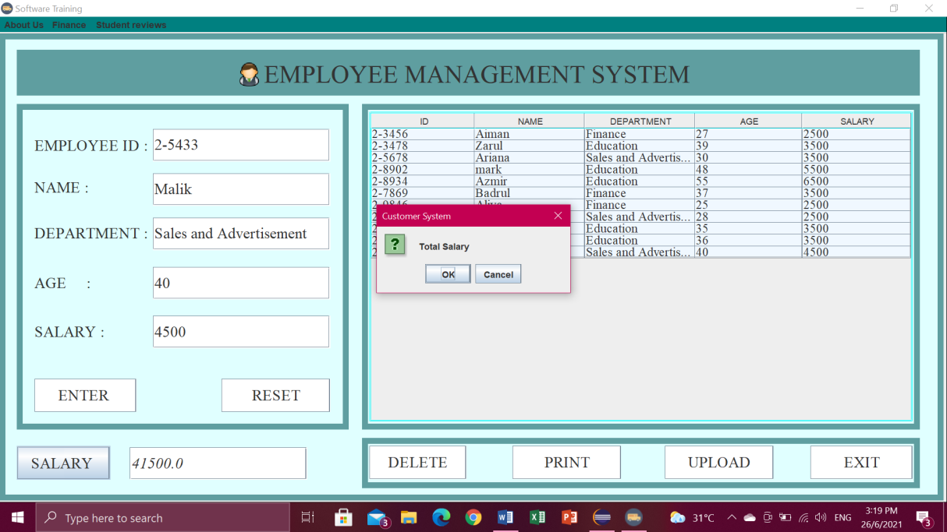

**Exit button**

* If you are click exit button, it will pop-up “Confirm if you want to exit”. Then just click Yes or No.

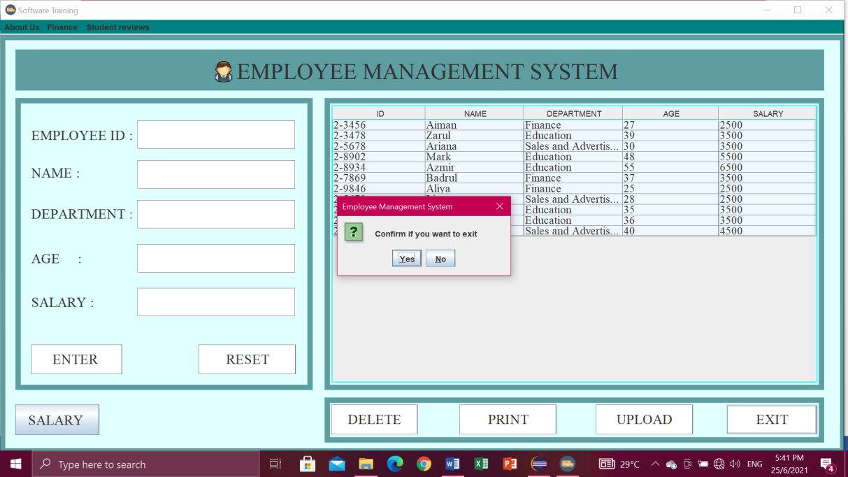

**Menu bar.**

* For the menu bars, you can click

1. About Us , in the menu item contains Intelleq Qs and Employee,
2. Finance, contains finance and sales,
3. Student reviews, contain Advertisement.

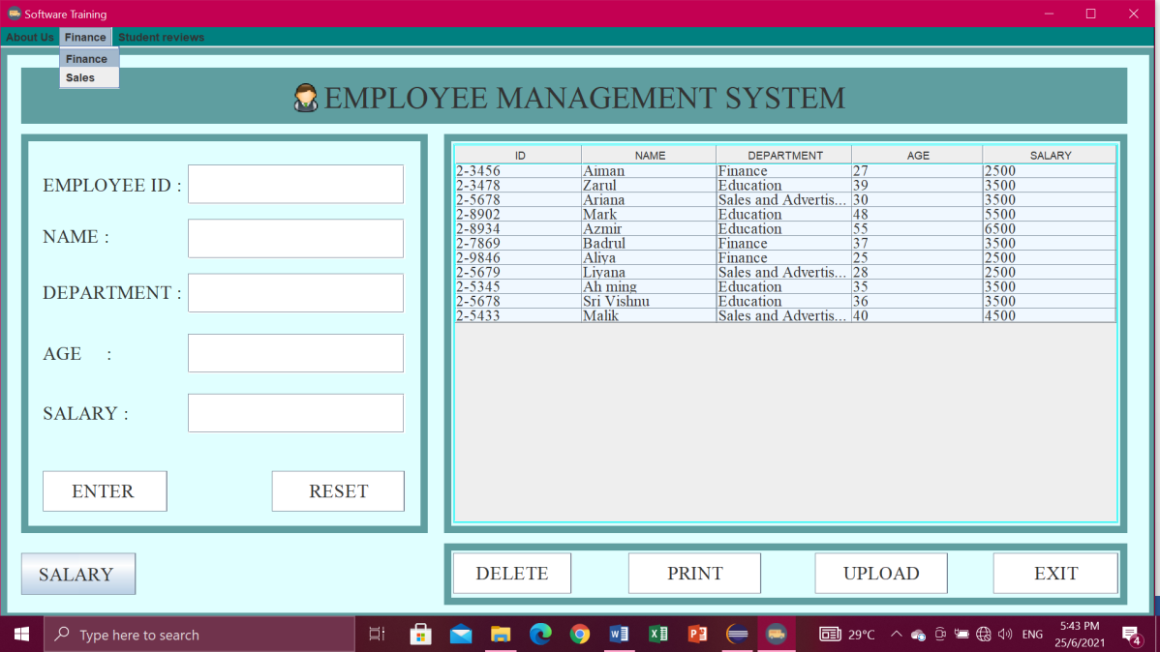

**FINANCE**

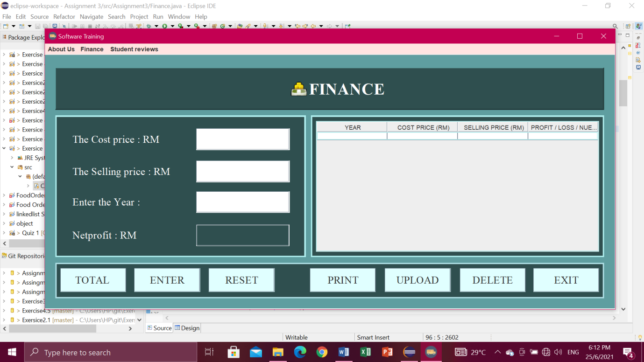

**Total button**

* First enter the cost price, enter the selling price, enter the year, and then click button TOTAL to get the total netprofit.

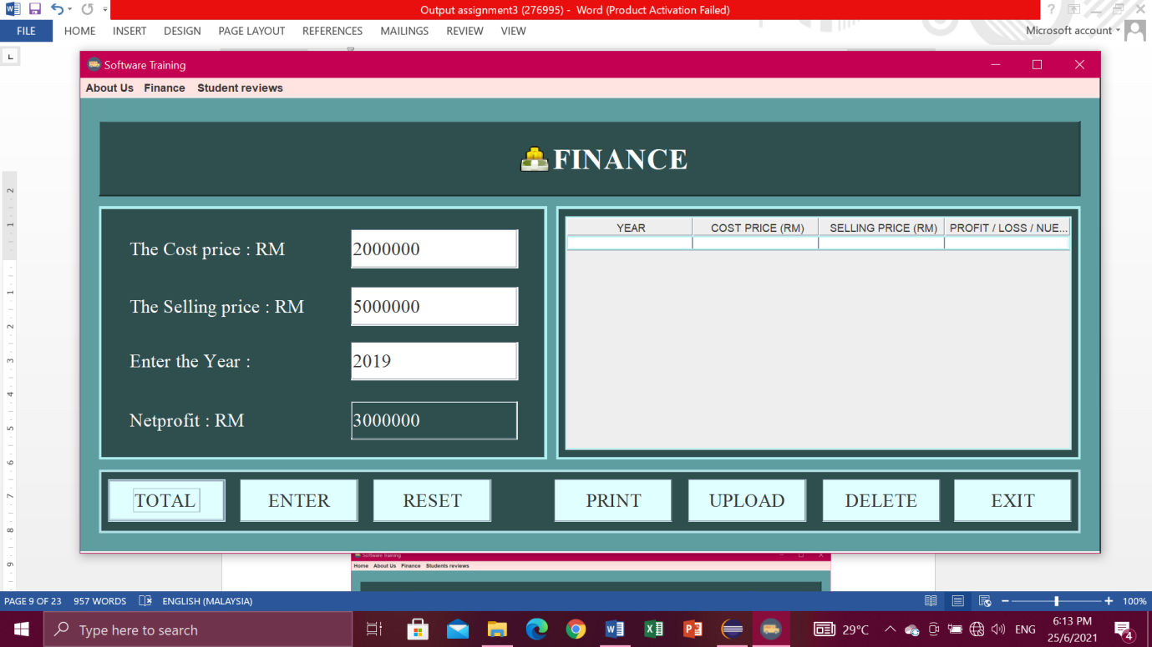

**Enter button**

* After click button TOTAL, you have to click button ENTER to display in the table.

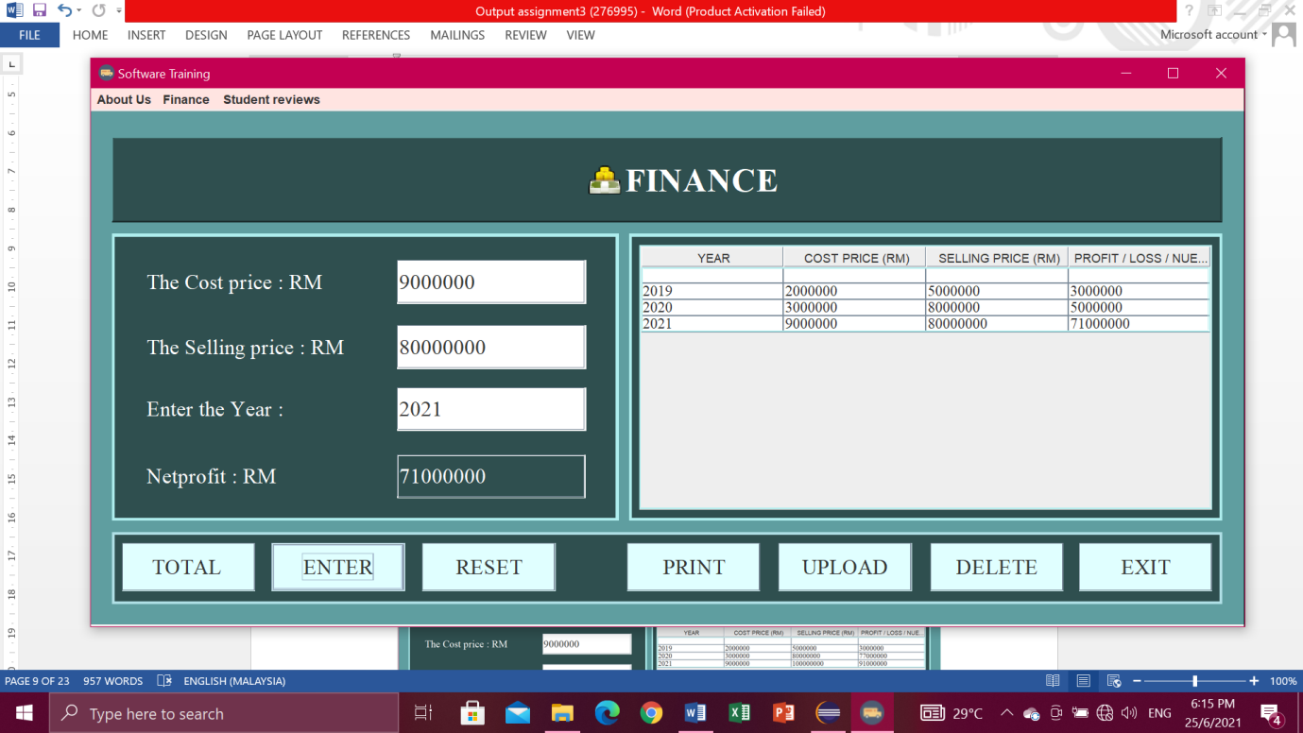

**Reset button**

* Click button RESET when don’t write data or key in data. So you don’t have to clean one by one.

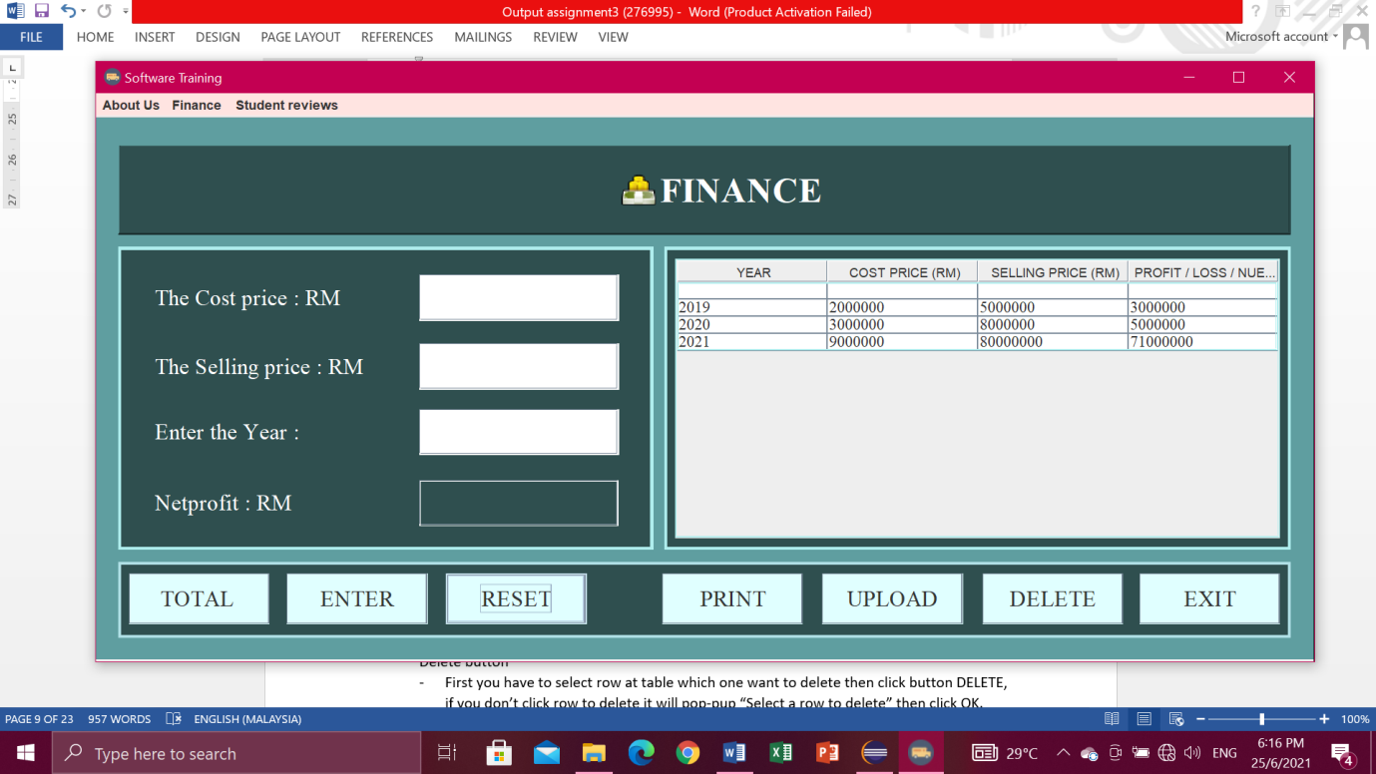

**Delete button**

* First you have to select row at table which one want to delete then click button DELETE, if you don’t click row to delete it will pop-up “Select a row to delete” then click OK.

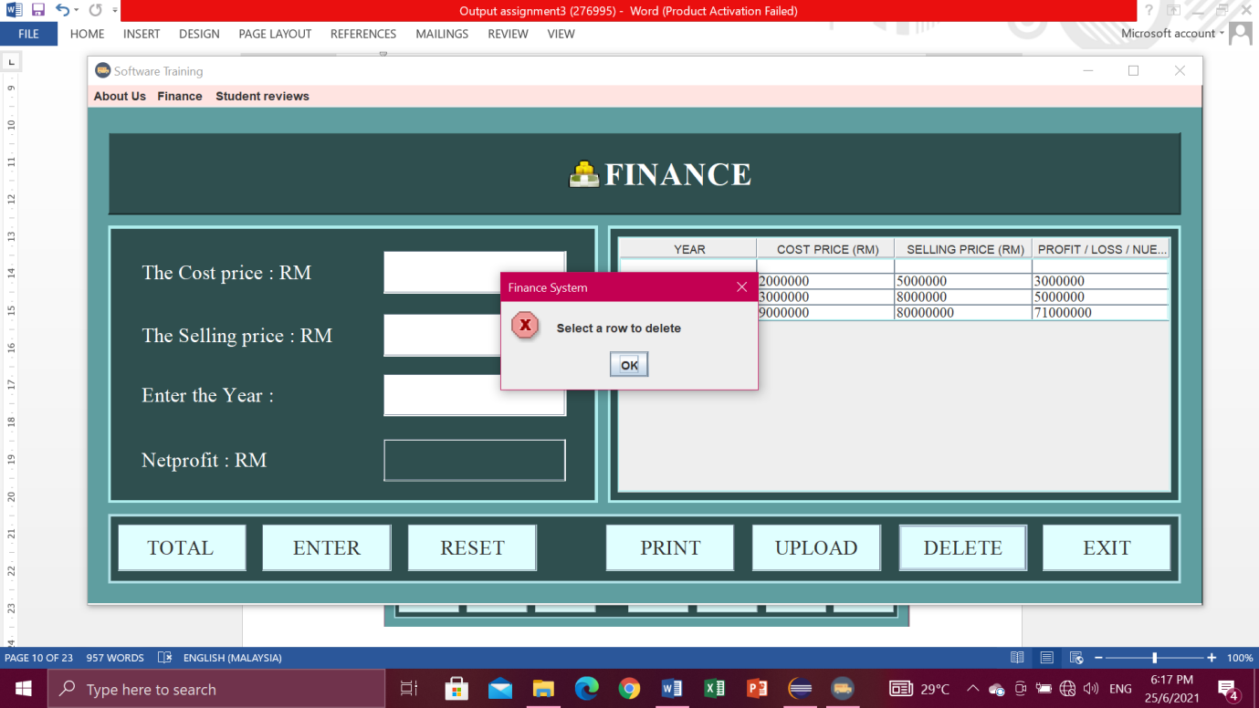

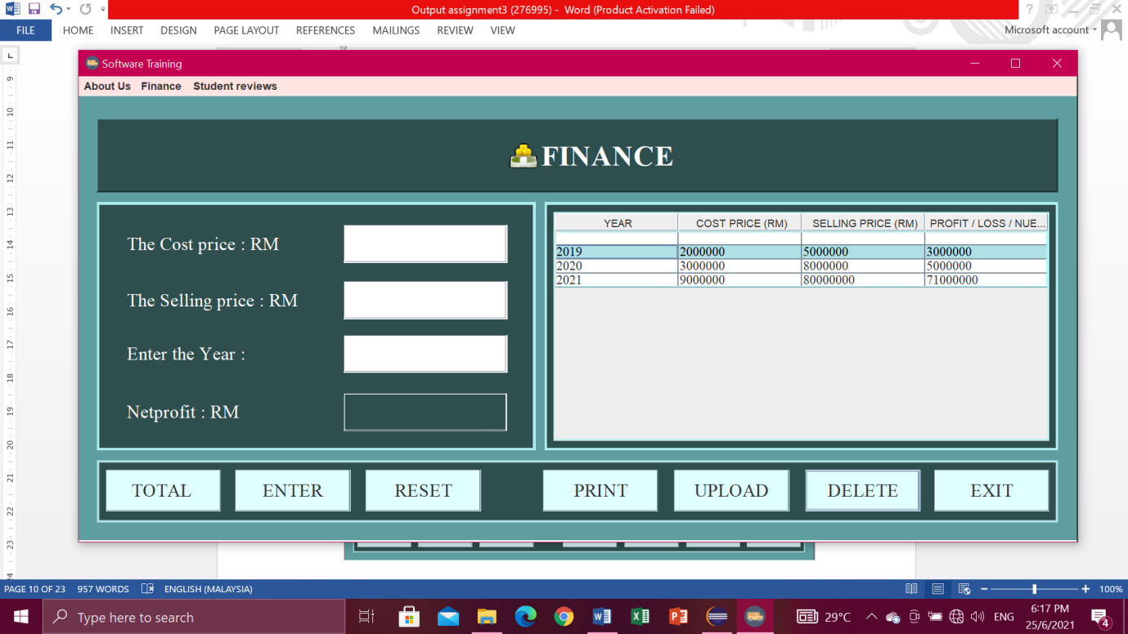

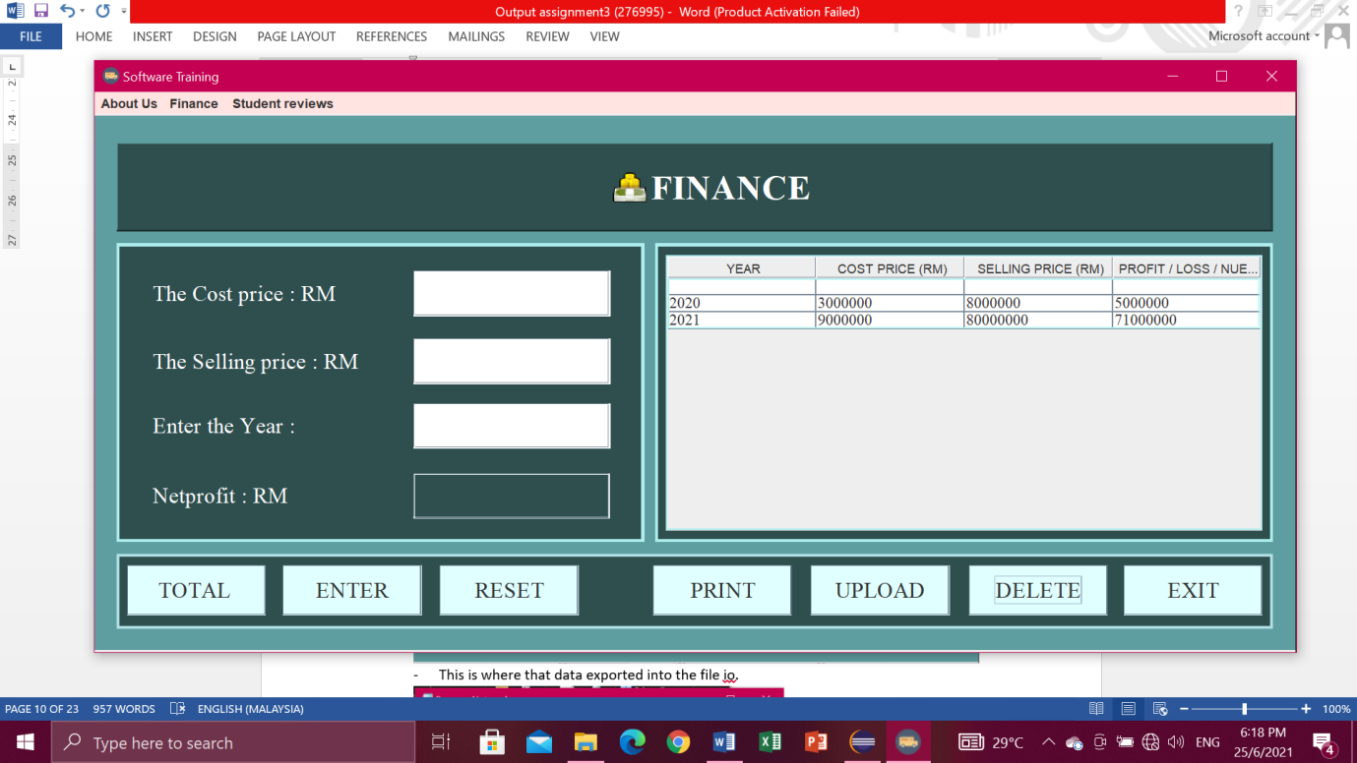

**Upload button**

* Click button UPLOAD. Then will pop-up “Data Exported”.

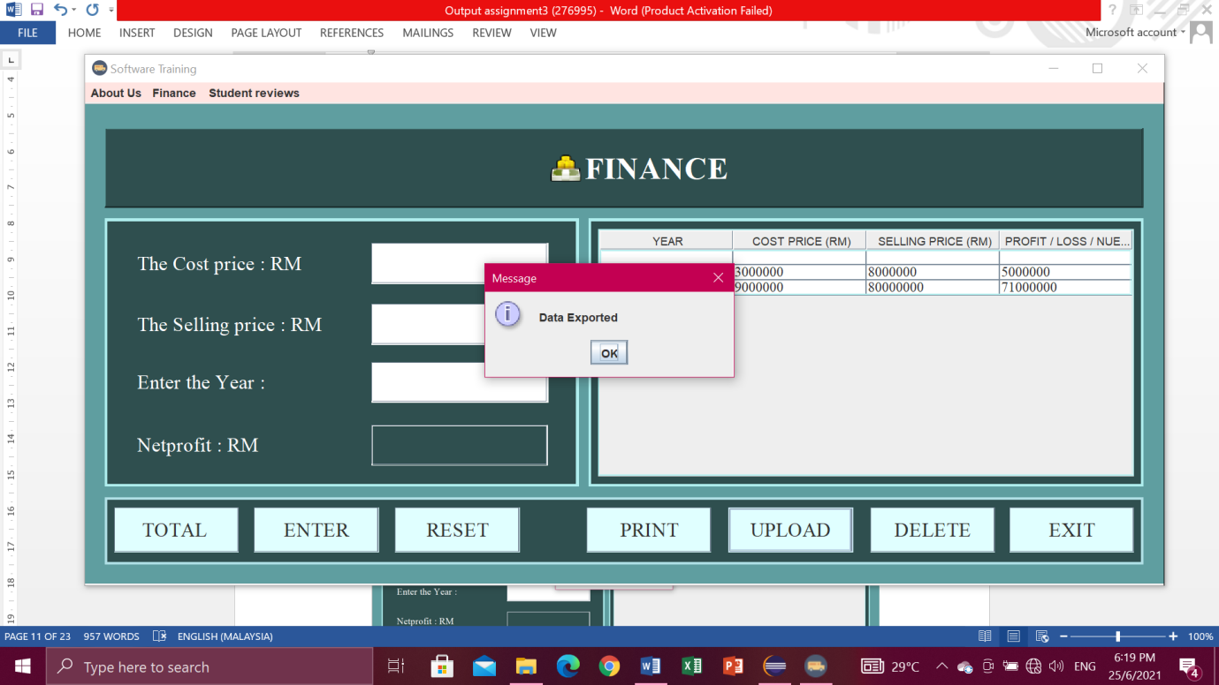

* Data exported into the file io.

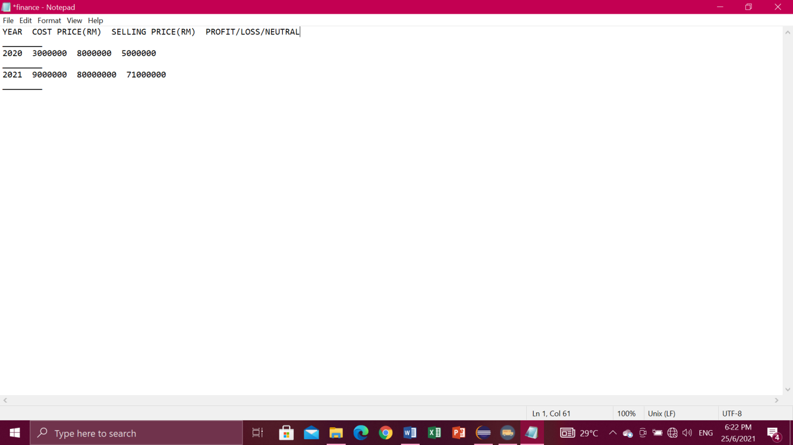

**Print button**

* You have to select a row first.

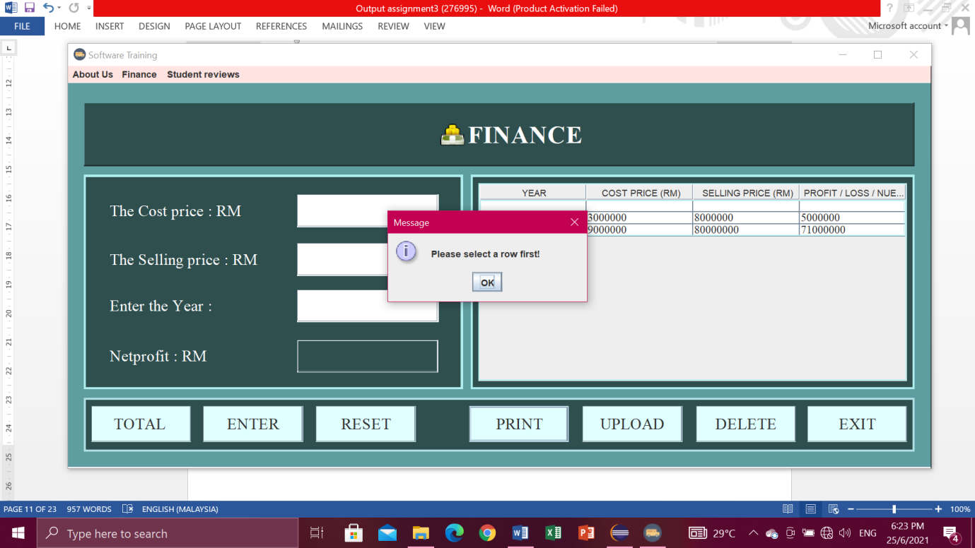

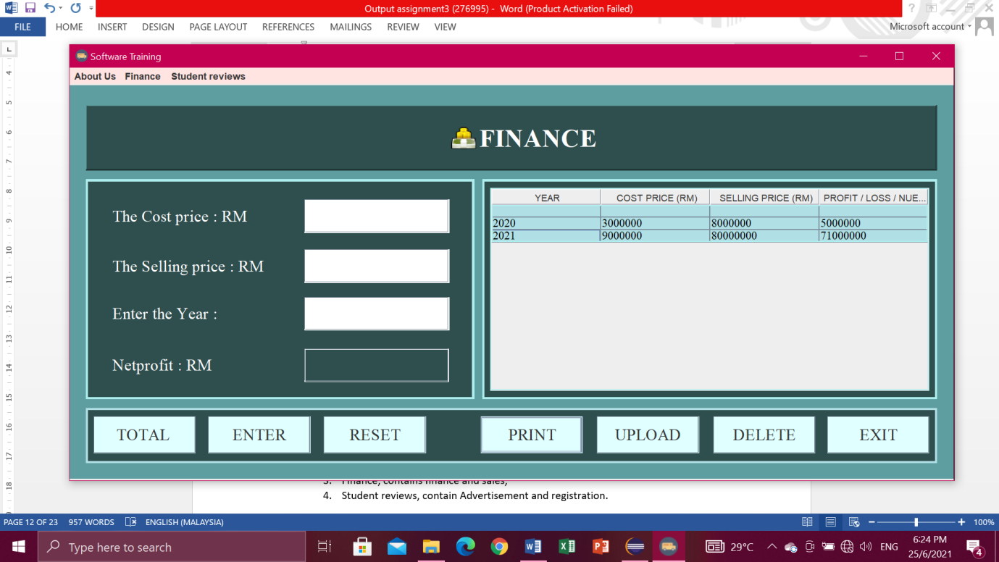

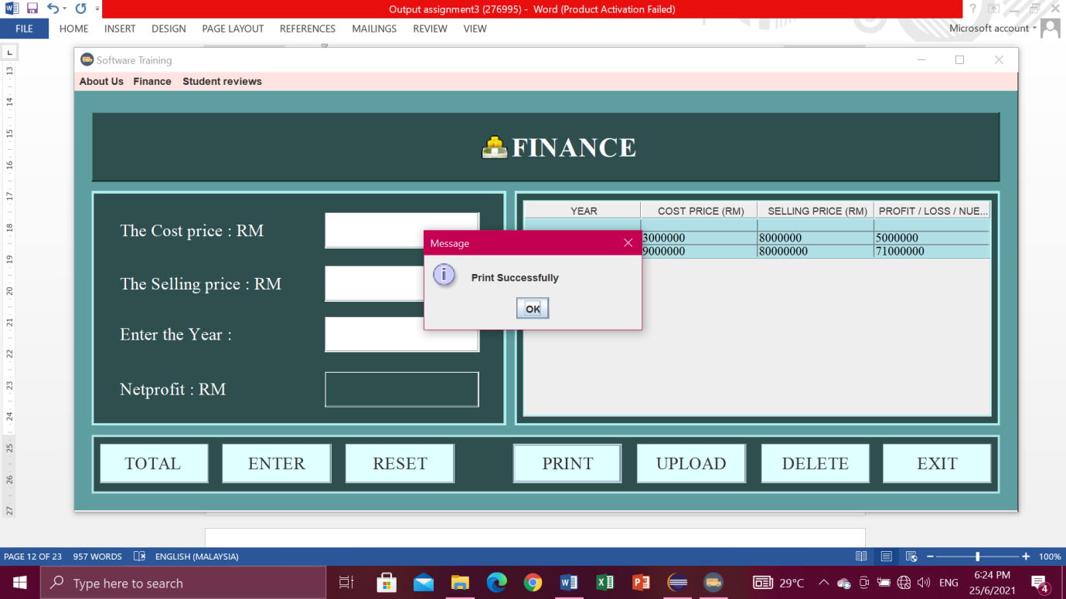

**Menu bar.**

* For the menu bars, you can click

1. About Us , in the menu item contains Intelleq Qs and Employee,
2. Finance, contains finance and sales,
3. Student reviews, contain Advertisement.

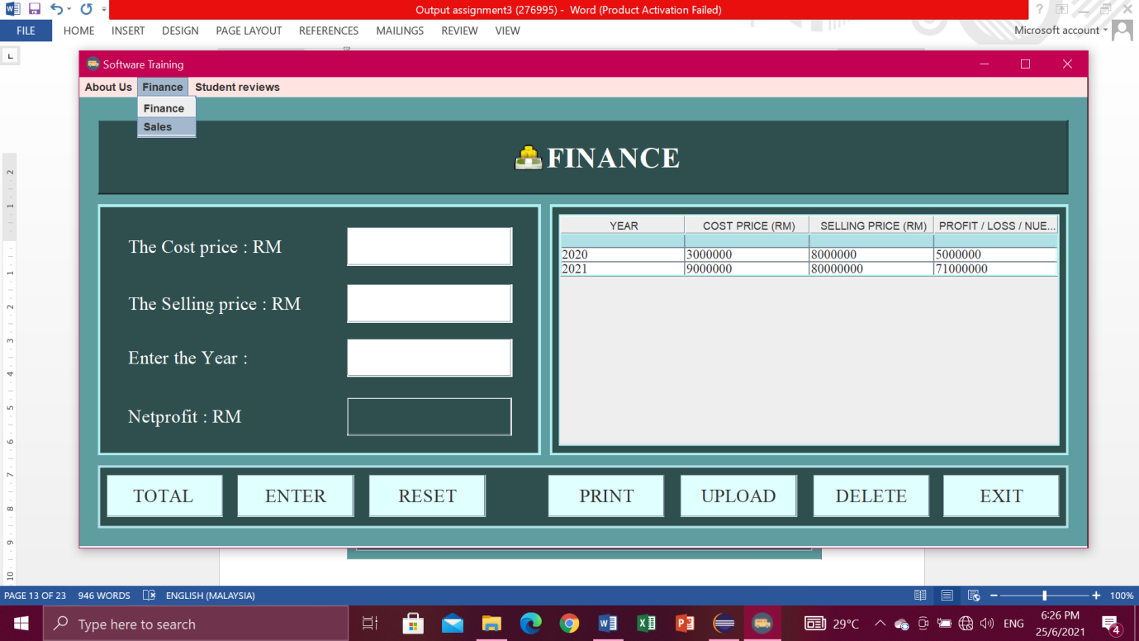

**Exit button**

* If you are click exit button, it will pop-up “Confirm if you want to exit”.Then just click Yes or No.

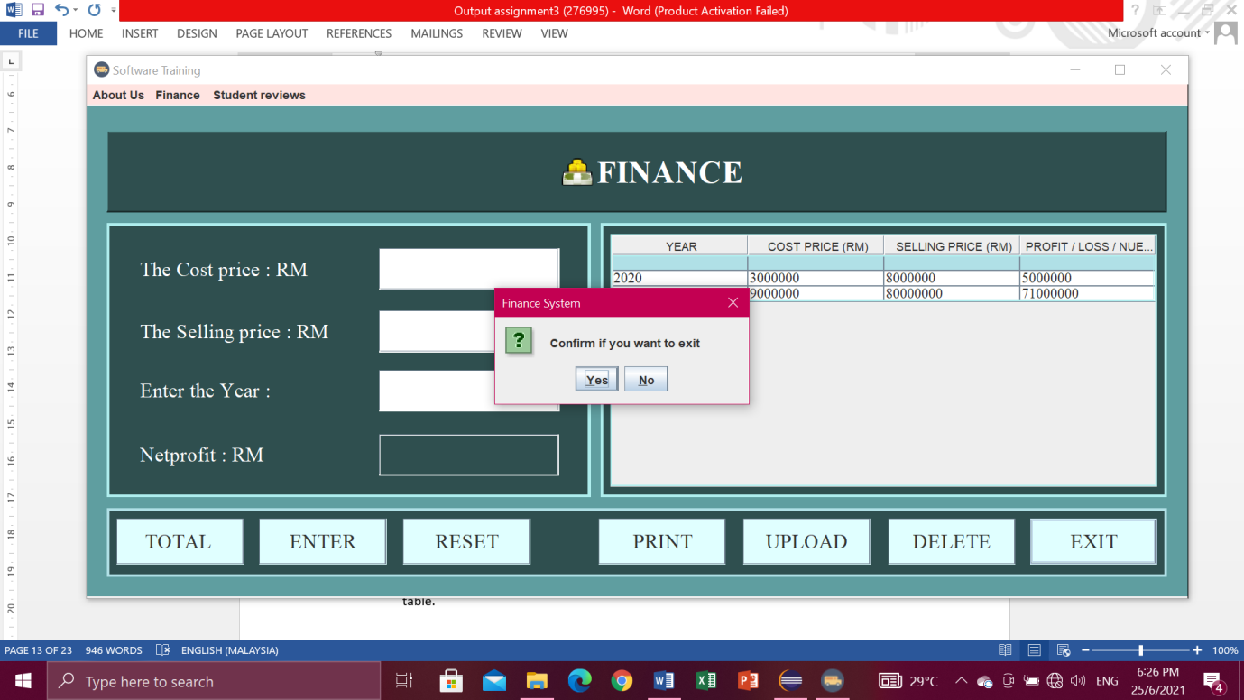

**SALES**

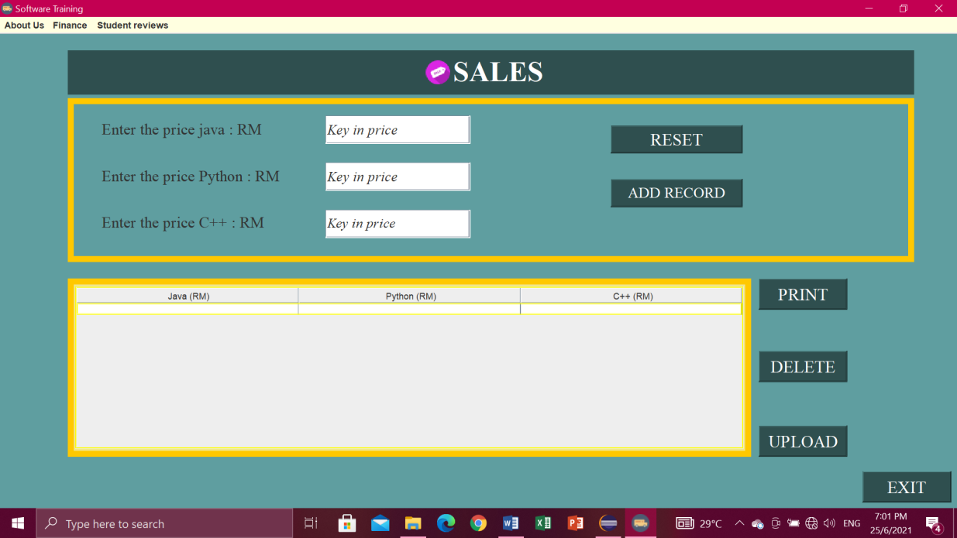

**Add record button**

* This button will pass the value to the customer and this button also will display in the table.

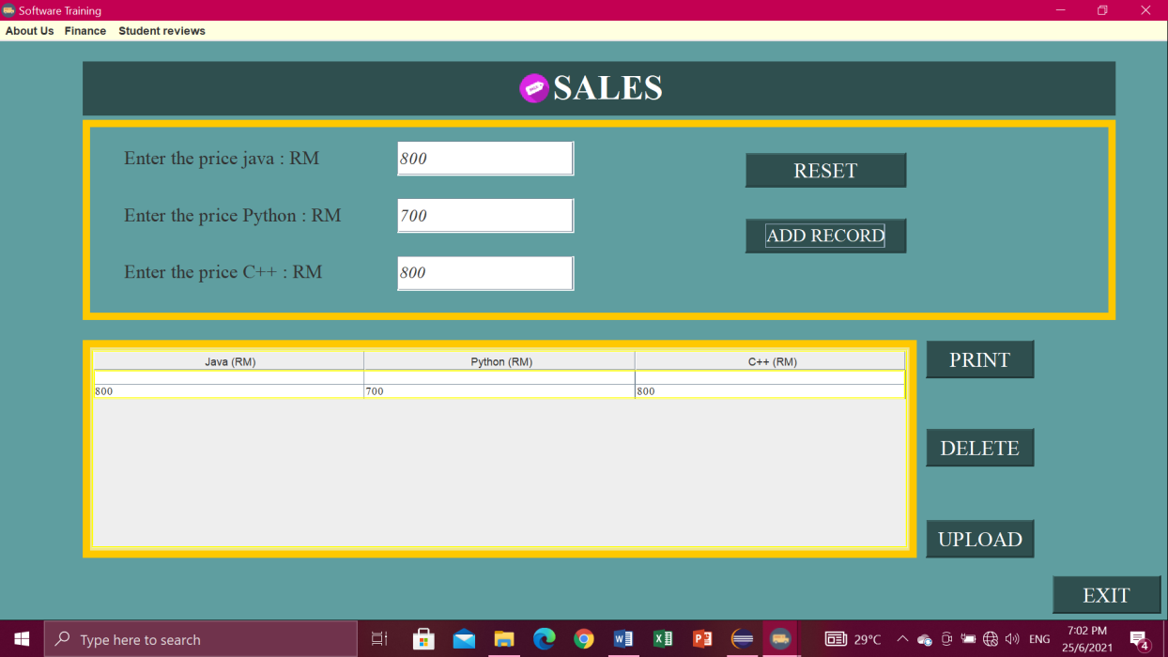

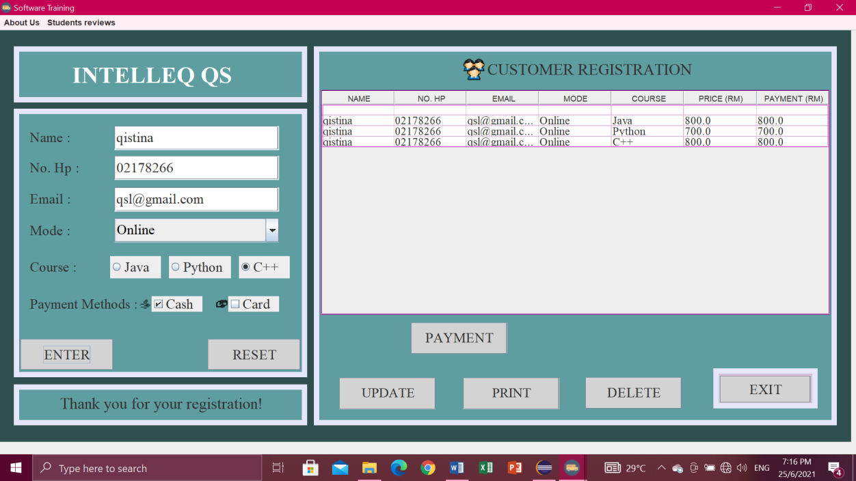

**Delete button**

* First you have to select row at table which one want to delete then click button DELETE, if you don’t click row to delete it will pop-up “Select a row to delete” then click OK.

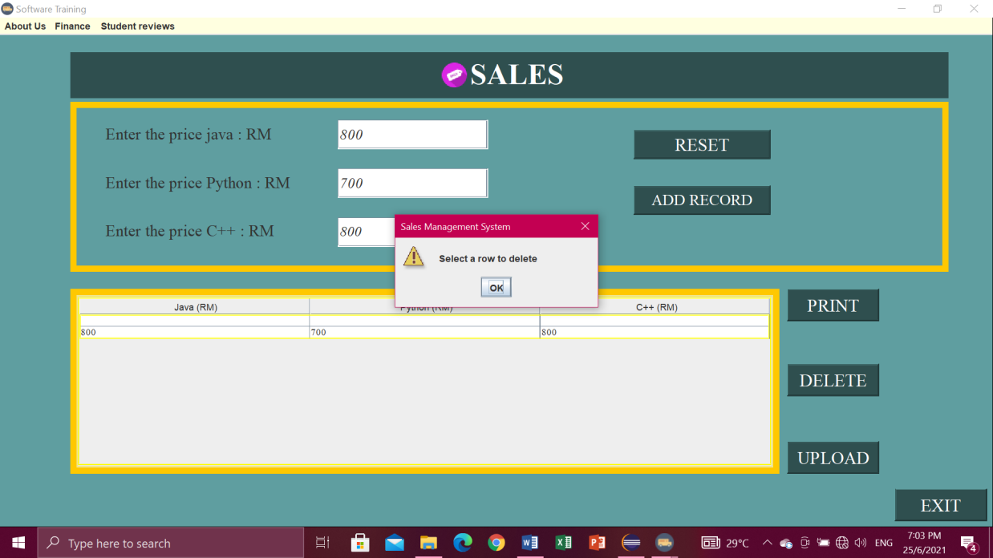

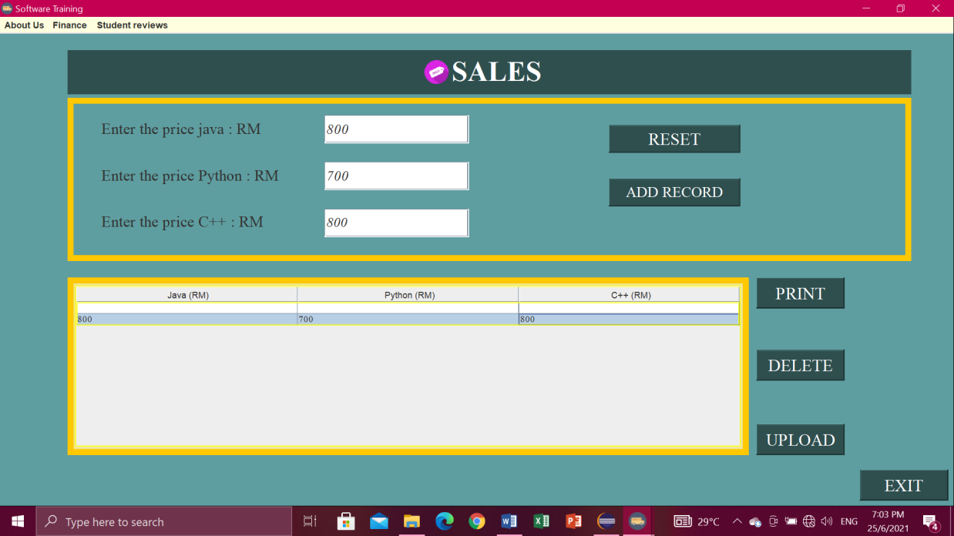

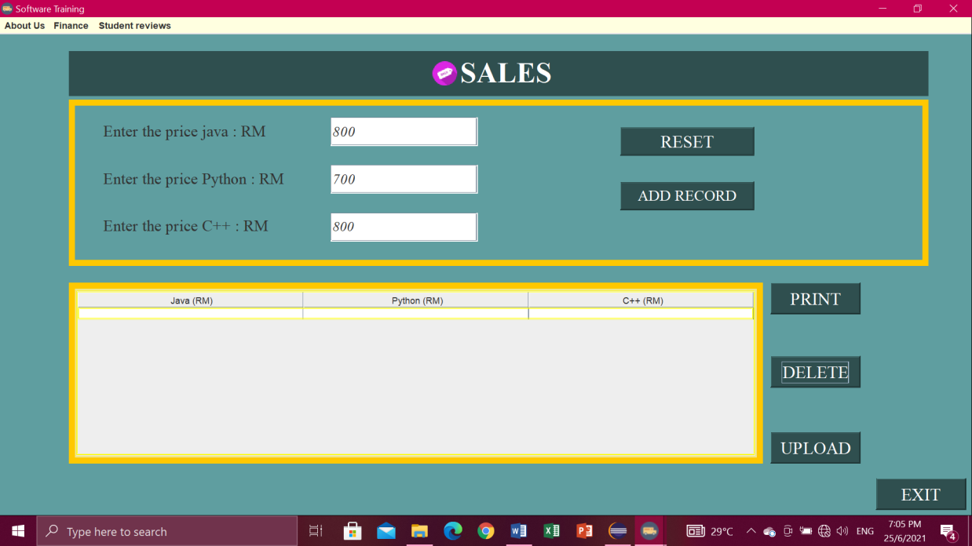

* If you click button DELETE but no data in table it will pop-up “No data to delete”.

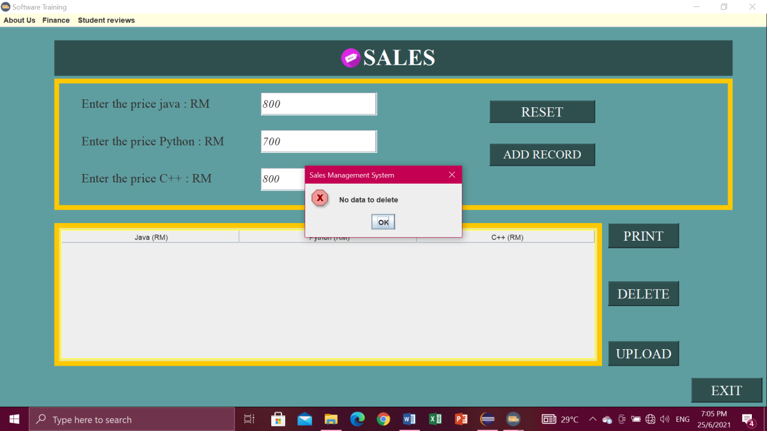

**Reset button**

* Click button RESET when don’t write data or key in data. So you don’t have to clean one by one.

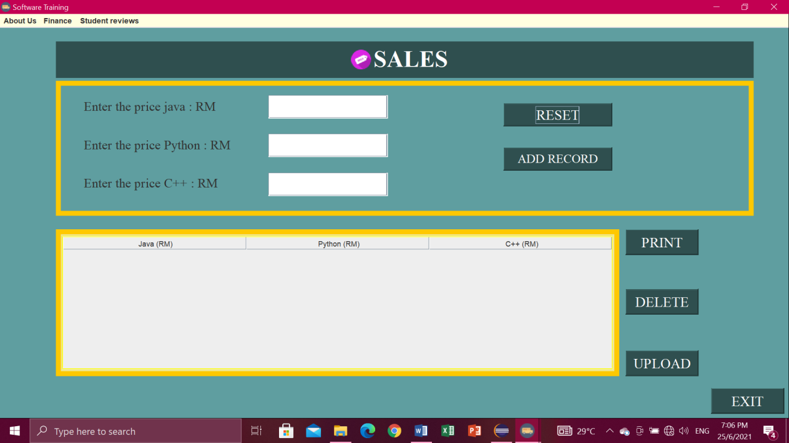

**Upload button**

* Click button UPLOAD. Then will pop-up “Data Exported”.

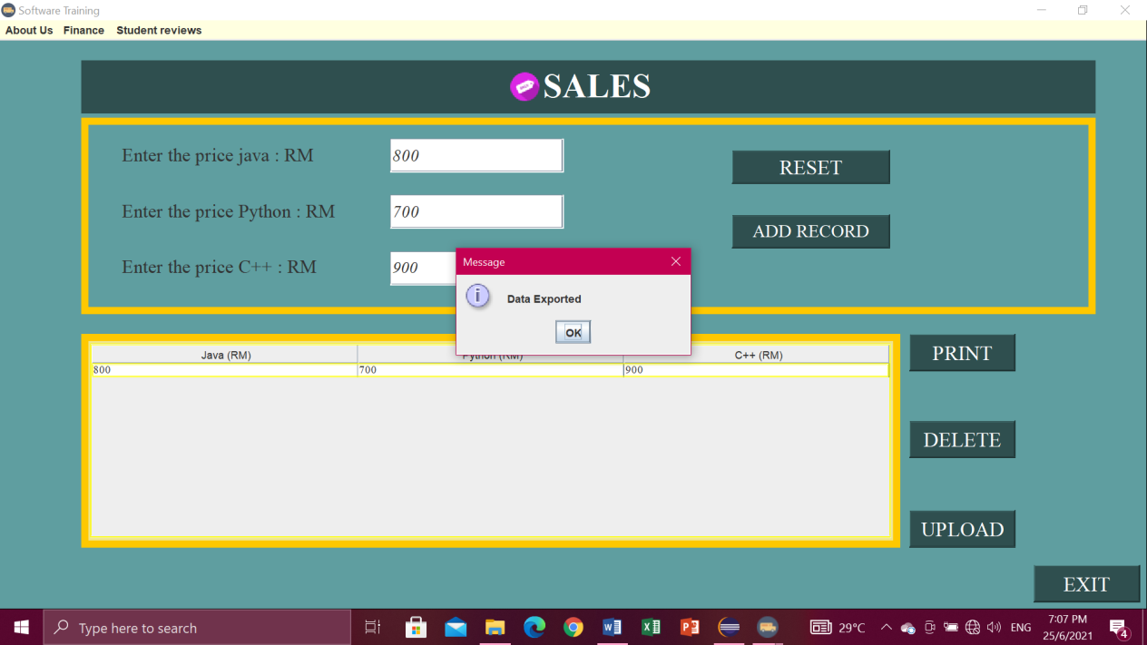

* The data exported into the file io.

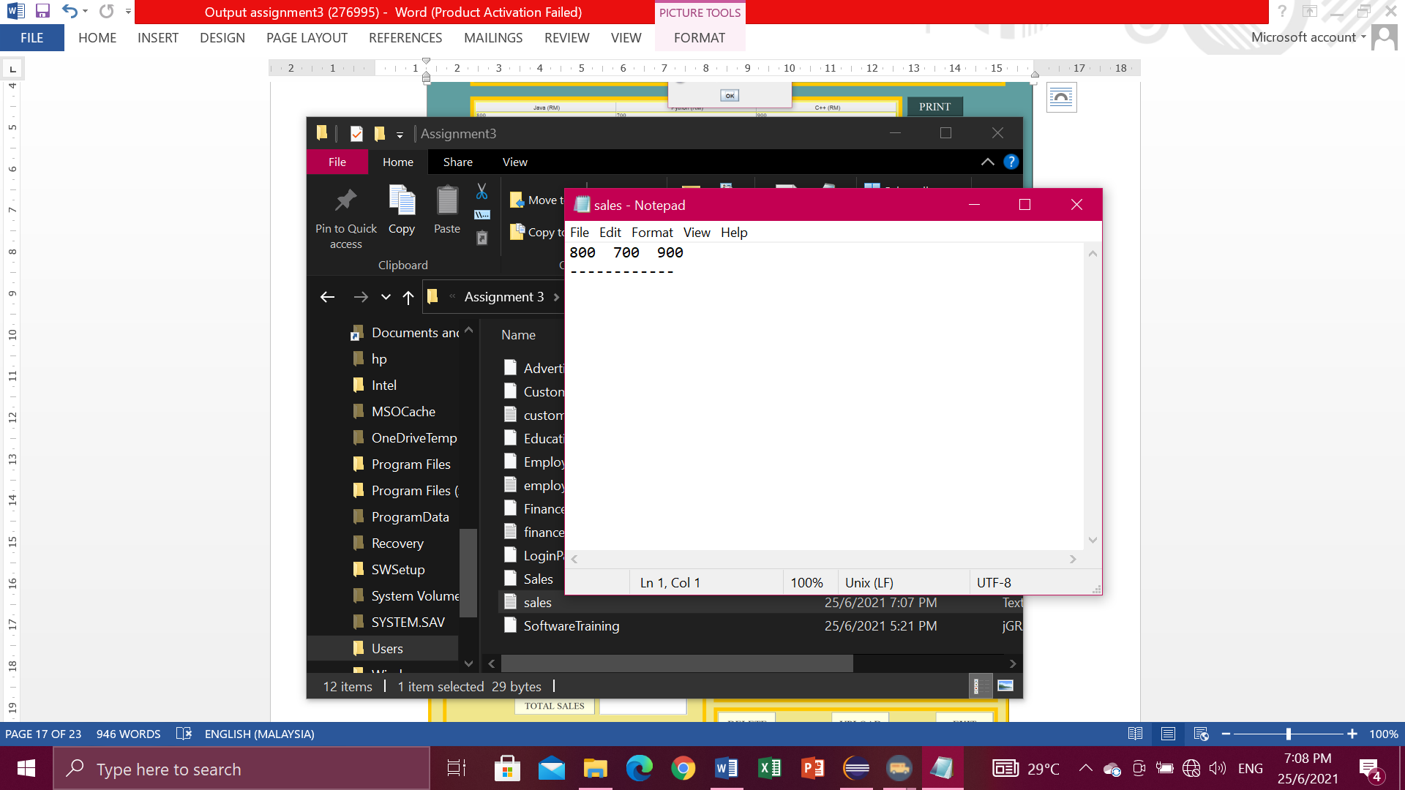

**Print button**

* You have to select a row first.

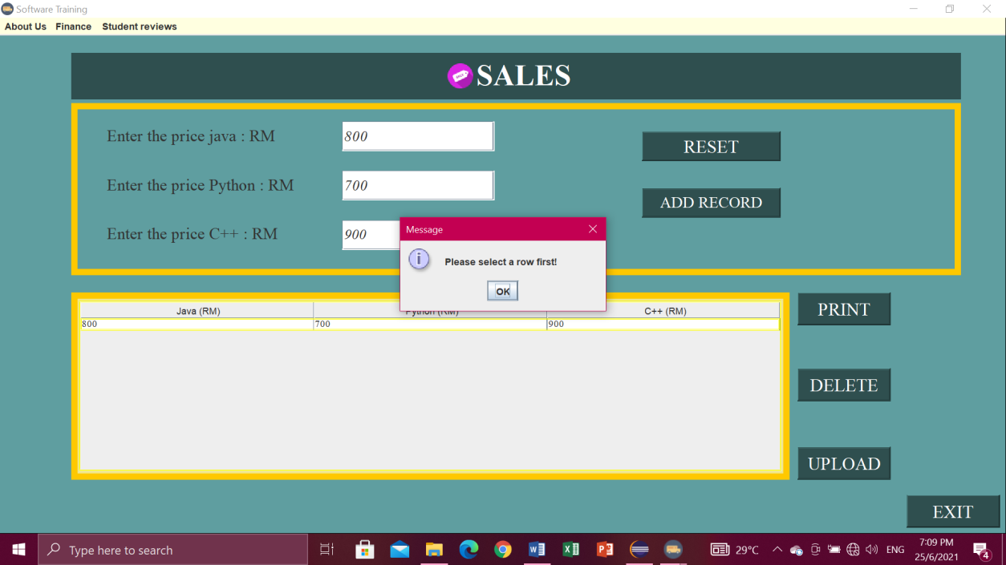

* Then it will pop-up “Print Successfully” and click OK.

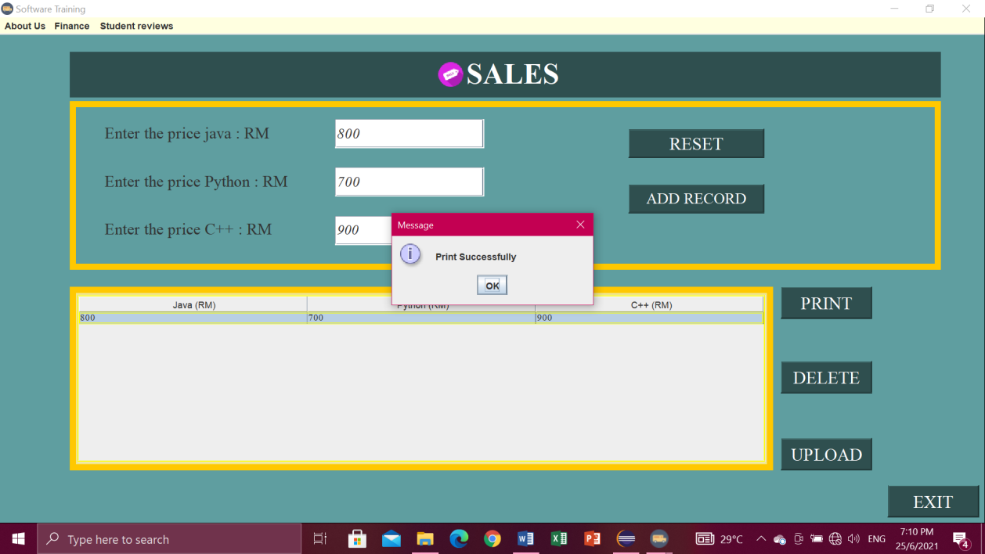

**Menu bar.**

* For the menu bars, you can click

1. About Us , in the menu item contains Intelleq Qs and Employee,
2. Finance, contains finance and sales,
3. Student reviews, contain Advertisement.

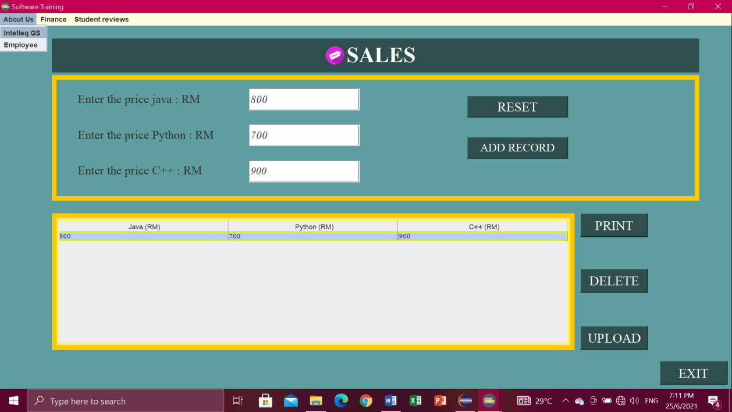

**Exit button**

* If you are click exit button, it will pop-up “Confirm if you want to exit”. Then just click Yes or No.

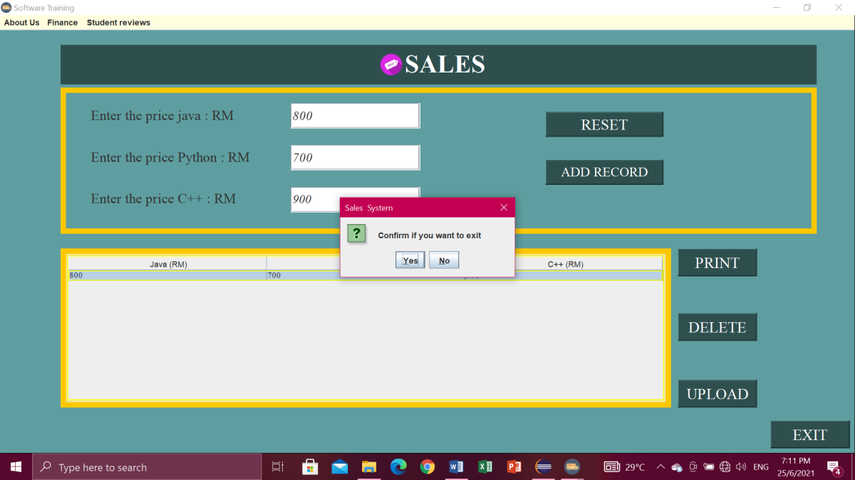

**ADVERTISEMENT**

- Show location, ads attract clients, courses, prices, course duration and student feedback.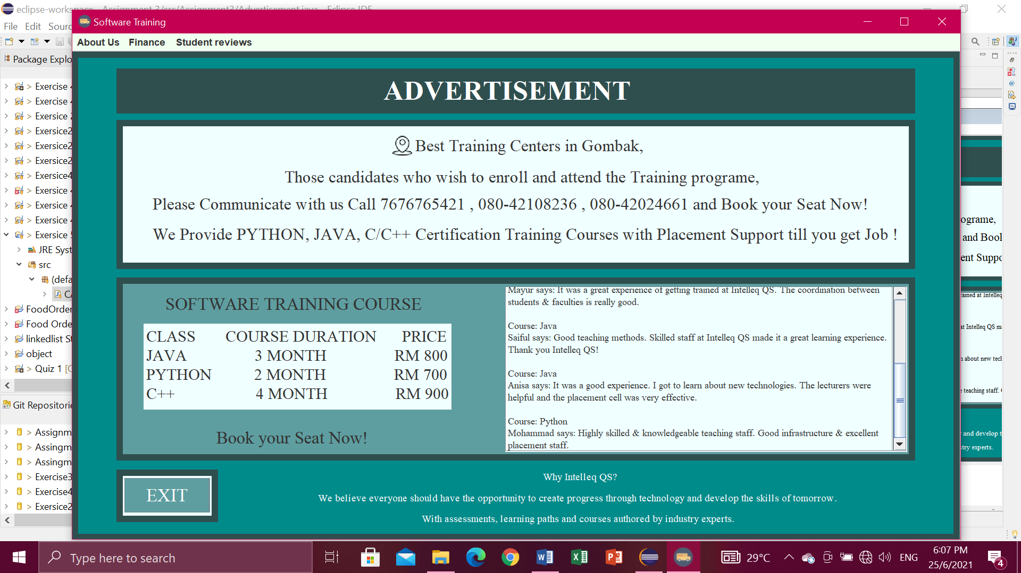

**Exit button**

* If you are click exit button, it will pop-up “Confirm if you want to exit”. Then just click Yes or No.

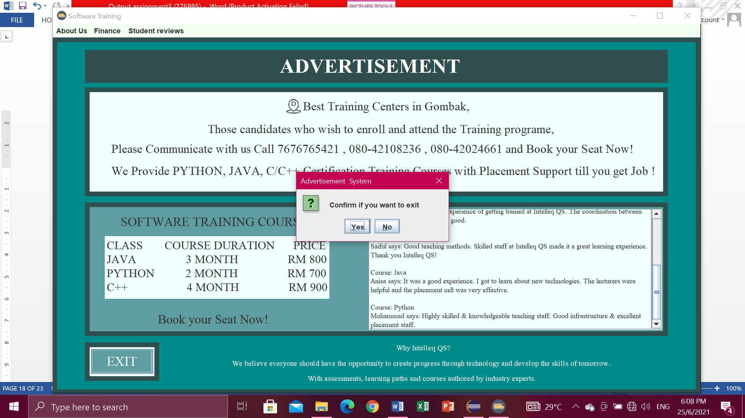

**Menu bar**

* For the menu bars, you can click

1. About Us , in the menu item contains Intelleq Qs and Employee,
2. Finance, contains finance and sales,
3. Student reviews, contain Advertisement.

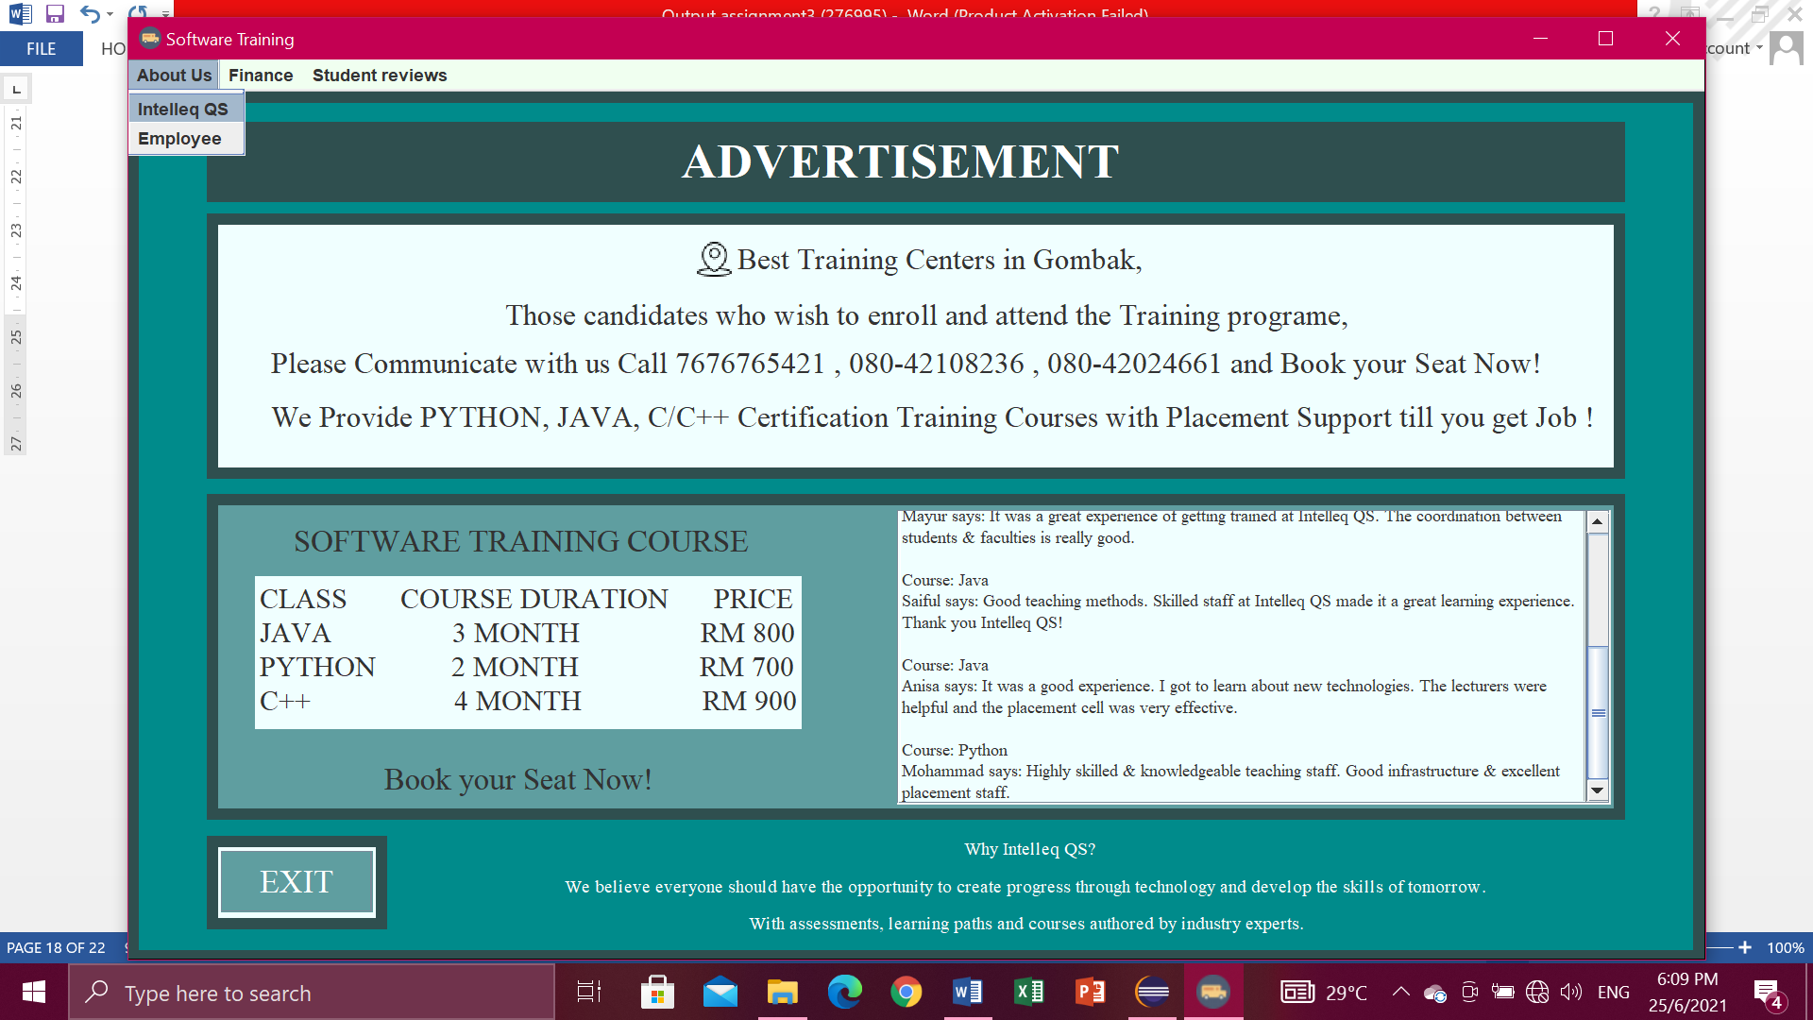

1. **(USER BUTTON) – CUSTOMER**

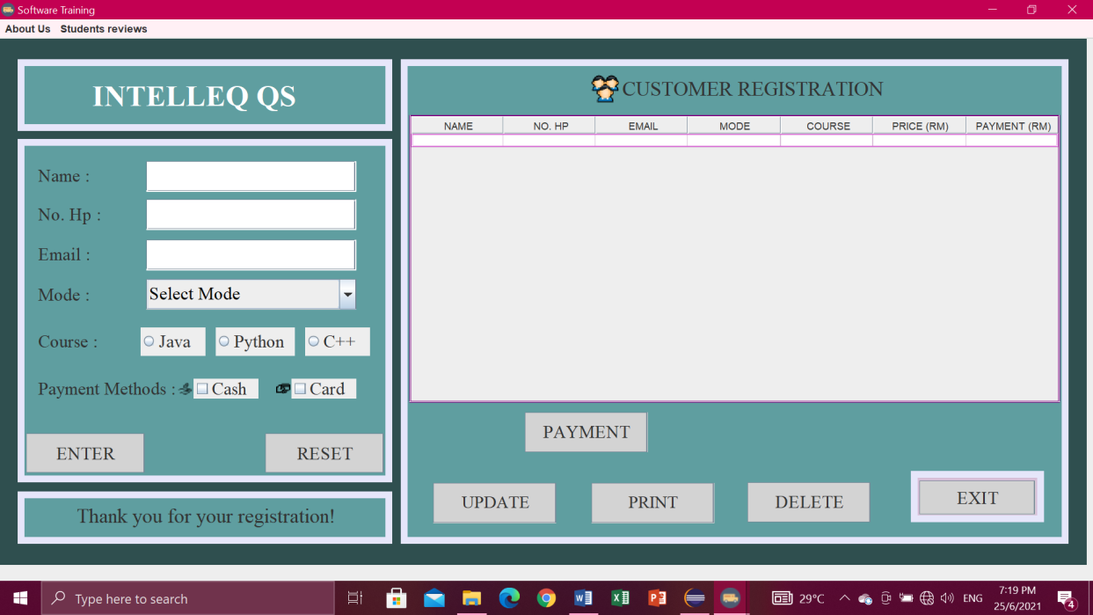

**Enter button**

* Enter Name, No. Hp, Email, Choose Mode, Course and Payment Methods. Then click button Enter. After click Enter it will display in the table.

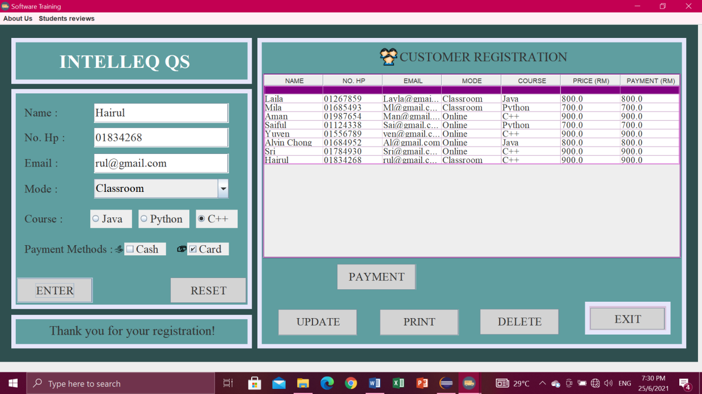

**Reset button**

* Click button RESET when don’t write data or key in data. So you don’t have to clean one by one.

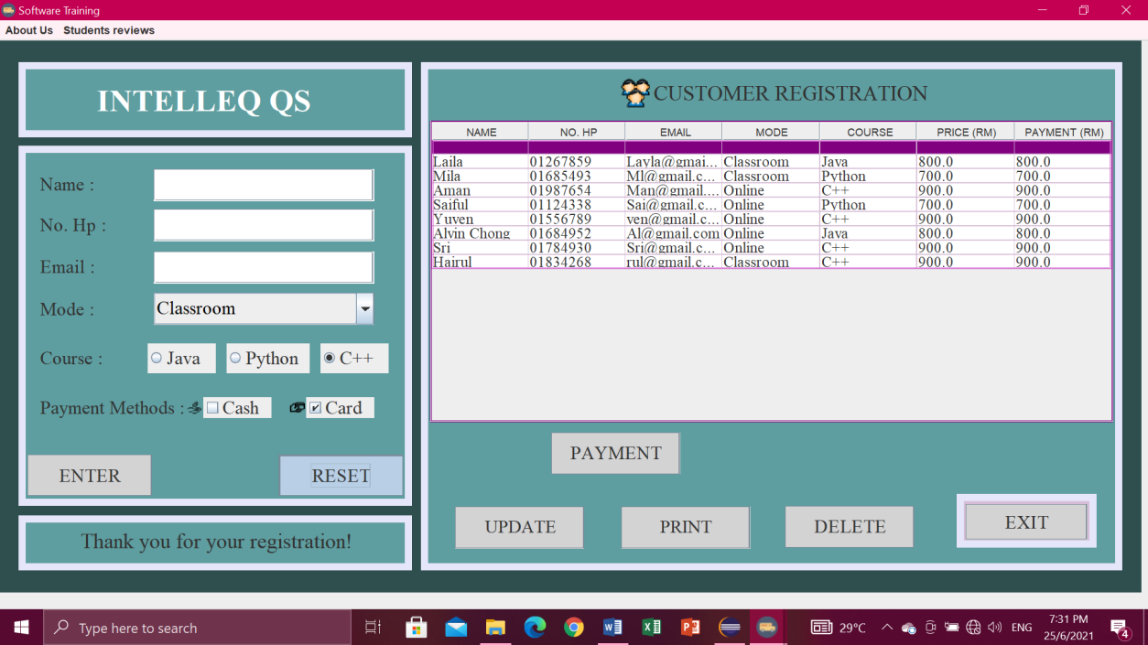

**Delete button**

* First you have to select row at table which one want to delete then click button DELETE, if you don’t click row to delete it will pop-up “Select a row to delete” then click OK.

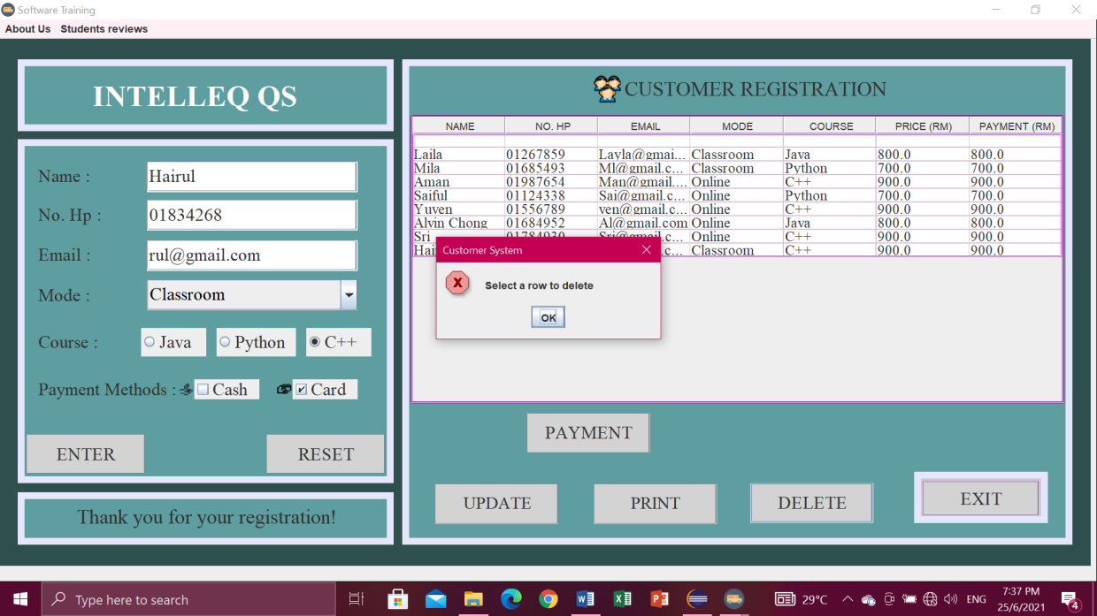

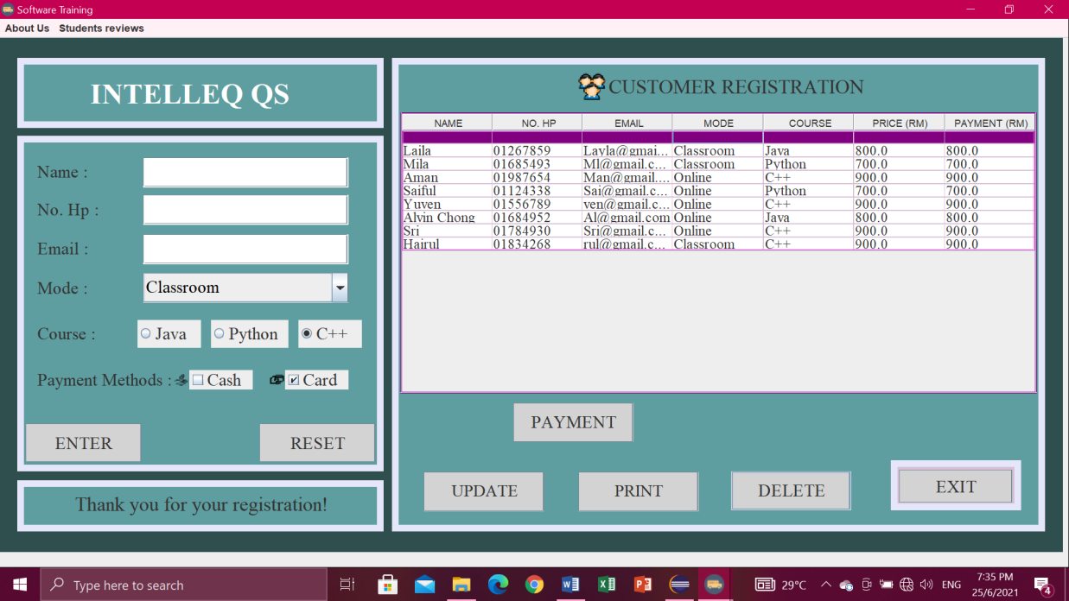

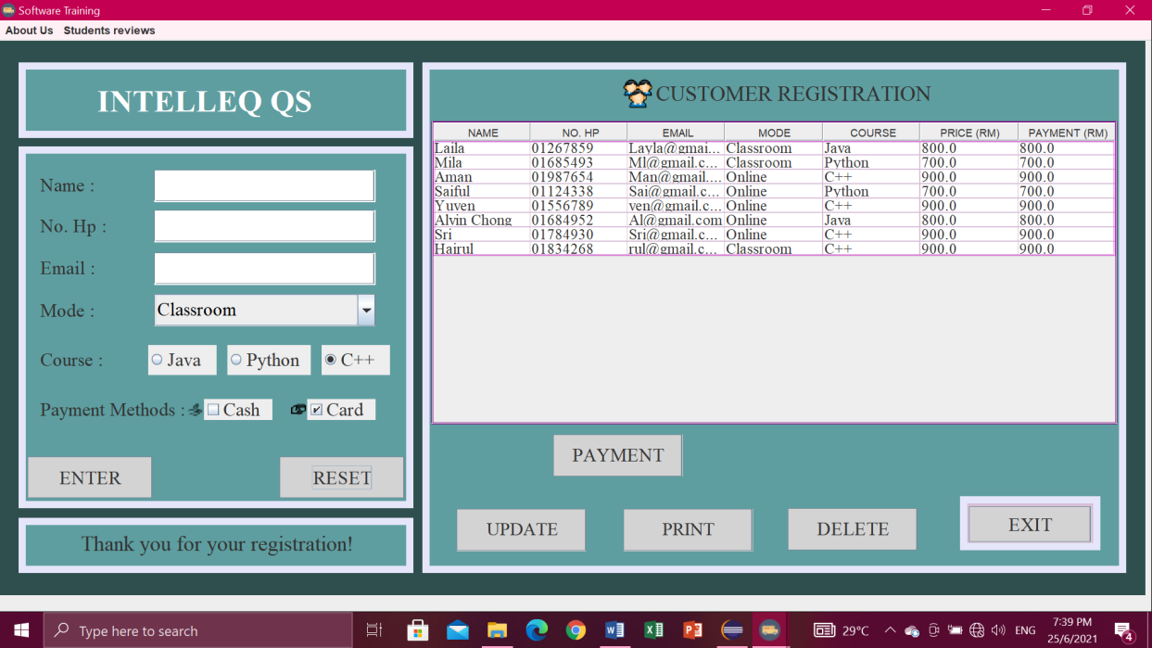

**Payment button**

* Click payment button then it will display total amount that customer have to pay and also pop-up “Registration Successful”. Then click OK or Cancel.

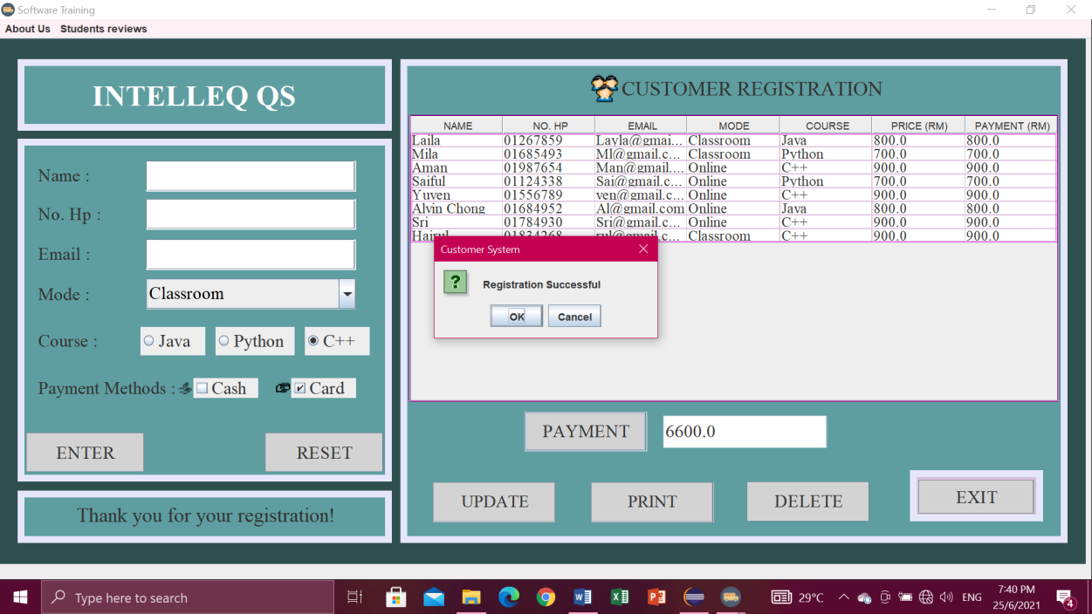

**Update button**

* Click button UPDATE. Then will pop-up “Data Exported”.

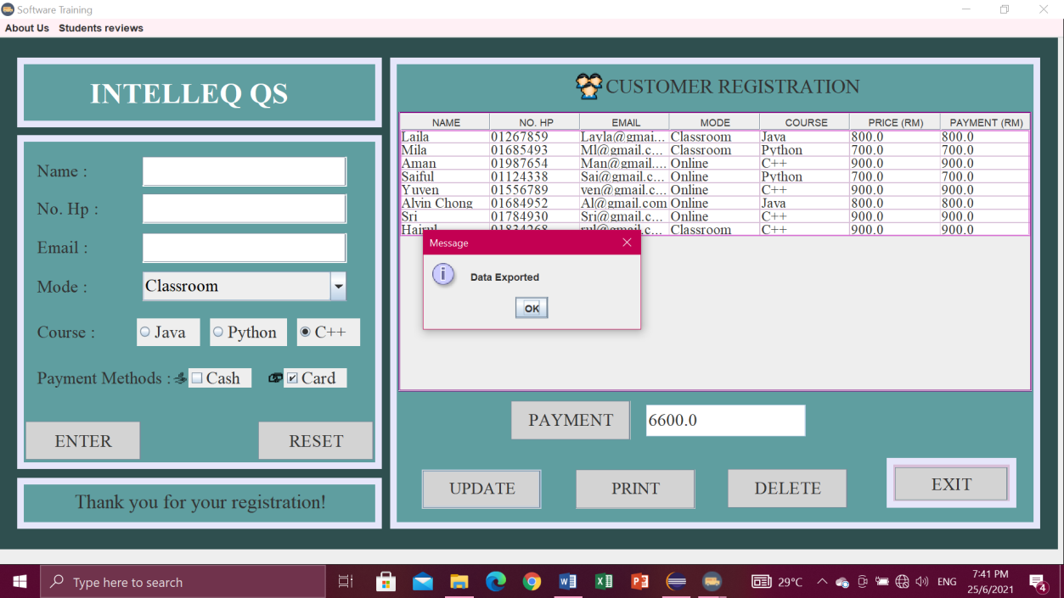

* The data exported into file io.

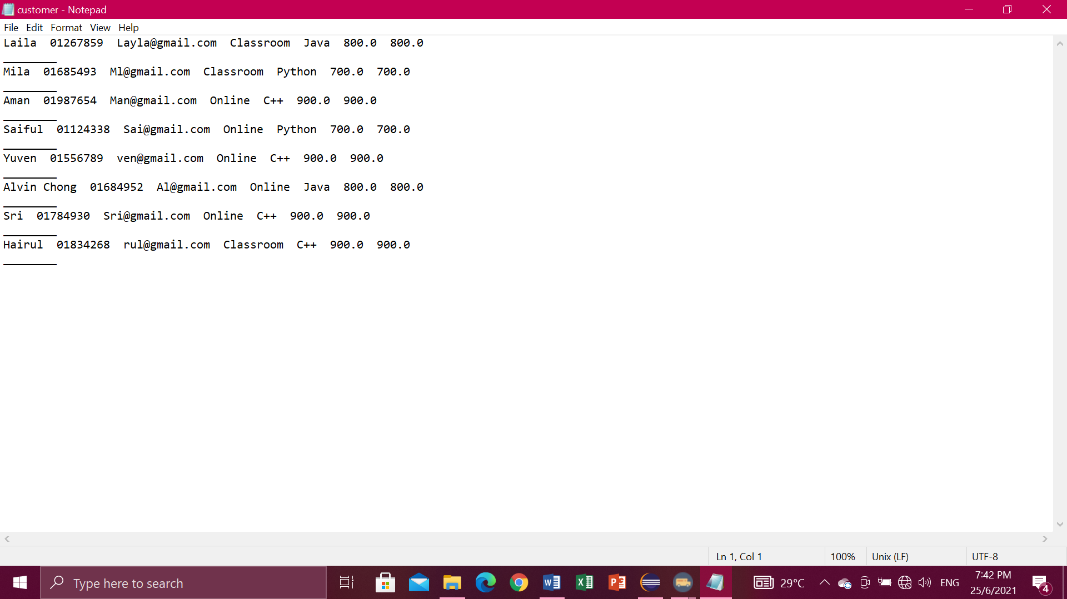

**Print button**

* You have to select a row first.

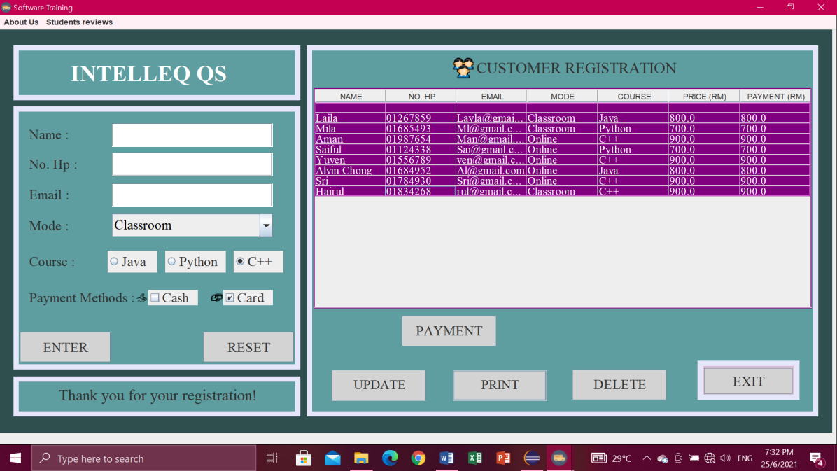

* Then it will pop-up “Print Successfully” and click OK.

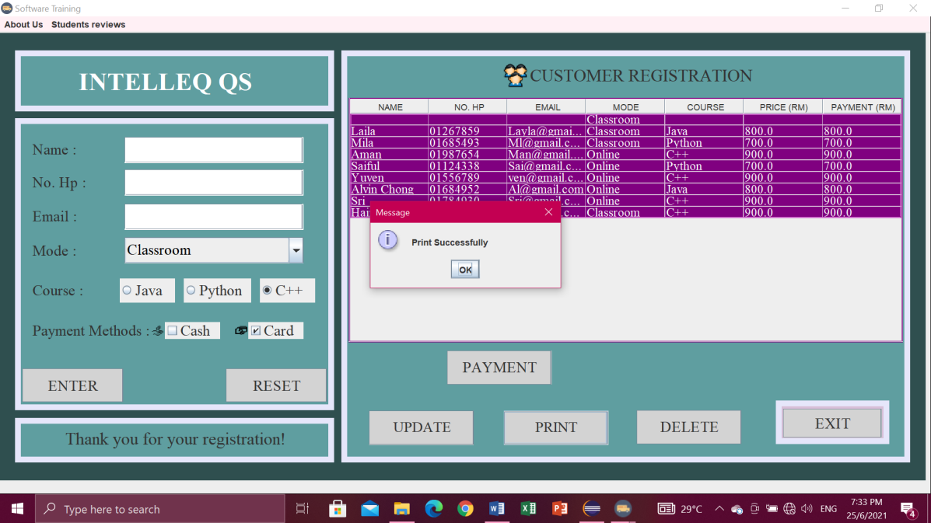

**Menu bar**

* For the menu bars, you can click

1. About Us , in the menu item contain Intelleq Qs,
2. Student reviews, contain Advertisement.

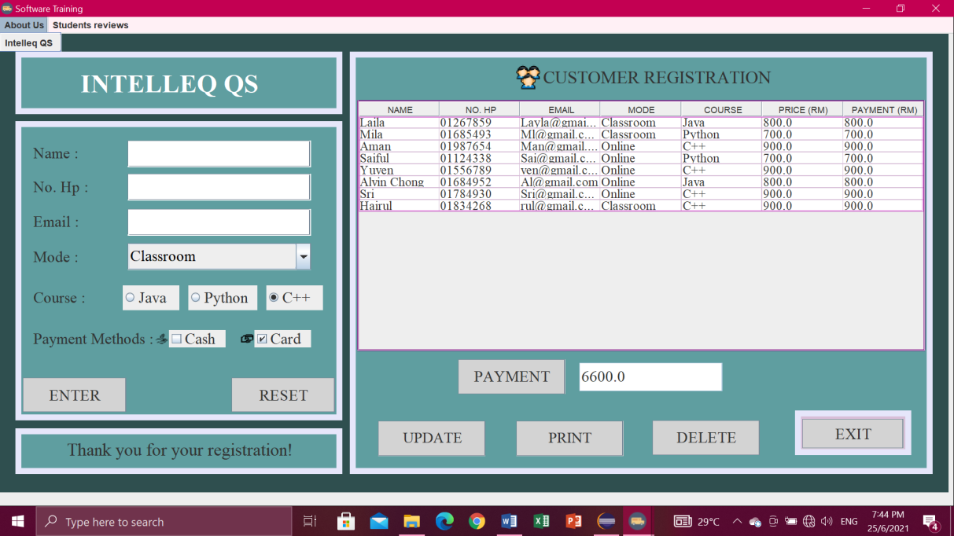

**Exit button**

* If you are click exit button, it will pop-up “Confirm if you want to exit”. Then just click Yes or No.

